Monikie Primary School
Relationships Policy


Updated February 2025

How do we create a positive ethos?
Our children are given clear guidance about appropriate behaviour and expectations based on our School Values. Our values are displayed in every classroom. All team members expect our children to demonstrate these values on a daily basis and show these values in and around the school. We talk about our school values at assemblies and in the classroom and celebrate successes linked to our school values.
We believe that positive behaviour is promoted by the solid relationships we build between pupils and all staff.
We developed our new school values in line with our families, staff, children and the local community. Our school values are:
- Respect
- Kindness
- Honesty
- Inclusion

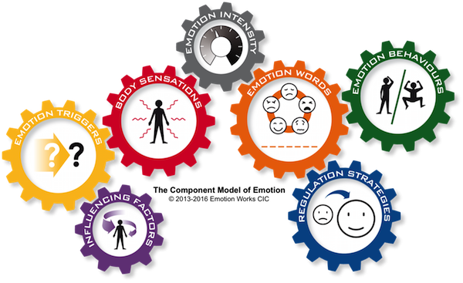
Children’s Wellbeing
In Monikie we use Emotionworks to develop children’s emotional literacy. They learn about different emotions, the triggers, intensity and ways to regulate themselves.

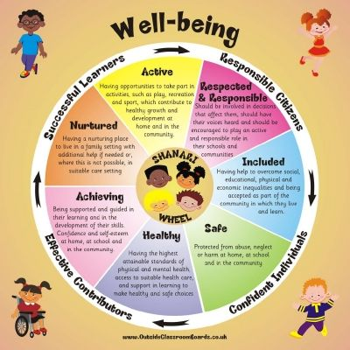

Wellbeing webs which are linked to the GIRFEC SHANARRI principles (pictured below) are conducted each term with children across the school. This gives an opportunity for teachers to check in with how children are feeling and to address any concerns.

Celebrating achievement
At Monikie we celebrate success in a range of ways. Celebrations are shared at assemblies, in classes through positive praise and recognition, by sharing on dojo and on achievement boards.
At assembly, we celebrate access linked to our schools values and children get house points for going above and beyond.

Behaviour Management
Scripted Language and limited vocabulary should be used with children who are not behaving in line with our school values.
The following protocol is used to manage children’s behaviour in Monikie:
If an incident occurs that requires adult intervention, a restorative conversation may be necessary. These are supported by an adult or peer mediator and would be between everyone involved.

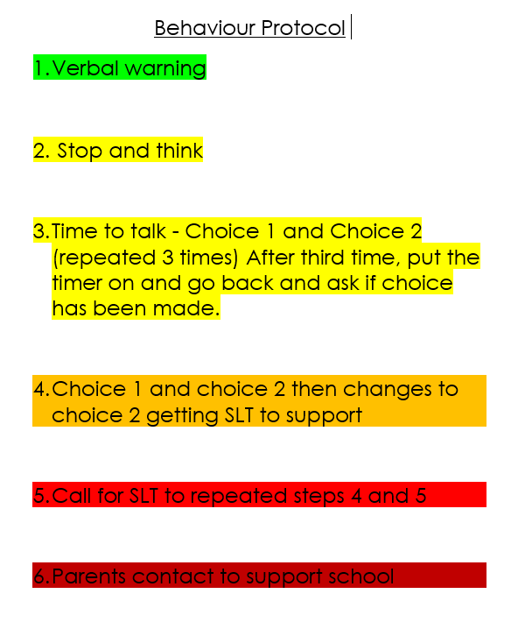
The Monikie Magic Questions
The following questions are used to structure a conversation.
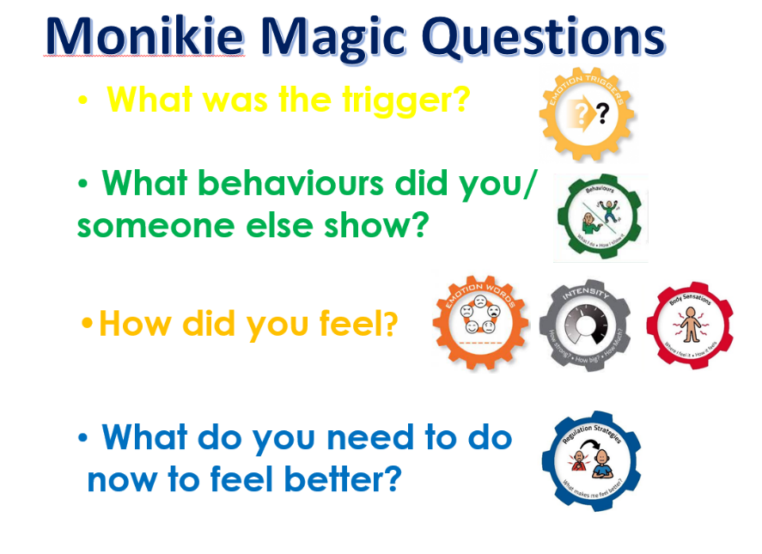

The Anger Rules
Everyone feels angry some times. The anger rules let pupils know that this is normal to have these feelings however there is a way of keeping pupils and everyone else safe when someone is angry.
It is ok to feel angry but it is not ok to:
- Hurt yourself
- Hurt others
- Damage property

Anti-Bullying Policy
We have developed an anti-bullying policy. This is in line with Angus Council guidance. Our anti-bullying policy is to provide guidance for the school community on the processes and procedures that should be followed both to prevent and to address bullying behaviour. Please take time to familiarise yourself with the content of this policy as it supports the development of positive relationships that we are promoting.

