Langlands Primary School
Positive Relationships Policy (August 2023)
At Langlands Primary School we are committed to supporting all children to ‘SHINE’.

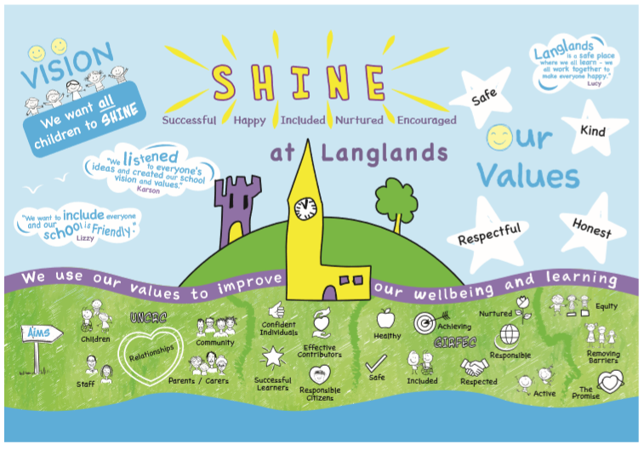

We believe that children’s wellbeing is at the heart of being able to get it right for every child (GIRFEC). At Langlands Primary School, we believe that a positive ethos where children feel safe, encouraged and supported is key to success. We strive for all our children to feel respected and cared for and encourage them to treat each other in this way. To build this ethos we have developed our Positive Relationships Policy.

Rationale for policy
This policy is being developed in May 2023 (launched August 2023) for the following reasons:
- Changes to the staff team have led to the need to ensure consistency of approach
- We recognise the need to develop positive, nurturing relationships and good behaviour in the context of Covid Recovery
- We are increasing our engagement with the United Nations Convention on the Rights of the child (UNCRC) and seek to place these articles at the heart of our positive relationships policy
- Our Pupil Leadership Group surveyed children in November 2022. It was completed by a sample of children from every class. Overall, the results were positive about how children felt about relationships at Langlands. There were some areas for improvement which linked with feeling safe, negative behaviours not being dealt with and a mixed response from behaviour in school is good. These will be considered as part of this review of the policy
- When refreshing our school vision and values, we consulted our school community and both parents and children highlighted the importance of children being safe, kind, respectful and happy
Children will be reminded of our school values of safe, kind, respectful and honest regularly. Our values replace school rules. Children should be involved in discussions as to how well they individually and collectively are meeting these expectations. Reminders about behaviour expectations should be clear, calm and consistent.

This also links to the Rights of the Child. Our values strengthen our school ethos and promote qualities of the four capacities within Curriculum for Excellence- Effective Contributors, Confident Individuals, Responsible Citizens and Successful Learners as well as our aim of getting it right for every child.
We have high expectations which are agreed collectively, referred to regularly and consistently applied to ensure we have a calm learning environment where everyone can flourish.

Promoting positive relationships- whole school approaches
We will promote our Positive Relationships Policy by:

- Promoting our values, expectations and understanding of children’s rights. Our values will be discussed to support learning and wellbeing. Children’s Rights provide a framework for discussions about school values
- Through curricular learning with a health and wellbeing focus, positive relationships will be discussed. The Zones of Regulation is used in every class to support children to talk about their emotions and build their understanding of self-regulation
- Promoting a Growth Mindset to support young people to be confident and resilient. Growth mindset in school not only helps children achieve the best they can but also improves their general wellbeing and relationships
- Through our House System which promotes a sense of responsibility and shared purpose

We operate a house system at Langlands Primary and have 4 houses. When the children start school, they are allocated to Airlie, Cortachy, Glamis and Guthrie. These houses have House and Vice captains as well as Junior House Captains (introduced August 2023) who oversee the collection of points, organise termly house events, encourage younger pupils and assist staff in school.
Children can be awarded with a certificate at assembly for following our school values and our learning dispositions. They will earn 25 points for the house if they receive a certificate.

Children can also earn house points for following our school values around the school.

Promoting positive relationships- Individual Classes

Class Charter (From August 2023)
Each class will devise a class charter for the children to use in their classroom. This should be linked to the UNCRC. These will be created by the class teacher and the whole class to ensure all children are aware of the expectations and to allow staff to deal with issues in a fair and consistent way. The class charter should be revisited at least once a term in order to maintain a high level of expectation.

Teachers and the children in their class can use their own positive behaviour management approaches in their classroom to encourage relationships and a positive classroom ethos. Examples might be:

- Recognition board
- Dojo Points
- Table Points
- Raffle Tickets
- King or Queen of the Day
- Star Table

Promoting positive behaviour in the playground

When children are playing outdoors, we want everyone to be safe, happy and included.

In our playground, we aim for:
- Adults to be positive role models
- Children should respect each other and treat each other kindly
- Children should be encouraged to play in a positive way and learn to resolve problems or conflicts
- Children show respect towards all adults in the playground
- Children will look after equipment and play sensibly with it, tidying up at the end of playtimes

To promote positive behaviour in the playground, children will be able to earn house points.

House points can be awarded to individual pupils or groups of children. House points can be awarded for positive behaviour in the playground, such as:

- Being a good role model and following the school values
- Demonstrating a quality e.g. kindness, manners, supporting a younger pupil or peer
- Assisting staff with tasks
- Going above and beyond the expected outcome

House points are collected at the end of every week by the House Captains and put in the house point total collectors. The total for the month and the accumulated total will be shared at the monthly whole school assembly.

Each term the house which has earned the most points will get a ‘House Treat’. This is the house with the highest number of points collected in the term and will not necessarily be the house with the largest overall, accumulated total.

The ‘House Treat’ will be the House and Vice Captain’s choice and will happen in the last week of term. This could include a movie afternoon, games afternoon etc.

The winning house for the year, the house with the biggest overall, accumulated total, is awarded the House Shield and an end of year award.

Zones of Regulation

The Zones of Regulation is a framework to teach self-regulation to children. There are four coloured zones.
- The blue zone is used to describe low states of alertness, eg. sad, tired, sick or bored
- The green zone is used to describe a regulated state, eg. calm, happy, content, focused
- The yellow zone describes a heightened state but still in control, eg. frustrated, anxious, excited
- The red zone is a very intense feeling and heightened state, eg. anger, panic, terror, devastation
There are no ‘bad’ zones and children are taught that they will experience all of the zones at different times. They are also taught strategies or ‘tools’ to get them back to the green zone as that’s where we want everyone to be! The children will use the Zones of Regulation to promote positive behaviour in school.

Restorative Approaches
We understand that at times, things may happen, and children will require some support. We have our ‘Stepped Support’ to provide a consistent approach to dealing with a range of situations. This links to the Zones of Regulation which all children use daily in school.

Reminder | Quiet reminder to make the right choice and link to school values. Message to be delivered private if possible.
Caution | Clearly make the learner aware of their behaviour. Remind about tools for self-regulation.
Regulate | Check in to see if the child needs some time to reflect in a quiet space. Give children an opportunity to re-engage.
Time out | Ask the child to work in a different area and take time to regulate.
Support | If there is an unsafe situation, SLT should be contacted for support
Repair | Restorative conversation about the incident/situation. This may involve a restorative task (Appendix 1/2) if it is a more serious incident.
Further support | Restorative conference – parent/ staff/ child (See appendix 3)  Behaviour support plan may be required

Restorative conversations are a key part of our Positive Relationships Policy. This is a way of working with children that acknowledges the central importance of effective relationships in schools. It places particular emphasis on developing respect, empathy, social responsibility and self-regulation. Conversations should be framed with reference to our values and Children’s Rights.
All staff will use the following questions to support these conversations-
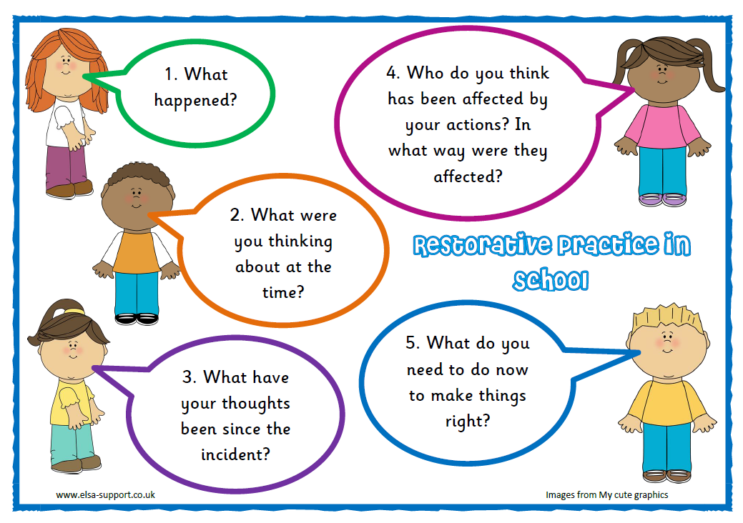

Use of Scripts

Staff will use scripts to support, divert, diffuse, and distract to support our children.
These scripts may include:
1. I can see this isn’t working, let’s try…
2. Stop, think and make a choice.
3. Let’s have a chat about how to make this better.
4. I’ve noticed that…why don’t we try…

Children will be encouraged to use scripts in the playground.
Playground Script
If someone is bothering you or doing something that you don’t like:
Please STOP! I don’t like that!

If they continue with the same behaviour:
Please STOP! If you keep doing that then I will need to get help.

If the behaviour continues:
I am going to get help now!

Following an incident, an adult may follow up and record a restorative conversation with those involved. This may involve a discussion using the ‘fix it’ folder or a “My choice my consequence” sheet (Appendix 1 and 2) to support a child/children in reflecting on the incident.
If the child is in a heightened state, it is best to let them calm down before reflection and restoration, therefore follow up conversations might occur the following day.
Where a child has been upset by another, it is good practice to ask them if they are happy to speak to the other and let them make an apology. Any apology made should be sincere and it should be clear that an apology is a commitment not to do it again.

When things do not go so well
The majority of our pupils are able to meet the school’s expectations on ensuring positive relationships. Some children will need additional support through a planned intervention. When this is the case, teachers should work with SLT, parents and the child to agree targets and strategies in our behaviour support plan.

We recognise that all behaviour is communication and where a child is presenting with distressed or heightened behaviour, it is important to consider all likely triggers and address them.

Preventing behaviours |  | Managing escalations |  | Managing crisis |  | Recovery and repairing relationships
Support Strategies  The things we do or say that keep the child in the green for as much time as possible | Behaviour  What the child does, says and looks like that gives us clues that he is calm and relaxed | Support Strategies  The things that we can do or say to stop the situation from escalating further and return the child to the proactive phase as soon as possible | Behaviour  What the child does, says and looks like that gives us clues that he is becoming anxious or aroused | Support Strategies  The things that we can do or say to quickly manage the situation and to prevent unnecessary distress, injury and destruction | Behaviour  What the Child does, says and looks like when he is challenging. | Support Strategies  The things that we can do or say to support Child to become calmer again and return to the proactive phase | Behaviour  What the child does, says and looks like that tells us that he is becoming calmer

Appendix 1
Restorative Task- My Choice, My Consequence
Name | Date | Adult involved
What happened?

What were you thinking about at the time?

What have your thoughts been since the incident?

Who do you think has been affected by your actions? In what way were they affected?

What do you need to do now to make things right?

Any agreed actions: | Shared with: (Please tick)  Class Teacher  SLT  Parent
Appendix 2
Restorative Task- My Choice, My Consequence
What happened?

What happened next?

How did you feel? | How do you think your friend felt?

What can you do to make it better?

Any agreed actions: | Shared with: (Please tick)  Class Teacher  SLT  Parent

Appendix 3
Restorative Conference

Child’s name- | Class- | Date-
Present at conference-

What’s been happening? What’s your thoughts?

Who has been affected by your actions?

What support do you need to improve the situation?

What needs to happen next?

Parent comments

Actions from meeting

