[Great Grange Relationships 2.0.docx](Great%20Grange%20Relationships%202.0.docx)

**REACH FOR THE STARS**

**AT**

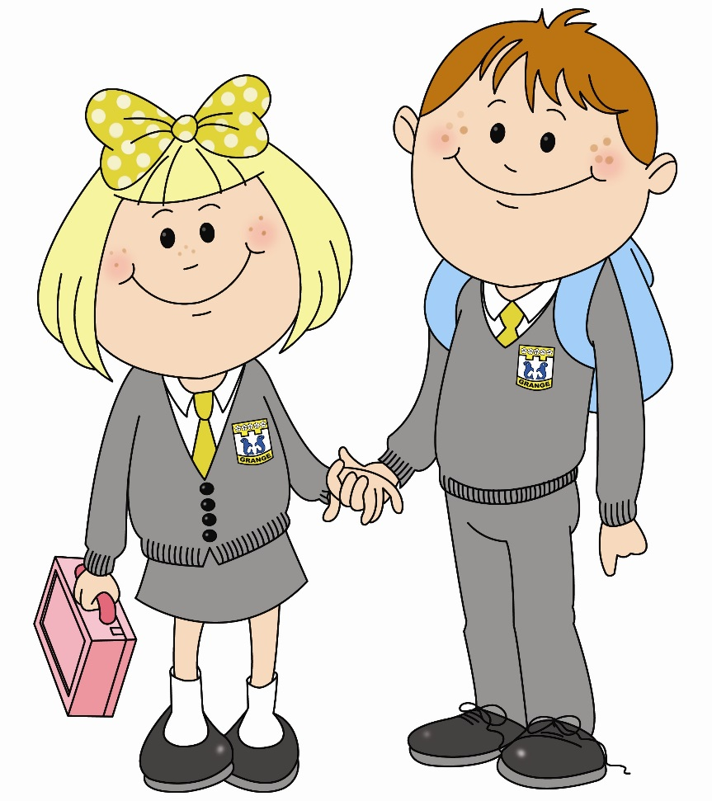



**Great Grange Relationships**





**1. Policy statement**

Grange is committed to creating an environment where positive relationships are at the heart of effective learning and children can enjoy their rights. Everyone is expected to maintain the highest standards of personal conduct, to accept responsibility for their behaviour and encourage others to do the same. Our relationships policy guides staff to teach kindness, self-discipline and a sense of responsibility for ourselves and others. It echoes our core values with an emphasis on kind and safe behaviour, a partnership approach to managing conduct issues and dynamic interventions that support staff and learners.

**2. Aim of the policy**

• To create a culture of excellence through exceptionally positive relationships: for learning and for community for life

• To ensure that all learners are treated fairly, shown kindness and supported to develop positive relationships

• To help learners regulate their behaviour and relationships and be responsible for the consequences

• To build a community which values kindness, care, good humour, responsibility and empathy for others

• To ensure that excellent relationships are an expectation for all

**3. Purpose of the policy**

This policy supports our school in promoting children’s rights and in particular links to the following articles of the United Nations Convention for the Rights of the Child (UNCRC) and the Sustainable Development Goals as follows:

**Article 3** – The best interests of the child must be a top priority in all things that affect children.

**Article 12** – Every child has the right to have a say in all matters affecting them, and to have their views taken seriously.

**Article 19** – Every child has the right to be protected from all forms of violence, abuse, neglect and bad treatment.

**Article 28** – Every child has the right to an education. Discipline in schools must respect children’s dignity.

**Article 31** – Every child has the right to relax, play and take part in a wide range of cultural and artistic activities.

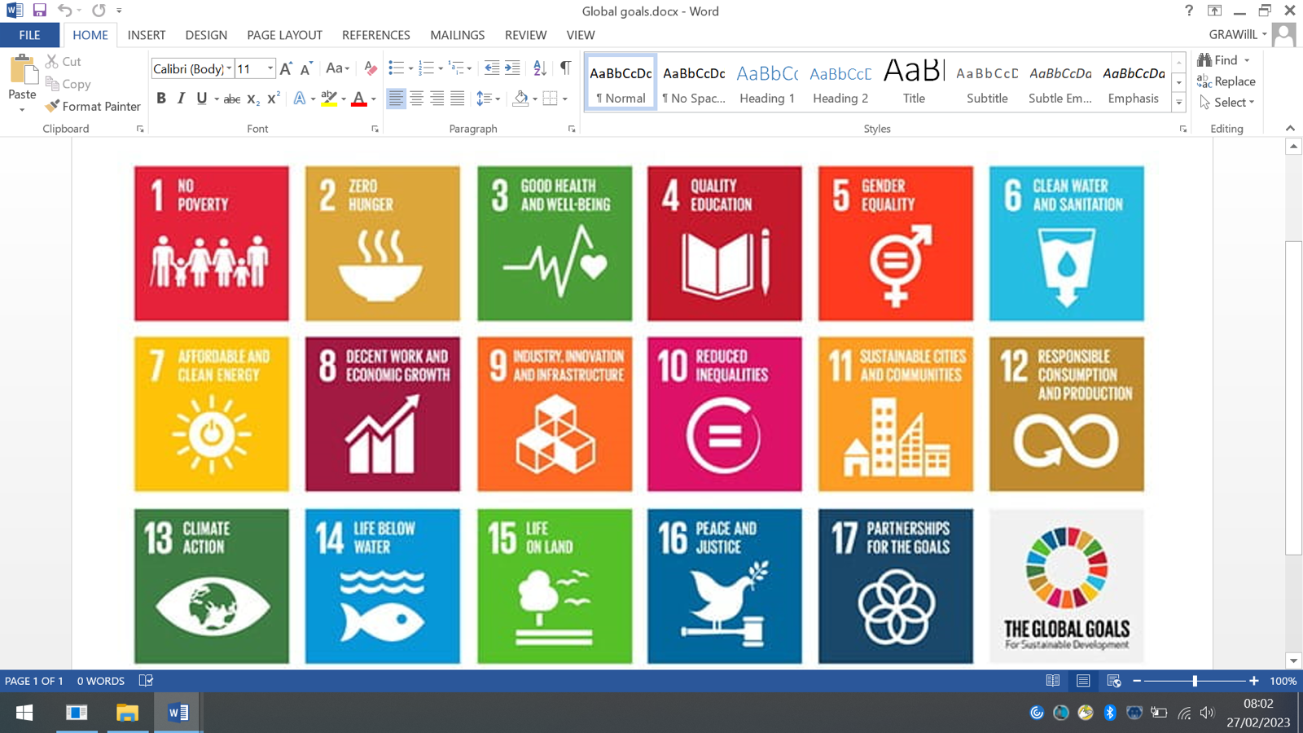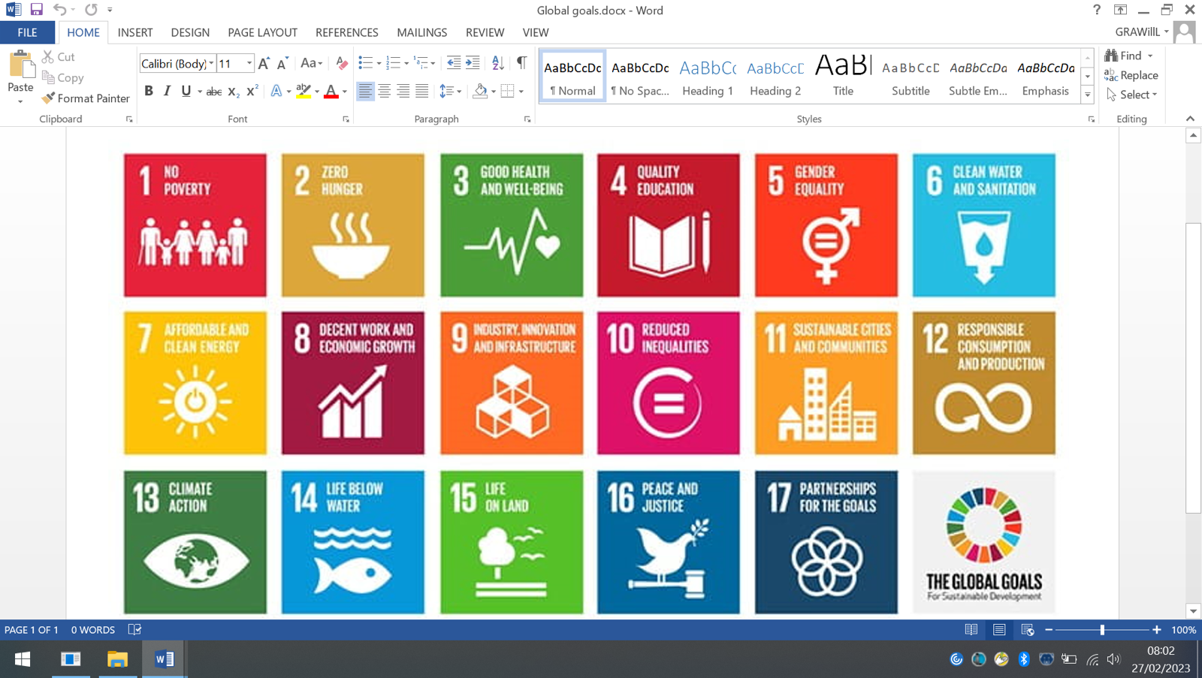

This policy provides simple, practical procedures for staff and learners that:

• Recognise behavioural norms

• Positively reinforces behavioural norms

• Promote kindness, self-belief and a sense of safety

• Teach appropriate behaviour through positive interventions

**4. Consistency in practice**

The kind, calm and consistent behaviour of all adults is the key to developing positive relationships and modelling regulated behaviour. This consistent approach will be demonstrated by every member of staff and be evident through every interaction. Where learners feel treated as valued individuals they respect adults and accept their authority.

**All staff**

1. **Meet and greet** at the door.

2. Refer to ‘**Be Kind, Be Safe, Believe’**

3. **Model** positive behaviours and build relationships.

4. **Plan** lessons that engage, challenge and meet the needs of all learners.

5. Use **praise or** **visible recognition** throughout every lesson.

6. Be **calm** and give ‘take up time’ when going through the steps.

7. **Follow up** every time, retain ownership and engage in reflective dialogue with learners.

8. **Never ignore** or walk past learners who are unregulated.

9. Have an emotional **check-in** with all learners at the start of each day and after breaks.

**School leaders**

School leaders will not deal with unregulated behaviour in isolation. Rather they will stand alongside colleagues to support, guide and model to show a unified consistency to the learners. They will:

1. Meet and greet learners at the beginning of the day
2. Be a visible presence in each department to encourage appropriate conduct especially at transitions
3. Support staff in returning learners to learning by sitting in on restorative meetings and supporting staff in conversations, including parents as required
4. Provide cover for staff to allow them to have restorative meetings with learners
5. Regularly celebrate staff and learners whose efforts go above and beyond expectations
6. Encourage the use of praise and recognition
7. Ensure staff training needs are identified and targeted
8. Use behaviour data to target and assess interventions
9. Regularly review provision for learners who require behaviour support plans

**Parents and carers**

1. Encourage children to ‘Be Kind, Be Safe, Believe’
2. Discussregulation and positive relationships.
3. Work with school staff to support regulated behaviour and positive relationships.
4. Support children to reflect upon and learn from conflict.
5. Work with school staff to implement a regulation plan if required.

**Behavioural norms**

* **Fantastic walking**
* **Legendary lines**
* **Kind connections**

**5. Recognition and rewards**

The use of praise in developing a positive atmosphere in the classroom and playground cannot be underestimated. It is the key to developing positive relationships, particularly with those learners who are hardest to reach.

*‘The advertising of poor behaviour to the rest of the class doesn’t help, but routinely advertising the behaviour that you do want does’* Paul Dix

At Grange we use approaches to recognise rather than reward regulated behaviour. We want our learners to be intrinsically motivated to demonstrate regulated learning behaviours and not to be reliant upon extrinsic rewards. All classes will enjoy *FAB Fridays (Fun Activities with Boxall)* on Friday afternoons when children will work together to develop identified social skills and our learner qualities: kindness, trying hard, regulation, creativity and self-belief. The focus of *FAB Fridays* should be directly related to the class Boxall Profile and the children’s social and emotional development, in ways that make the learning visible.

**Classroom**

1. **Positive feedback** will be specific about regulation and the learner qualities that children are demonstrating.
2. **Recognition boards** will be used in every classroom to keep a focus on regulation, positive relationships and a collective effort by the whole class to achieve a small reward e.g. song, dance!
3. **Class Dojo messages** to parents when children’s go above and beyond the expected standard

**School and playground**

1. **Positive feedback** will be used by all staff when they see children being kind and being safe.
2. **House Tokens** will be used in the playground for support staff to identify one or two children from each class each week who have gone above and beyond.
3. **Class Dojo** will be used to share a photo of the house tokens each week with parents.

**Nine ways to sharpen use of recognition boards Paul Dix**

1. Target your recognition board at learning attitudes not just functional behaviours. Make sure that the behaviour you choose raises the expectation for the children and is not “simply something they can already do well.”
2. Names go on the board to recognise pupils who are demonstrating the desired learning behaviours.
3. Names or tallies are never removed from the board. Learners who disrupt are dealt with privately. Once a name is on the recognition board for good conduct it cannot come off for poor conduct.
4. Learners can nominate others to be put on the board. Try stopping an activity after 15mins and ask them to write up 4 names of other children who have been consistently demonstrating the desired behaviour.
5. Emphasise peer responsibility. It is not a competition between individuals, rather a whole class helping everyone get their name on the board.
6. Recognition boards need to be refreshed hourly, daily or weekly depending on age of children and context in which you are working.
7. Pupils are recognised for effort not achievement.
8. When everyone’s name is on the board a collective “whoop” is appropriate. Large rewards are not necessary.
9. Use the recognition board to persistently and relentlessly catch learners demonstrating the right behaviours.

**6. Practical steps for promoting positive behaviour and relationships**

|  |  |
| --- | --- |
| **Redirect** | Gentle encouragement, small act of kindness.  Be aware of body language, facial expression and tone of voice.  A private reminder of the expectations **Be Kind, Be Safe, Believe.**  Repeat reminders if necessary. |
| **Regulate** | Verbal caution delivered privately.  Make the learner aware of their behaviour and outline consequences.  Allow them to reflect away from others in a quiet space in classroom.  Offer a private final opportunity to engage and a positive choice. |
| **Remove** | Ask the learner to work in the upper/ middle open area.  If the open area is busy request support from SLT in middle area.  Serious/ unsafe incidents and/ or a learner needs to co-regulate in a quiet space staff should request support from SLT in middle area. |
| **Repair** | A restorative meeting should take place before the next lesson.  If required staff can request support from SLT for the meeting.  Ongoing unresolved concerns require a restorative conference.  The conference might lead to a regulation plan being developed. |

**Redirect**

Make eye contact and use facial expression to show you are querying the behaviour. You might use a reminder to the whole class at this stage referring to the zones of regulation and learner qualities as appropriate for the lesson or context.

A reminder of the expectations for learners **Be Kind, Be Safe, Believe** delivered privately to the learner. The member of staff makes them aware of their behaviour. The learner has a choice to do the right thing. The reminder can be repeated and the goal is to de-escalate and keep things at this stage.

**Regulate**

A clear verbal caution delivered privately to the learner making them aware of their behaviour and clearly outlining the consequences if they continue. The learner has a choice to do the right thing. Learners will be reminded of their good previous good conduct to prove that they can make good choices. Scripted approaches at this stage are encouraged:

**30 second intervention**

* Gentle approach, personal, non-threatening, side on, eye level or lower.
* State the behaviour that was observed and which rule/expectation/routine it breaks.
* Tell the learner what the consequences of their action is. Refer to previous good behaviour/ learning as a model for the desired behaviour.
* Walk away from the learner; allow them time to decide what to do next. If there are comments, as you walk away write them down and follow up later.

***We resist endless discussions around behaviour and spend our energy returning learners to their learning.***

* The learner is asked to speak to the teacher away from others
* Boundaries are reset
* Learner is asked to reflect on their next step. Again they are reminded of their previous conduct/attitude/learning.
* Learner is given a final opportunity to reengage with the learning / follow instructions

Learners should only stand outside classrooms if they need to cool down and/or to defuse a situation. In general, three minutes should be enough.

***Staff will always deliver the steps calmly and with care. A disregulated adult can never support a child to regulate.***

**Remove**

If the step above is unsuccessful, or if a learner refuses to take time to regulate then the learner will be asked to leave the room. The learner should spend the remainder of the lesson working in the open area. However, if the area is unsupervised or busy it might be more appropriate for the learner to work in a quiet space in a neighbouring classroom. If required, contact SLT to escort the learner to an alternative workspace and/ or to provide co-regulation.

Where there is a situation that is unsafe or a serious breach of conduct then SLT should be called by sending a pupil to SLT in middle area/ office. All serious incidents will result in a restorative conversation that will be recorded as a written reflective exercise and reported to parents.

**Repair**

When a learner has been offered time out because they have not responded to warnings (persistent low level behaviour) or when there is a single act of significant behaviour (swearing or hurting), a reflective exercise or restorative conversation is carried out by the staff member they were with at the time. Staff can request support from SLT to provide cover or to sit alongside them during these conversations. This will usually take place during the break following the incident, in some cases this might be the following day to allow time for de-escalation.

This should be done using a written format (see appendix) as a record of the incident which is stored in the Incidents File (SLT office). This is an opportunity to reflect and resolve the situation and will need to be done during the next break following the incident. Learners should be asked to write on the sheet if they are able to do so or the adult can complete it for them as required. Feedback will be provided to parents when behaviour has reached this level. This can be done by phone call then sharing the sheet via Class Dojo or a face to face conversation.

**5 restorative questions:**

* What happened?
* What were you thinking?
* Who else has been affected?
* What should we do to put things right?
* How can we do things differently in the future?

**Restorative conference**

Where a learner has repeatedly needed to be removed a restorative conference will be arranged. This meeting will include the teacher, learner, support staff (if appropriate), parent/ carer and a member of the SLT. The meeting will address the learner’s: progress and achievement, learning needs, attitude, behaviour and relationships. This will be recorded using the Restorative Conference template and recorded on Latest Pastoral Notes.

**Regulation plan**

In some cases, it might be that a child requires additional support with managing their emotions and behaviour. Where this is the case a behaviour support plan will be produced by the member of SLT responsible and in partnership with the learner, parents and staff. The member of SLT responsible will:

• Develop an appropriate behaviour support plan (see appendix)

• Monitor, review and mentor using the support plan

• Adapt the support strategies in place as required

* Work in partnership with and communicate regularly with parents/ carers

1. **Scripts for staff and children**

|  |  |
| --- | --- |
| **Redirect** | Speak privately at eye level, use verbal and facial communication.  **‘I see that you are** (struggling to get started, getting frustrated etc.)**’**  **‘I need you to be kind/ safe and** (pick up your bag, keep yourself safe, get started etc.)**’**  **‘I believe you can do it, you’ve got this!’** |
| **Regulate** | Speak privately at eye level, use verbal and facial communication.  **‘I have asked you to ... and you have not stopped/ walked away’.**  **‘It is the rule of being kind/ safe that you have broken’.**  **‘I need you to … or you will need to use the Calm Corner’.**  **‘I believe in you, remember yesterday when you…’** |
| **Remove** | Speak privately at eye level, use verbal and facial communication.  **‘I can see that you are…** (not ready to join us, still angry etc.).**’**  **‘I need you to be kind/ safe and take your work to the open area/ the other class.’**  **‘I will come to see you at break/ lunch/ end of day because I believe we can sort this out together.’** |
| **Repair** | **‘What happened?’**  **‘What were you thinking?’**  **How did this make people feel?’/ ‘Who else has been affected?’**  **‘What should we do to put things right?’**  **‘How can we do things differently in the future?’** |

1. **Playground**

We will use our playground scale to help children understand the size of their problems when there is conflict. This will also help to ensure everyone knows how problems can be resolved and when adult support is required.

|  |  |  |
| --- | --- | --- |
| **The size of the problem** | | |
| **Little**  **Deal** | * Silly name calling * Small arguments * Accidental injury * Nobody to play with * Disagreements about games/rules * Cheating | Children resolve conflicts using a script:   1. **‘Please STOP! I don’t like that.’** 2. **‘Please STOP! If you keep doing that I will need to get help.’** 3. **‘I am going to help now.’**   Peer Mediators can support in resolving Little Deal problems. |
| **Big**  **Deal** | * Unsafe play * Upsetting or annoying others * Leaving out | Support staff help to regulate and use script:   1. **‘I need you to be stop… it’s the rule of being kind/ responsible that you are breaking.’** 2. **‘If you don’t stop…. I will need you to come for a walk and talk.’** 3. **‘You still haven’t stopped so I need you to walk and talk or go inside to calm down.’** |

**Little Deal**

For minor fall outs and disagreements children will be encouraged to sort it out themselves. At this stage they can use the script to help them and they are encouraged to find someone else to play with or somewhere else to play.

If a child has nobody to play with or they need help resolving a small disagreement or incident they can ask for help from older pupils. They can go to a Regulation Station or approach one of the older pupils. The older pupils will help to mediate and/ or find someone for the child to play with. If required the Peer Mediators will seek support from the SPSA allocated to the year group.

**Big Deal**

At this stage children might be playing unsafely or being persistently unkind to others, and adult interventions is required. Support staff would try to divert and diffuse the situation using the scripts. Children might need to go for a *walk and talk* with a member of staff or they might need to go inside to calm down. The support staff involved would follow up any conflict by having a restorative conversation while outside or once the children are back in class. SLT can be called upon to cover support staff to allow them to follow up and if this takes up significant time then ‘*catch up on learning time’* will be required at the next break.

Where there is a situation that is unsafe or a serious breach of conduct such as deliberately hurting others physically or emotionally then SLT should be called using the middle/ upper area walkie talkie. All serious incidents will result in a restorative conversation that will be recorded as a written reflective exercise and reported to parents.

**Repair**

For younger children the *Time to Fix It* form can be used alongside the *Fix It Folder*, older children can use the Restorative Meeting form (see appendix).The staff and other children involved in the incident would be part of the restorative conversation and SLT can sit alongside them during the meeting. This will either take place during the next break or during class time meaning that *catch up on learning* would be required at the next break.

This should be done using a written format (see appendix) as a record of the incident which is stored in the Incidents File (SLT office). Learners should be asked to write on the sheet if they are able to do so or the adult can complete it for them as required. Feedback will be provided to parents when behaviour has reached this level. This can be done by phone call then sharing the sheet via Class Dojo or a face to face conversation.

**Playground supervision**

* One SPSA will be appointed to each year group and also allocated to an area of the playground.
* The children will all know which area of the playground that their SPSA can be found. The SPSA will be responsible for overseeing the risk assessment and safe play for their allocated area of the playground.
* The SPSA will be the point of contact for children in that year group who require support with their problems.
* The SPSA will get to know the year group by name and interact and play with children to ensure everyone feels included.
* The SPSA will liaise with class teachers regarding any support required or incidents in the playground.
* Peer Mediators will report any persistent problems to the SPSA so that teachers can also be made aware.
* All SPSAs will carry a First Aid bag with basic supplies for dealing with minor injuries in their allocated areas, children should only be sent inside with more serious injuries.
* SPSAs should compete accident/ incident forms outside – if they need to come inside SLT must be alerted to ensure the playground is adequately supervised.

**Getting help**

In the first instance children will be encouraged to use the script accompanied by the STOP hand signal, if there is a small problem:

* **‘Please STOP! I don’t like that.’**
* **‘Please STOP! If you keep doing that I will need to get help.’**
* **‘I am going to help now.’**

If children persistently have smaller problems (e.g. 3 times in a row) they are encouraged to tell an adult. This might be their allocated SPSA or their class teacher. Each class will also have a Worry Box for children to pop their name inside should they need to talk to someone. Class teachers will check the box regularly so that they can follow up on any worries the children might have.

1. **Anti-bullying**

It is important that everyone knows what to do when bullying occurs. Parents and children should know that they can share their worries with their class teacher, support staff or other trusted adults in the school. All members of staff and parents have a duty to act on any reports or suspicion of bullying. The School Leadership Team should be informed of any concerns as follows:

* Nursery – P1 Mrs Simpson / Mrs Oldham
* P2-4 Mrs Oldham
* P5-7 Mrs Smith

**What is bullying?**

At Grange, our approach to anti-bullying is informed by Respect Me (Scotland’s anti-bullying service). They advise:

*Bullying behaviour can harm people physically or emotionally and, although the actual behaviour might not be repeated, the threat that it might can be sustained over time, typically by actions: looks, messages, confrontations, physical interventions, or the fear of these. This behaviour can include:*

* *Being called names, teased, put down or threatened face to face and/or online*
* *Being hit, tripped, pushed or kicked*
* *Having belongings taken or damaged*
* *Being ignored, left out or having rumours spread about you (face to face and/or online)*
* *Sending abusive messages, pictures or images on social media, online gaming platforms or phone*
* *Behaviour which makes people feel like they are not in control of themselves or their lives*
* *Being targeted because of who you are or who you are perceived to be (face to face and/or online)*

We recognise that a single incident can impact on a person and can therefore be a bullying incident. And we recognise there is not always an intent to bully on the part of the child displaying bullying behaviour. They may be modelling behaviour they have experienced. Every child involved in bullying needs our support and we do this within our culture of positive relationships.

**Responsibilities**

There is a collective responsibility to addressing bullying:

**Parents** have a responsibility to monitor their child’s online world and to speak to them about their friendships. They have a responsibility to report any concerns to the school as soon as they occur and to work in partnership with the school to resolve them.

**Staff** have a responsibility to monitor relationships and report any concerns or changes to a child’s behaviour as soon as it is noticed to the SLT.

**Children** have a responsibility to report any concerns about their peers to a trusted adult (age and stage appropriate). Our ‘Getting Help’ system is in place to support this.

**Recording and monitoring bullying**

Working together with parents is key to this being successful and it is important that parental views are included as part of the recording process.

Where the investigation indicates that there has been a bullying incident, this will be recorded as such on SEEMIS in the Bullying and Equalities module. All parents involved will be informed that the incident has been recorded as a bullying incident.

Where the investigation indicates that this has been a conflict rather than bullying, it will be recorded on SEEMIS in Latest Pastoral Notes. All parents involved will be informed that the incident has been recorded.

**Support for children involved**

As bullying happens within relationships, the most desirable outcome (where possible) is to restore the relationship and move forward positively.

These supports are used for a child experiencing bullying behaviour:

• A named member of staff is identified to check in with the child regularly

• Helped to develop positive strategies and appropriate assertive skills

• Monitored by teacher and/or SPSA

• Involved in restorative conversations

• Encouraged to discuss feelings and emotions – e.g. through Zones of Regulation, Bounce Back

• Social skills groups

These supports are used for a child displaying bullying behaviour:

• Made aware of the seriousness of their actions and possible consequences

• Monitored by teacher and/or SPSA

• Where deemed necessary referred to an external agency for targeted support

• Social skills groups

• Supported through monitoring and regular review with parents

Where there is clear evidence that a pupil is targeting another unkindly or is unable to regulate their behaviour or emotions in a specific context, it might be the case that the pupil in question will be kept out of that context (depending on where/when the incidents are taking place) for a short period of time to allow things to settle but this approach is unlikely to be a long term solution. While the child is out of the context, they will work with a member of staff to discuss issues and to make a plan for change.

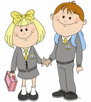**Time to Fix It**

|  |  |
| --- | --- |
| **Child’s name:** | **Class:** |
| **Date:** | **Staff member:** |
| **How do I feel?** | |
|  | |
| **Who?** | |
|  | |
| **What happened?** | |
|  | |
| **How will I fix it?** | |
|  | |
| **How do I feel now?** | |
|  | |

**Parents have been contacted to make them aware of the incident. Yes/ No**

**Please file in the Incident folder in SLT office.**

**Restorative Meeting**

|  |  |
| --- | --- |
| **Child’s name:** | **Class:** |
| **Date:** | **Staff member:** |
| **What happened?** | |
|  | |
| **What were you thinking?** | |
|  | |
| **Who else has been affected?** | |
|  | |
| **What should we do to put things right?** | |
|  | |
| **How can we do things differently in the future?** | |
|  | |

**Parents have been contacted to make them aware of the incident. Yes/ No**

**Please file in the Incident folder in SLT office.**

**Restorative Conference**

|  |  |  |
| --- | --- | --- |
| **Child’s name:** | **Class:** | **Date:** |
| **In attendance:** | | |
| **Describe what has happened. What are your thoughts?** | | |
|  | | |
| **Who has been affected by your actions?** | | |
|  | | |
| **What support has been given to improve the situation?** | | |
|  | | |
| **What needs to happen to next?** | | |
|  | | |
| **Parent comments** | | |
|  | | |

**Child’s Plan required Yes/ No**

**Please file in Incidents folder in SLT record on Latest Pastoral Note**

**Regulation Support Plan**

|  |  |  |  |  |  |  |  |
| --- | --- | --- | --- | --- | --- | --- | --- |
| **Preventing behaviours** | | **Managing escalations** | | **Managing crisis** | | **Recovery and repairing** | |
| **Support strategies**  The things we do or say that keep the child in green for as much time as possible. | **Behaviour**  What the child does, says and looks like that gives us clues that they are calm and relaxed. | **Support strategies**  The things that we can do or say to stop the situation from escalating further and return the child to green. | **Behaviour**  What the child does, says and looks like that gives us clues that they are becoming anxious or aroused. | **Support strategies**  The things that we can do or say to quickly manage the situation and to prevent distress, injury, or damage. | **Behaviour**  What the child does, says and looks like when they are distressed. | **Support strategies**  The things that we can do or say to support the child to become calm and return to green. | **Behaviour**  What the child does, says and looks like that tells us they are becoming calm. |
|  |  |  |  |  |  |  |  |
| **Signatures** | | Child: | | | Parent: | | |

**Restorative Meeting**

|  |  |
| --- | --- |
| Responding to unregulated behaviour | Helping those harmed by others |
| What happened? | What happened? |
| What were you thinking? | What were you thinking? |
| Who else has been affected? | How have you and others been affected? |
| What should we do to put things right? | What has been the hardest thing for you? |
| How can we do things differently in the future? | How can we do things differently in the future? |