**CHANGES TO NUTRITIONAL REQUIREMENTS FOR FOOD AND DRINK IN SCHOOLS – Q&A’s**

This Q&A document provides information about new statutory nutritional requirements arising from ‘The Nutritional Requirements for Food and Drink in Schools (Scotland) Regulations 2020’, which come into force in April 2021, and advises on their likely effects for school meals, and the actions Tayside Contracts has taken in preparation for these changes, working with our Education colleagues in the three Tayside Councils.

We are committed to supporting the aims of these regulations, to improve Scotland`s health, although we acknowledge their introduction presents challenges to the delivery of a cost-effective school meal service.

**Q What are the drivers for change behind the new Food and Drink requirements for schools?**

1. The reason for changes in school meals is to improve the health of Scotland as a nation and to tackle obesity in line with the Child Healthy Weight Strategy (2020-2030)**.**

In 2018 the Scottish Government published the strategy - A Healthier Future – Scotland’s Diet & Healthy Weight Delivery Plan . This strategy has a clear vision – ‘*to create a Scotland where everyone eats well, and we all have a healthy weight.’* The First Minister has also pledged to halve childhood obesity by 2030. However the Scottish Government cannot achieve these ambitions alone. Schools and school meal provision has a role to play in the strategy. The new regulations and legislation align themselves with this strategy as it is recognised that eating habits are instilled during childhood, with 30% of Scotland’s children classed as overweight, and 16% at risk of obesity.

The new regulations are a progression on the previous legislation around school meals (which has been in place since 2008) and have been updated to align with more recent scientific dietary advice.

**Q When does the new legislation come into effect?**

**A**. The new legislation was originally scheduled to be implemented in October 2020, however it was delayed due to the pandemic and will now be effective from Thursday 8th April 2021.

**Q What are the main changes associated with the updated regulations?**

1. A summary of the new regulations for primary and secondary school meals can be found in Appendix 1.

**Q What changes will there be to the primary meal service?**

1. The changes associated with the primary meal lunch service have already been implemented as a phased approach, and were incorporated in the 2019/20 school menu. The current Tayside Contracts 2020/21 school lunch menu is fully compliant with the new regulations. The changes associated with breakfast service in schools are yet to be made, and this will impact the range of cereals and bread products that will be on offer.

**Q What changes have there already been to the primary meal service?**

**A**. The recent changes to the primary school menu has already had a considerable impact on the meal choices available to pupils, due to the limitations imposed on the frequency of serving certain food types. This made it very difficult to continue to offer four daily choices whilst maintaining the necessary range and variety of meals. Therefore, the menu was reduced from a four to a three-choice menu in line with the majority of other Scottish local authorities.

The new regulations only allow milk, flavoured milk and water to be served in primary schools, however this is already in place. A joint Tayside-wide decision was made to withdraw the option of fruit juice with primary school lunches in 2017, making fresh milk the preferred drink option and water as an alternative. This decision was taken in response to the growing concerns about the effects of fruit juice on the oral health of children due to its acidity in combination with sugar which can be damaging to teeth.

**Q How will the changes impact the secondary meal service?**

1. The impact of the April 2021 changes on the secondary meal service will be more significant, because -unlike the primary meal service - there has not been an opportunity to implement gradual changes. This was due to take place between April and September 2020 in advance of the original implementation date of October 2020, with a phasing-out plan for non-compliant products and the introduction of new compliant products, to pre-empt and avoid a negative impact on meal uptake. Unfortunately, the Covid-19 lockdown and school closures meant this did not take place as planned. Subsequently, all the changes to food and drink will take place simultaneously on the 8th of April.

Whilst recognising that introducing healthy choices in the school meal service support the healthy eating agenda, it is noted that there may be an impact on school meal uptake. For example, the graph below shows primary meal uptake levels, with the grey vertical lines representing the implementation of the change to drinks in 2017, and the change to the lunch menu in 2019 (mentioned in the previous answers). We will be monitoring closely meal uptake levels with these latest changes to the secondary school menu.

**Note:** *The graph reflects meal uptake up to the end of financial year 2019/20 and therefore does not include any effect of the Covid pandemic.*

**Q Are there any changes to the drinks on offer in secondary schools?**

1. The new regulations permit the sale of low caffeine sugar free branded carbonated drinks (such as Diet Coke and Pepsi Max), which have not been on sale in schools for over 15 years. These replace fruit juice-based drinks which are not now allowed in secondary schools. Only drinks with no added sugar will be compliant (such as flavoured water, and milk).

The Councils in Tayside have made the decision to withhold the sale of branded carbonated drinks for now, due to their commitment to the Child Healthy Weight Strategy which will be launched across Tayside this summer. The intention is for all food and drink provision across the authorities to align with the strategy’s culture. While the sale of carbonated branded soft drinks may act as an incentive to help maintain and increase secondary meal uptake when the changes to the wider menu are introduced in April, more evidence is required to support the benefit of offering sugar free carbonated drinks in schools across Tayside, as the sale of these does not fit well with the ‘whole systems approach’ to child health.

Part of the debate has been around the caffeine content of the drinks that can be offered. The following diagram provides information on the caffeine content of drinks.

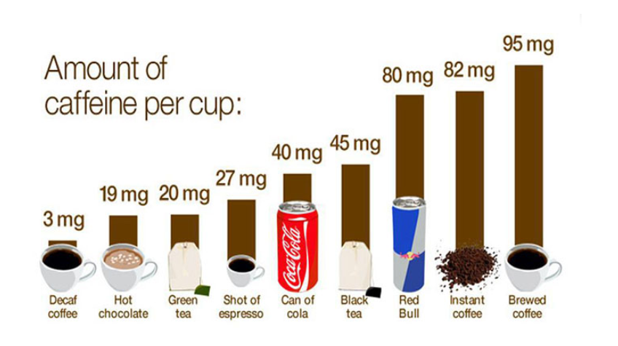

Tayside Contracts will carry out a consultation exercise across all three Council areas to engage with pupils, school staff, parents and carers, NHS and Council health and wellbeing staff. This will inform a collective assessment of the introduction of the proposed carbonated soft drinks range in line with the ‘whole system approach’ to establish whether their sale will encourage pupils to take up healthier meal options in school as part of an overall meal approach.  Pending the outcome of the consultation, only caffeine free non-carbonated soft drinks such as flavoured still waters, flavoured milk and hot beverages (tea and coffee) will be sold by Tayside Contracts in schools.

**Q What actions have been taken to mitigate a negative impact on secondary meal uptake?**

1. As the service provider for the three Tayside Councils, Tayside Contracts serves school meals to around 30,000 pupils per day. This equates to just under 9% of all school meals served in Scotland. The challenge for Tayside Contracts is to balance costs with statutory requirements and to deliver a healthy yet appealing school meal to young people across Tayside.

Therefore, the Tayside Contracts Food and Nutrition team have carried out extensive recipe testing and sourcing of new products, to produce a range of dishes with low sugar and fat content, as alternatives to our popular items which will no longer be compliant, to ensure that our meals are as appealing and nutritious as possible.

We know that pupils and parents control the choice whether they want a school meal on any given day. This means that if school meals are not appealing, the alternatives are a packed lunch, mobile food vendors, or high street food outlets, which we know can be less healthy options.

We are working hard to maximise the number of pupils using our healthy, nutritious and safe meals service. We have recently carried our customer stakeholder survey and case studies, and this will be the basis for a report and action plan to boost school meal numbers, to be presented to the Tayside Contracts Joint Committee in June 2021.

**Q What training has been implemented for Secondary School Cooks?**

1. Tayside Contracts carried out consultation and training with secondary school cooks prior to February 2020, however given the time that has elapsed since, a refresher training programme was rolled out to all secondary catering teams during March 2021.

**Q Have these changes been communicated to schools and pupils?**

**A**. The consultation process for secondary schools started more than 18 months ago via a survey about the school meals service, which included information about the proposed changes and requests for feedback. We recognise the importance of communications to broaden understanding about the need for these latest regulations, the changes that we have made, and also the advantages for pupils choosing a high quality, safe, nutritious school meals compared to the less healthy alternatives.

To fully engage with schools, pupils and parents, a short video has been produced to convey the changes in an engaging format for young people.

In order to help pupils and parents select the healthy, safe and nutritious choice of school meals (over the less healthy alternatives), we greatly value the support of our constituent Councils, school staff and Elected Members to convey the benefits of school meals, as these changes to school meals will come into effect after the Easter 2021 Holidays.

We will continue consultation, engagement and communication after the implementation of the regulations to assess the meal service from a customer perspective, and primary and secondary meal uptake will continue to be monitored to review the effect of these changes on our service.

**Q Does Tayside Contracts provide any other meals which will be affected by the new legislation?**

**A**. Tayside Contracts provides meals for the Dundee Bairns’ charity during school holidays, which will also fall under the school meals legislation.

Other meal services provided by Tayside Contracts such as Community Meals for Dundee City Council and our Hospitality Service for events and corporate catering will not be affected by the new legislation.

**Appendix 1**

