**Home Learning Guidance**

In preparation for our closure, please be assured that staff will be working to ensure learning continues. We will be doing this through the use of Dojo.

Teachers will be posting learning and tasks for your children to complete on the class story. Evidence of any completed tasks can be then be submitted through the student portfolio and feedback will be given.

**Instructions to access student portfolio**

<https://classdojo.zendesk.com/hc/en-us/articles/115004708883-How-Does-My-Child-Log-into-Their-Student-Account-at-Home-#web>

To log in follow this link

<https://student.classdojo.com/#/login?redirectTo=%2Fstory>

Pupils can log in using a QR code / text code

Every pupil will be issued with the QR code and the class codes will be messaged to all parents. The codes are unique to each class and last only 48 hours.

When entering using the class code, you will then select your child’s name from the class list. A screen similar to the one below will appear:

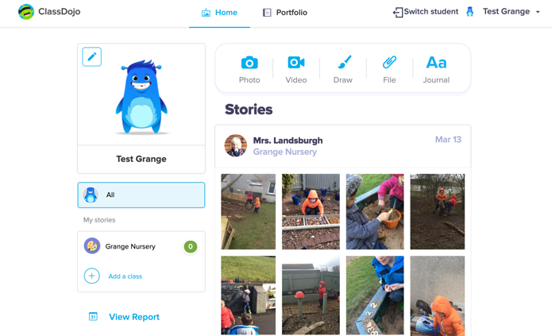

To submit a piece of work select the portfolio option at the top of the page

Teacher created activities / tasks may be viewed in portfolios / may appear in the class story.

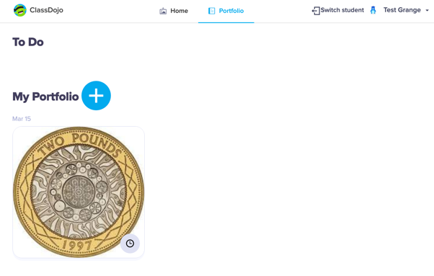

Then click on the “+” sign and choose what method you are using to submit evidence.

There is also the option to type a comment at the bottom and then click submit.

**Discovery Education – Espresso**

We also have a subscription to Discovery Education - Espresso and the student login is:

Username: student26219

Password: grange

This may require to be used if teachers direct you to it or feel free to explore it for yourself.

**\*\*Please note that you can only log in once a day so if you log in stay logged in for the day and log out later on.\*\***

**EPIC Reading App**

Students are being given remote access until end of June for FREE. Children have already been using this app in class and class teachers can assign appropriate books and quizzes to individual children.

Class Teachers may Dojo you to ask you for your email address to send you a link to join the Epic class. We must ask for email addresses for GDPR reasons.

If you have any issues please contact myself by messaging me through Dojo.

Kind Regards

Pippa Landsburgh

Principal Teacher