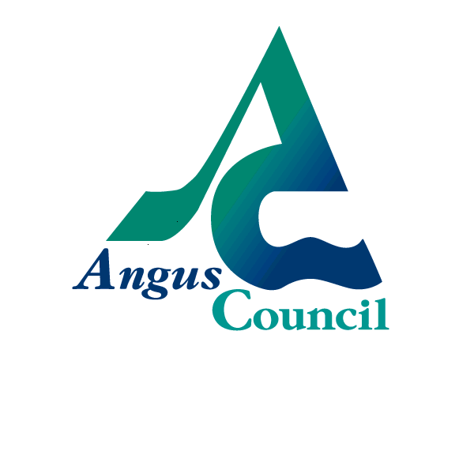

Standards and Quality Report

School: Grange | Head Teacher: Lorraine Will
Publication Date: May 2019

Grange Primary School serves the western area of Monifieth. The school opened in 1975 and as the Specifically Resourced School of the Monifieth cluster we cater for a wide range of diverse learning needs. We have 14 classrooms, 3 rooms which are used to provide additional support as well as shared activity areas. We also have a dedicated Nursery class which caters for 25 morning children and 25 afternoon children. Currently we have 352 pupils in P1-7 organised into 14 classes.
REACH FOR THE STARS
AT





At Grange we aim for everyone to be STARS . . . #believe
S
Safe #rightchoices

T
Trying hard #positivity

A
Active #engageyourself

R
Respectful #acceptance

S
Successful #progress

Review of progress with improvement plan for session 2018-19
School Improvement Priority 1: 86% of learners who are not yet making expected progress will show increased levels of engagement in their learning
NIF Priority:  Improvement in attainment  Closing the attainment gap  Improvement in health & wellbeing  Improvement in employability & destinations | How Good is our School 4 Challenge Question/s:  - How confident are we that all learners experience activities which are varied, differentiated, active, and provide effective support and challenge? (2.3)  - How well do we communicate the purpose of learning and give effective explanations for all learners? (2.3)  - How well are we enabling our children to become independent learners? (2.3)  - How well do our questioning strategies enhance higher-order thinking skills? (2.3)  - To what extent are our tools for change impacting positively on staff and improving outcomes for all learners? (1.3)
Progress & Impact:
Direct observation
In almost all classes observed:
- Learners can discuss their learning, progress and next steps
- Teachers have improved classroom dialogue using a range of strategies
- Teachers use questioning strategies effectively to engage learners and promote higher order thinking
- Teachers co-create success criteria with children to improve their understanding of the purpose of their learning
- Plenaries are used effectively to assess progress towards learning goals

Peoples’ Views
- Our staff survey shows that all teachers have found working collaboratively in Impact Teams to be an effective way to improve questioning and classroom dialogue
- Almost all staff report that our professional learning has supported improvements in learning and teaching
- A recent survey shows that almost all parents feel their children are making good progress and that they get the help they need to do well
- Pupil focus groups during learning visits show that all identified children could use the Learner Qualities to identify their development as effective learners

Quantitative Data
- Our staff survey data shows that all teachers believe that they have improved engagement in learning by improving the quality of questioning and differentiation
- The number of targeted children demonstrating moderate to high levels of involvement on the Leuven Scale has increased from less than half to the majority
- Our school overview of attainment shows that almost all children are making expected progress in literacy and numeracy and a few are working beyond the expected standard
Next Steps:
- To ensure SOLO questioning, WAGOLLS, SOLO tasks and plenaries are a continued focus for improvement
- To improve impact measures used by Impact Teams
- To continue to improve differentiation with a focus upon challenging all learners
- To increase the number of children exceeding expected standards
School Improvement Priority 2: By January 2019 43% of learners not yet making expected progress in writing and numeracy will be on track
NIF Priority:  Improvement in attainment  Closing the attainment gap  Improvement in health & wellbeing  Improvement in employability & destinations | How Good is our School 4 Challenge Question/s:  - How well do staff know learners as individuals? (2.4)  - Are staff able to access effective training to build their capacity to engage with the needs of diverse learners? (2.4)  - How good is our understanding of differentiation? (2.4)  - How well do we involve parents to ensure learners benefit from the right support at the right time? (2.4)  - How well do we know the steps we have taken have improved outcomes for learners? (3.1)
Progress & Impact:
Direct observation
- All teachers use our assessment data spreadsheet to track and moderate progress and to identify learners’ needs
- Our tracking meetings show that all teachers have a good understanding of individual children and their needs
- Class timetables have been reviewed to ensure that all additional support is allocated at the most appropriate times
- All teachers are consulted by Additional Support Needs (ASN) staff to identify the right interventions and appropriate classroom differentiation
- Most children receive additional support in class and a few benefit from targeted support in one of our ASN locations
- All of our more vulnerable learners have benefitted from well-being activities and the majority of these children have visibly presented as more confident and engaged as a result

Peoples’ Views
- Feedback shows that all parents whose children receive additional support are satisfied with the progress being made
- A few parents have requested further information to support their children’s learning at home more effectively
- All of our children involved in outdoor learning have reported a positive impact upon their well-being
- Pupil focus groups show that children are very positive about the additional support they receive from our ASN team and their progress
- Staff feedback shows that our SPSAs have found training in numeracy has improved their understanding and ability to support children effectively

Quantitative Data
- All identified learners are benefitting from additional support from our ASN team
- All identified learners are involved in activities to improve their well-being
- Our ASN data shows that all children receiving additional support have made progress in learning
- Well-being webs show that most of our identified learners feel happy with their achievements in learning

Next Steps:
- For all staff to undertake numeracy training
- To test the use of Numicon and Sound Reading System as catch-up interventions
- Pedagogy Team to support staff to continue to differentiate effectively
- To improve home learning information for parents

What is our capacity for improvement?

How good is our leadership and approach to leadership?
Staff, children and parents are actively encouraged to lead and improve our school and its community through MAD groups, the Parent Council, Grange Gabbers and Nursery Natters. Staff are supported in taking forward elements of the school improvement plan and this year we have appointed a team of Principal Teachers Pedagogy as leaders of learning and teaching. Their focus is upon working collaboratively with class teachers to improve learning and teaching and in particular differentiation to ensure all children are challenged appropriately. This year support staff and have taken a lead in piloting professional learning and interventions in numeracy as part of a wider Regional Improvement Collaborative project. Our Learning Council continues to be an effective mechanism for gathering children’s views and pupil focus groups are embedded in our self-evaluation processes. The children are always fully involved in leading whole school events e.g. Christmas Service, Grange Has Got Talent.

Our staff are highly skilled and enjoy opportunities to collaborate and evaluate learning and teaching. Our staff Impact Teams support teachers in sharing practice and working collaboratively to improve. Staff regularly plan and review class work individually, with stage partners and in stage groups to make improvements. Our culture of self-evaluation is focussed on using professional dialogue and feedback to improve outcomes for our learners.

Senior leaders carefully guide the strategic direction and pace of change in consultation with staff to ensure improvements result in positive outcomes for learners and are sustainable. Termly Staff Grange Gabbers meetings and ‘huddles’ are used to check in with staff and give them regular opportunities to give feedback. The Model for Improvement is used to fully involve staff using PDSA cycles and tests of change. Professional learning is planned to support school improvement priorities and staff are fully consulted to ensure it is relevant. Staff are encouraged to share their learning, expertise and practice.

How good is the quality of education and care we offer?
Staff have regular opportunities to reflect upon and improve the quality of experiences for learners. These opportunities include Impact Teams, Teach Meets, collaborative planning, attainment and moderation discussions, peer walkthrough visits, pupil focus groups and feedback sessions.

The termly triangulation of data from planning feedback sessions, learning visits and attainment discussions helps staff to reflect on the impact of planned learning and consider appropriate next steps.

Innovative approaches to learning and teaching are becoming more evident across the school. There is a balance of methodologies: individual tasks, cooperative learning, active learning, and gradually increasing outdoor learning and use of ICT. Our staff make good use of formative assessment approaches to motivate and engage pupils.

The development of our monitoring and tracking system has supported moderation discussions at staff/stage meetings and feedback discussions with line managers. The rich information and data generated from the data spreadsheet will help us further respond to, and meet the needs of learners in a timely manner.

We use standardised test data to support teacher’s professional judgements about the progress of individuals and groups of pupils. We use this information to analyse whole school trends over time.

How good are we at ensuring the best possible outcomes for all our learners?
Relationships across our school community are positive and supportive. Most children feel that their teacher knows them and likes them. Almost all children feel able to go to a trusted adult for help and most feel that staff support them to do well.

All staff engage in regular professional learning to ensure they are fully up to date with local and national legislation affecting the rights, wellbeing and inclusion of all children.

We deploy support staff strategically to help leaners who are not yet making expected progress or who are ‘at risk’ of missing out. Barriers to learning are discussed with SLT at planning and tracking meetings and regular review meetings with the ASN team ensure we are supporting our children effectively. Wellbeing indicators are used universally and in a targeted way as required to identify any emerging issues.

Our children’s achievements in school, at home or in the community are shared and celebrated readily using social media, Class Dojo, our school blog and Learn to Learn assemblies. Parents are actively involved in improving our school through developing a Parent Council improvement plan and by integrating parental engagement into all school improvement priorities.

We have developed effective partnerships with local business and creative industries to support our Reading Café and our whole school interdisciplinary topics such V&A @ Grange.

We are keen to ensure that all children have the opportunity to develop and apply more sophisticated computational thinking skills through the use of software. Our digital learning strategy aims to support children to make informed choices about the way digital technology can and should be used to support and enhance their learning.

Pupil Equity Funding

Description of Expenditure
- Trainee teacher to release a member of staff to provide health and well-being activities for identified children
- ICT resources for all classes to increase learner engagement through innovative approaches
- Maths and library resources to improve approaches and children’s experiences in literacy and numeracy
- Standardised assessments for our P1 children to identify baseline measures and to support teachers’ planning
- Visible Learning training for our Principal Teachers to ensure our improvements in learning and teaching are research based
- Playground resources to develop our use of outdoor learning opportunities to support children’s social and emotional development
- Taekwondo sessions for children who require additional support with self-regulation
- Financial support for P7 residential trip

Impact
- All identified vulnerable learners have benefitted from well-being activities
- Out use of ICT has increased and staff confidence in using it creatively as increased
- We have piloted maths resources as part of our Tayside Collaborative project to improve our catch-up interventions
- Reading resources have improved the quality of the Daily 5 approach which has increased reading engagement
- Our P1 teachers have used the information from assessments to plan to meet children’s needs in literacy and numeracy
- Visible Learning research has influenced our professional learning and shared understanding of effective learning and teaching
- We have started to develop our forest area for outdoor learning and to improve the play experiences at breaks for all children
- All P7 children are taking part in out residential trip

Quality Indicator | Evaluation (six-point scale)
1.3 Leadership of Change | Very Good
2.3 Learning, teaching and assessment | Very Good
3.1Ensuring wellbeing, equity and inclusion | Very Good
3.2 Raising attainment and achievement | Very Good
Other QI(s) linked to improvement work

