
Grange Primary School Improvement Plan 2019-20
Aim | Primary Drivers | Secondary Drivers | Change Ideas | Measures
20% of children will be working beyond the expected standard in literacy and numeracy by May 2020 | Collaborative practice  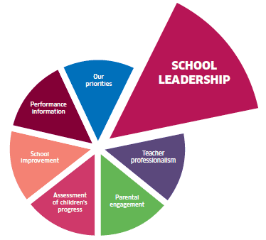  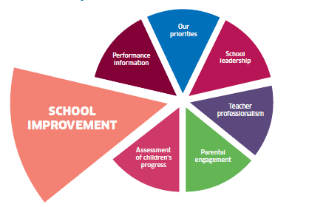 | Staff, children and parents understand what we mean by ‘challenge’ | Create an operational definition for ‘challenge’  Share examples of ‘challenge’ e.g. blog, video, dojo etc. | Pupil and parent focus groups – use operational definition
 |  | Staff, children and parents understand the definition of ‘beyond expected standard’ | Create an operational definition of ‘beyond expected standard’ linked to the Learning Ladders | Pupil and parent focus groups – use operational definition
 |  | Staff work collaboratively in Impact Teams to increase challenge | Impact Teams meet regularly to plan challenging learning experiences using PDSA cycles | Pupil and parent focus groups – use operational definition
 | High quality  learning and teaching  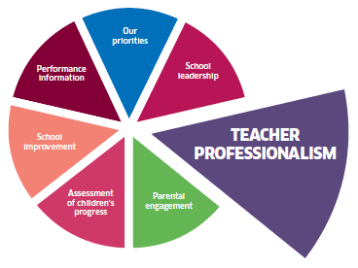  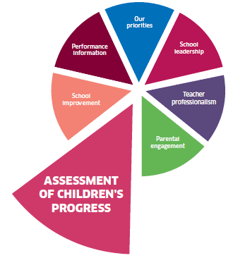 | Staff organise classrooms to promote independence and challenge | Use Daily 5 approach to provide independent tasks  Introduce ‘Stuck Strategies’ | Learning visits – classroom organisation and stuck stops  Planning and tracking meetings – learning ladders  Learning visits/ pupil groups - level of challenge
 |  | Staff use Learning Ladders to identify next steps in learning | Review Learning Ladders and create a rubric to show next steps
 |  | Staff use a variety of resources and approaches to provide challenge | Use WAGOLLS and up-level them to increase challenge  Use SOLO verbs and the Minion Measure to increase challenge
 | 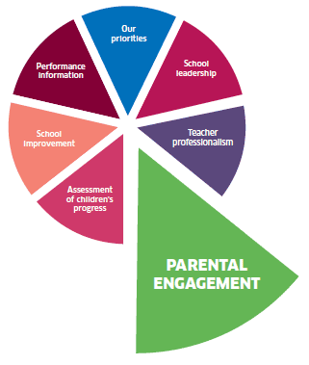  Use of data to measure progress | Teachers use assessment evidence to plan next steps in learning | Review assessments and results to ensure they allow for more able to demonstrate progress | Planning and tracking meetings – review of class data spreadsheet  Learning Walks and pupil groups – review of Learning Journeys
 |  | Teachers use Learning Journeys to support children in evaluating their progress | Use Feedback Fridays to review progress with individual children to ensure all children are making progress
 |  | Teachers use data to support and moderate judgements about children’s progress | Use tracking meetings and moderation workshops to focus on the progress of our most able learners
Grange Primary School Measurement Plan 2019-20
2.3 How well are we enabling learners to become independent learners and develop the four capacities?
2.3 How confident are we that all learners experience activities which are varied, differentiated, active, and provide effective support and challenge?
2.3 How well do we record, analyse and use assessment information to identify development needs for individual learners and specific groups?
Measure | Concept | Operational Definition | Data Collection | Personnel
Outcome  Number of children in September, January and May who are working beyond the expected standard | Raising attainment  Are we getting closer to our aim of showing an increase to 20% of learners who are 5s for reading, writing, listening and talking and numeracy? | Numerator:  The number of children who are assessed to be level 5 at moderation meetings  Denominator:  The total number of children in the school | This measure will be calculated in September, January and May based on all the data gathered at moderation meetings | VT
Process  Pupil and parent focus groups September and January | Shared language  Do we have a shared understanding of ‘challenge’ and ‘beyond expected standard’? | Sample group of ‘capable 4s’ interviewed at learning visits  Proforma sent home to their parents to check understanding of terms | This will be measured by SLT and will be a count of pupils and parents | LW
Process  Learning visits Term 1 and 3 | Classroom organisation  Are children given independent tasks to allow teacher to work with a focus group?  Can they use ‘stuck strategies’? | The number of teachers providing independent tasks, focus group teaching and stuck strategies during Learning visits | SLT will complete checklist during learning visits September and January | PL
Process  Termly planning and tracking meetings | Learning Ladders  Are teachers using Learning Ladders to increase challenge? | Qualitative data using reflective questions which will be included in the planning and tracking meetings | SLT will complete proforma during termly planning and tracking meetings | MO
Process  Learning visits Term 1 and 3  Impact Team PDSA cycles | Challenging tasks  Are teachers using WAGOLLS, SOLO verbs, Stuck Strategies and Minion Measure to increase challenge? | The number of teachers who indicate a positive response on Learning Visit checklist | SLT will complete checklist during learning visits September and January | PL
Balancing  Teacher judgements September, January and May | Progress of ‘not yet’ learners  Are we raising the attainment of our more vulnerable learners? | The number of children who are assessed to be vulnerable 4s at moderation meetings | This measure will be calculated in September, January and May based on all the data gathered at moderation meetings | VT
Grange Primary School Improvement Plan 2019-20
Aim | Primary Drivers | Secondary Drivers | Change Ideas | Measures
85% of identified children will use well-being indicators to show they feel ‘included’ by May 2020 | Collaborative practice  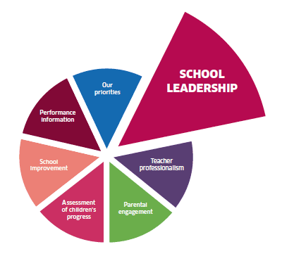 | Staff, children and parents understand our school rules and relationships policy | Review school rules to ensure a shared understanding  Finalise relationships policy involving all stakeholders | Staff, pupil and parent focus groups – shared language and understanding
 |  | Staff, children and parents use a shared language to resolve problems | Extend the use of micro-scripts and revise as required  Consistently use restorative conversations
 |  | Staff, children and parents work together to promote resilience and growth mindset | Use Learn to Learn to link Learner Qualities to resilience  Provide information about resilience for parents
 | High quality  learning and teaching | Teachers plan for health and well-being weekly | Introduce Bounce Back as a resource to support teachers  Provide weekly opportunities for outdoor learning (PEF) | Teacher feedback – use of outdoors, circle time, yoga each week  Pupil feedback – lunch time clubs
 |  | Children have the social skills they need to play positively in the playground | Use Circle Time/ Playground Zones to improve playtimes  Devise a programme of extra-curricular activities(PEF)
 |  | Children use a range of self-regulation strategies | Use regular check-ins/ outs to increase self-awareness  Introduce yoga and mindfulness (PEF)
 | 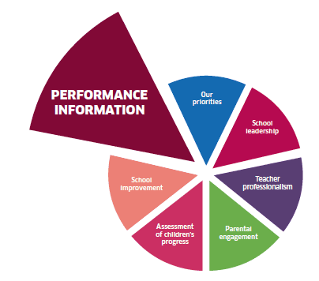  Use of data to measure progress | Teachers use check in/ out information to evaluate children’s well-being | All classes collect daily well-being data  Use the data at Circle Time sessions and with individuals | Daily class data – rating scale of happiness  Well-being webs for vulnerable learners – number of children who feel included  SPSA data – daily number of children using Time Outs
 |  | Staff, children and parents review well-being indicators to measure progress and identify next steps | Review the well-being web proformas to ensure they allow all children to demonstrate progress
 |  | Children gather data related to playground issues to evaluate and make improvements | Introduce a system to collect data and evaluate at Learn to Learn
Grange Primary School Measurement Plan 2019-20
3.1 How well do children show consideration for others and demonstrate positive behaviour and relationships?
3.1 How well does our school ensure that the curriculum is designed to develop and promote equality and diversity, eliminate discrimination?
3.1 How do we ensure there is an ethos and culture of inclusion, participation and positive relationships across the whole community?
Measure | Concept | Operational Definition | Data Collection | Personnel
Outcome  Number of children who indicate a positive response on the ‘included’ well-being indicator  Number of children who feel ‘respected’ using Rights Respecting Schools survey | Well-being  Are we getting closer to our aim of showing 90% of learners who feel included? | Numerator:  The number of children from an identified group who indicate they feel ‘happy’ about being included  Denominator:  The total number of children in the identified group | All children will complete well-being webs for Learner Led Conferences in October and for end of year reports in March  Complete survey June 2019 and February 2020 | VT
Process  Staff, pupil and parent survey November and February – use MAD group as sample | Shared language  Do we have a shared language of well-being including rules, micro-scripts and restorative conversations? | The number of staff, pupils and parents who indicate ‘lots/ loads’ when asked about language of well-being | Survey Monkey using the Minion Measure as rating scale in November and February | LW
Process  Termly planning and tracking meetings | Learning experiences  Are teachers planning weekly Bounce Back, Circle Time, yoga and outdoor experiences? | The number of teachers who have included well-being activities in planning | SLT will complete proforma during termly planning and tracking meetings | MO
Process  SPSA data using Time Out zone | Social skills  Are children having positive playtimes and are we reducing the number of conflicts? | The number of Time Outs recorded by SPSAs each day | P7 pupils will gather SPSA data each week and present it monthly at Learn to Learn | VT
Process  Termly planning and tracking meetings | Equity  Are we offering extra-curricular activities that allow all children to participate? | The number of children participating in extra-curricular and out of school activities | SLT will complete proforma during termly planning and tracking meetings | PL
Balancing  Staff feedback at planning meetings | IDL experiences  Is our focus on HWB having a negative impact on our IDL projects? | The number of teachers who feel they are delivering high quality IDL | SLT will gather this quantitative data during planning meetings | MO
Grange Primary School Improvement Plan 2019-20
Aim | Primary Drivers | Secondary Drivers | Change Ideas | Measures
90% of all learners will be achieving expected standards in literacy and numeracy by May 2020 | Collaborative practice | ASN staff and class teachers collaborate effectively to support progress | Teachers plan effectively for SPSAs to support learning  Teachers use the Learning Ladders to identify targets | Pedagogy team planning meetings – SPSA support  Staff, pupil and parent focus groups  Parent feedback – linked to learning visits
 |  | Staff, children and parents understand the definition of ‘not yet achieving expected standard’ | Create an operational definition of linked to the Learning Ladders
 |  | Parents can support learning targets at home | Share learning targets and home learning activities with parents
 | High quality  learning and teaching | Pedagogy team collaborate with teachers to support effective differentiation | Team meet with teachers 2 weekly to track progress and plan differentiated support (PEF) | Pedagogy team planning meetings – differentiation  Staff feedback and pupil data– SRS and Numicon training  Staff feedback – Talk for Writing training
 |  | Staff are trained to deliver interventions for literacy and numeracy | Staff team attend Sound Reading System training (PEF)  Staff attend training and introduce Numicon (PEF)
 |  | All classes benefit from support for writing which is planned effectively | Pedagogy team attend Talk for Writing training and share approaches with all staff (PEF)
 | Use of data to measure progress | Teachers use assessment evidence to plan next steps in learning with support staff | Review assessments and class work with SPSAs to plan support | Planning and tracking meetings – review of class data spreadsheet  Learning Walks and pupil groups – review of Learning Journeys
 |  | Teachers use Learning Journeys to support children in evaluating their progress | Use Feedback Fridays to review progress with individual children to ensure all children are making progress
 |  | Teachers use data to support and moderate judgements about children’s progress | Use 2 weekly tracking meetings to focus on the progress of supported children
Grange Primary School Measurement Plan 2019-20
3.1 How well can we demonstrate improved attainment for groups and individuals facing barriers to learning, including poverty?
3.2 How well are our approaches to raising attainment improving outcomes for children and young people?
3.2 How well is our focus on literacy and numeracy leading to raising attainment across the curriculum?
Measure | Concept | Operational Definition | Data Collection | Personnel
Outcome  Number of children in September, January and May who are making expected progress in reading, writing, listening and talking and numeracy | Raising attainment  Are we getting closer to our aim of 90% of learners who are 4s and 5s for reading, writing, listening and talking and numeracy? | Numerator:  The number of children from the denominator who are making expected progress  Denominator:  The total number of children in the school | This measure will be calculated in September, January and May based on all the data gathered at moderation meetings | VT
Process  Pupil and parent focus groups September and January | Shared language  Do we have a shared understanding of ‘not yet making expected progress’? | Sample group of ‘capable 4s’ interviewed at learning visits  Proforma sent home to their parents to check understanding of terms | This will be measured by SLT and will be a count of pupils and parents | LW
Process  Pupil and parent focus groups | Parental engagement  Do parents and pupils feel that they are making progress with learning at home? | Qualitative data to reflect the quality of the resources and support from school staff | This will be gathered from pupils and parents by teachers at Progress Update meetings in January | PL
Process  PT Pedagogy fortnightly support meetings | Differentiation  Are teachers planning differentiated learning and support? | The number of teachers planning differentiated tasks, resources and timetable support | PT team will gather this data fortnightly and feedback to HT monthly | LW
Process  SRS data for P2 and numeracy diagnostic data for P4 | Interventions  Are the interventions having a positive impact upon progress? | SRS data will be gathered and analysed in line with the programme guidance  Numeracy diagnostics will be reviewed for progress termly | SLT will analyse data with teachers at termly tracking meetings | MO
Balancing  Termly planning and tracking meetings | Well-being  Are we raising the attainment of our vulnerable 4s? | The number of children who are assessed to be vulnerable 4s at moderation meetings | This measure will be calculated in September, January and May based on all the data gathered at moderation meetings | VT
Grange Early Level Improvement Plan 2019-20
Aim | Primary Drivers | Secondary Drivers | Change Ideas | Measures
15% of returning children in nursery and Primary 1will be working beyond the expected standard in literacy and numeracy by May 2020 | Collaborative practice | Staff, children and parents understand what we mean by ‘challenge’ | Create an operational definition for ‘challenge’  Share examples of ‘challenge’ e.g. blog, video, dojo etc. | Pupil and parent focus groups – use operational definition
 |  | Parents can support learning targets at home | Share learning targets and home learning activities with parents | Pupil and parent focus groups – use operational definition
 |  | Staff work collaboratively in Impact Teams to increase challenge | Impact Teams meet regularly to plan challenging learning experiences using PDSA cycles | Pupil and parent focus groups – use operational definition
 | High quality  learning experiences | Staff are trained to deliver interventions for literacy and numeracy | Staff team develop use of Word Aware  Staff attend training and introduce Numicon (PEF) | Learning visits – classroom organisation and stuck stops  Planning and tracking meetings – learning ladders  Learning visits/ pupil groups - level of challenge
 |  | Staff use Learning Ladders to identify next steps in learning | Review Learning Ladders and create a rubric to show next steps
 |  | Staff use a variety of resources and approaches to provide challenge | Use provocations and up-level them to increase challenge  Use SOLO to further develop higher order questioning
 |  | All staff benefit from support for writing to enrich learning experiences | Pedagogy team attend Talk for Writing training and share approaches with all staff (PEF)
 | Use of data to measure progress | Staff use Learning Journeys to support children in evaluating their progress | Use Folio Fridays to review progress with individual children using questions and prompts | Planning and tracking meetings – review of class data spreadsheet  Learning Walks and pupil groups – review of Learning Journeys
 |  | Staff use data to support and moderate judgements about children’s progress | Use tracking meetings and moderation workshops to focus on the progress of our learners
Grange Early Level Measurement Plan 2019-20
2.3 How well do we support practitioners in undertaking their role in evaluating children’s progress?
2.3 How well does the information we gather about children’s progress inform our planning and improvement?
3.2 How do we ensure children understand their own progress in a meaningful way?
Measure | Concept | Operational Definition | Data Collection | Personnel
Outcome  Number of children in September, January and May who are working beyond the expected standard | Raising attainment  Are we getting closer to our aim of showing an increase to 15% of learners who are 5s for reading, writing, listening and talking and numeracy? | Numerator:  The number of children who are assessed to be level 5 at moderation meetings  Denominator:  The total number of children in the nursery | This measure will be calculated in September, January and May based on all the data gathered at moderation meetings | VT/ PL
Process  Pupil and parent focus groups September and January | Shared language  Do we have a shared understanding of ‘challenge’? | Sample group of ‘capable 4s’ interviewed at learning visits  Proforma sent home to their parents to check understanding of terms | This will be measured by SLT and will be a count of children and parents | LW
Process  Termly learning visits | Interventions  Are the interventions having a positive impact on progress? | Word Aware data will be gathered and analysed  Numeracy observations will be reviewed for progress termly | SLT will analyse data with staff at termly tracking meetings | PL
Process  Termly planning and tracking meetings | Learning Ladders  Are staff using Learning Ladders to increase challenge? | Qualitative data using reflective questions which will be included in the planning and tracking meetings | SLT will complete proforma during termly planning and tracking meetings | MO
Process  Learning visits Term 1 and 3  Impact Team PDSA cycles | Challenging tasks  Are staff using WAGOLLS, SOLO and open-ended experiences to increase challenge? | The number of staff who indicate a positive response on Learning Visit checklist | SLT will complete checklist during learning visits September and January | PL
Balancing  Staff judgements September, January and May | Child-centred learning  Are we continuing to provide child-led learning experiences? | The quality of child-centred planning | This measure will be considered at nursery planning meetings | PL

Grange Early Level Improvement Plan 2019-20
Aim | Primary Drivers | Secondary Drivers | Change Ideas | Measures
100% of children will use well-being indicators to show they feel ‘included’ by May 2020 | Collaborative practice | Staff, children and parents understand our school rules and relationships policy | Review green choices to with staff, children and parents  Finalise relationships policy involving all stakeholders | Staff, children and parent focus groups – shared language and understanding
 |  | Staff, children and parents use a shared language to resolve problems | Extend the use of micro-scripts and revise as required  Consistently use restorative conversations
 |  | Staff, children and parents understand attachment theory | Provide information about attachment theory for parents
 | High quality  learning experiences | Staff plan for health and well-being weekly | Introduce Bounce Back as a resource to support staff  Provide daily opportunities for high quality outdoor play (PEF) | Staff feedback – use of outdoors, circle time, yoga each week
 |  | Children use a range of self-regulation strategies | Use regular check-ins/ outs to increase self-awareness  Introduce yoga and mindfulness (PEF)
 | Use of data to measure progress | Staff use check in/ out information to evaluate children’s well-being | Collect daily well-being data  Use the data to support individuals | Daily class data – rating scale of happiness  Well-being webs for vulnerable learners – number of children who feel included
 |  | Staff, children and parents review well-being indicators to measure progress and identify next steps | Review the well-being web proformas and use Blether Boards to ensure they allow all children to demonstrate progress
Grange Early Level Measurement Plan 2019-20
3.1 Have we successfully established an inclusive learning environment and setting?
3.1 How welcome and included do all children, parents/carers and partners feel? How do we know?
3.1 How well do practitioners understand attachment theory and its impact on future development and learning?
Measure | Concept | Operational Definition | Data Collection | Personnel
Outcome  Number of children who indicate a positive response on the ‘included’ well-being indicator | Well-being  Are we getting closer to our aim of showing 100% of children who feel happy? | Numerator:  The number of children from an identified group who indicate they feel ‘happy’ about being included  Denominator:  The total number of children in the identified group | All children will complete an adapted well-being web in October and for end of year reports in March | VT
Process  Staff, pupil and parent survey November and February | Shared language  Do we have a shared language of well-being including rules, micro-scripts and restorative conversations? | The number of staff, pupils and parents who indicate ‘lots/ loads’ when asked about language of well-being | Survey Monkey using the Minion Measure as rating scale in November and February | LW
Process  Nursery planning meetings | Learning experiences  Are teachers planning weekly Bounce Back, Circle Time, yoga and outdoor experiences? | The number of well-being activities in planning | SLT will gather information during planning meetings | PL
Process  Staff observations and interactions | Self-regulation  Are children having positive play experiences and are we reducing the number of conflicts? | The number of restorative conversations by staff each day | Staff gather data each week and analyse at planning meetings | PL
Process  Termly planning and tracking meetings | Well-being measures  Are we using our check-in data and well-being indicators to meet children’s needs? | The number of staff/ child interactions to support wellbeing | SLT will complete proforma during planning meetings | PL
Balancing  Staff feedback at planning meetings | Child-centred learning  Is our focus on HWB having a negative impact on our child-led learning? | The number of staff who feel they are delivering high quality play experiences | SLT will gather this quantitative data during planning meetings | PL
Grange Parent Council Improvement Plan 2019-20
Aim | Primary Drivers | Secondary Drivers | Change Ideas | Measures
By May 2020 95% of parents will be at level 3 or above on a scale of parental engagement | Collaborative planning | Parents share their views to influence and improve school life | Create programme of Grange Gabbers/ Nursery Natters with focus for each meeting | Create a scale of parental engagement used to measure the planned activities
 |  | Parents share their skills to influence and improve school life | Invite parents to share skills linked to each IDL topic and MAD group
 |  | The school shares their work with parents and seeks feedback | Create a monthly HT blog to share progress and seek feedback
 |  | Parents have clear information about the ways in which the school has acted upon their views and opinions | Provide ‘You said…We did’ information on blog annually  Parent Council share information from each meeting with all parents
 | Engaging learning experiences | The school offers a range of activities to support family learning | Plan a programme of activities based upon survey results and school topics | Use Survey Monkey at each event and count attendance  Use Grange Gabbers and Nursery Natters meetings to gather views
 |  | The school supports parents to be able to discuss progress and to extend learning out with school | Create questions for parents to use and post on blog  Encourage parents to access Learning Ladders
 |  | Parents and teachers communicate to support children’s learning and to celebrate success | Use Learning Journeys to share children’s learning  Introduce STARS awards
 | Home learning | Parents and children are motivated to carry out home learning activities | Flipped learning which does not involve written tasks | Parent survey for home learning
 |  | Parents understand how numeracy concepts are taught in school | Create ‘How to’ videos archived on the blog for numeracy | Parent survey for home learning
 |  | Parents understand how to support learning at home | Information on blog about spelling, number and Big Writing | Parent survey for home learning

