
Grange Primary School Improvement Plan 2018-19
Aim | Primary Drivers | Secondary Drivers | Change Ideas | Measures
By May 2019 x% learners who are not yet making expected progress will show increased levels of engagement in their learning | Collaborative practice  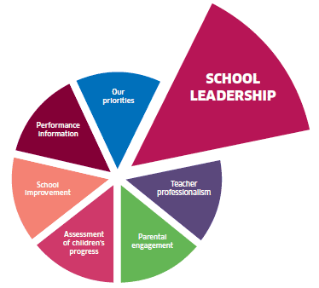  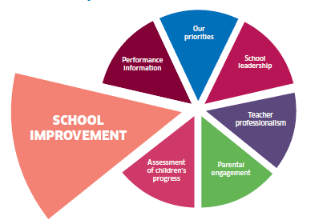 | Staff have time to collaborate to share good practice | All staff meet regularly to share successes and good practice | Staff confidence – Linkert scale
 |  | Collectively staff focus on improving one area of practice at a time | All trios investigate one aspect of SOLO at the same time to allow staff to share resources and experiences | Staff confidence – Linkert scale
 |  | Stage trios have time allocated to plan and share ideas | Staff trios meet regularly to allow staff to plan and share tests | Staff confidence – Linkert scale
 |  | Staff use research to improve understanding of SOLO | Staff trio meetings include professional reading linked to SOLO to improve understanding | Staff confidence – Linkert scale
 | High quality  learning and teaching  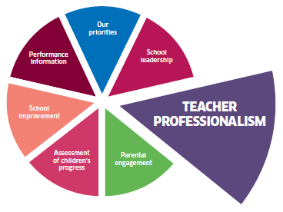  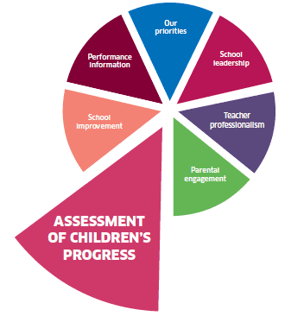 | Staff plan engaging approaches and challenging tasks using SOLO levels | Staff work in trios to plan activities linked to SOLO levels to improve levels of engagement | Staff use of SOLO for questions, feedback, SC, tasks – frequency count  Children’s level of engagement during lessons – Leuven scale
 |  | Staff use SOLO to plan questions prior to lessons | Planning quality questions using SOLO verbs will improve engagement during discussions
 |  | Staff have time to give each child quality feedback using SOLO levels | Staff timetable 1:1 feedback and use SOLO to help children understand their next steps
 |  | Co-creation of success criteria using Learning Ladders and SOLO levels | Staff use SOLO verbs when they co-create SC with children so that progress in learning is explicit
 | 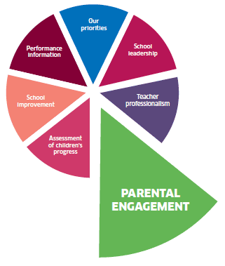  Learner participation | Children understand the vocabulary of the Minion Measure | All staff and children use specific vocabulary for Minion Measure in SC so that it is embedded in classroom language | Children’s accuracy – Linkert scale
 |  | Children are confident to talk about their progress in learning with parents using the Minion Measure | Parents are given SOLO questions to use at home to help children build confidence in using the Minion Measure | Children’s accuracy – Linkert scale
 |  | Children can accurately review their progress using Minion Measure | Children have regular opportunities during plenaries to review their progress in class using assessment evidence to improve accuracy | Children’s accuracy – Linkert scale
Grange Primary School Measurement Plan 2018-19
1.1 How well do we encourage staff to reflect on and share their own practice?
1.3 To what extent are our tools for change impacting positively on staff and improving outcomes for all learners?
2.3 How confident are we that all learners experience activities which are varied, differentiated, active, and provide effective support and challenge?
2.3 How well do our questioning strategies enhance the learners’ experience and enable higher-order thinking skills?
Measure | Concept | Operational Definition | Data Collection | Chart
Outcome  Number of children each week who rate interest in learning as above average on a rating scale | Learner engagement  Are we getting closer to our aim of showing a 50% increase in learners who rate interest in learning as 4 or 5 on rating scale? | Numerator:  The number of children from the denominator who rate interest in learning as 4 or 5  Denominator:  The number of children identified in June 2018 as not yet making expected progress | This measure will be calculated monthly based on all available data to the end of the previous calendar month. | P
Process  Weekly observation of class discussion during Big Writing using Leuven scale to rate level of engagement | Quality questioning  Is our use of questioning strategies engaging learners in discussions? | Every two weeks teachers will plan questions using SOLO verbs and different questioning techniques (Aug-Dec)  Sample one discussion for each class and A&E children | Each week the DHT/ PTs/ teachers will observe in identified classes and groups of learners and count the number of children at 4 or 5 of the scale of engagement | R
Process  Weekly review of planning to count differentiated tasks | Engaging tasks  Are staff planning challenging tasks using SOLO to differentiate? | Every two weeks teachers will use SOLO to plan differentiated tasks and/ or SC (Jan-April)  Staff will identify number of times each week | Each week the DHT/ PTs/ teachers will count the number of differentiated tasks and/ or SC in each class | R
Process  Weekly review of learning with identified learners and count accurate assessments | Self-assessment  Are learners accurately assessing their progress during feedback sessions? | Weekly group of learners self-assessing progress in learning | Each week DHT/PTs/ teachers will review learning with an identified group from one class and count how many make an accurate assessment | Case studies
Process  Number of staff every two weeks who rate confidence as above average | Staff confidence  Are the approaches to improvement impacting positively on staff? | Every two weeks teachers will work together in trios to discuss and work on PDSA cycles | Teachers to rate themselves on a group chart at the end of each trio session | R
Balancing  Number of children who are not yet making expected progress in each class | Progress in learning  Is the use of SOLO having an impact on children’s progress? | Teacher professional judgement on progress using Learning Ladders | DHT/PTs tracking meetings September, January and May count number of A&E children | %

Grange Primary School Improvement Plan 2018-19
Aim | Primary Drivers | Secondary Drivers | Change Ideas | Measures
By January 2019 50% of learners not yet making expected progress in writing and numeracy will be on track | Collaborative practice  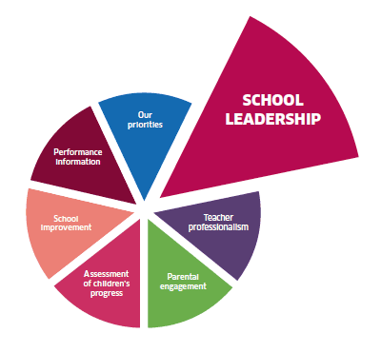 | Clear timely referral process for children not yet making expected progress | Revise referral process for children who require additional support | Staff collaboration – Linkert scale
 |  | ASN staff and class teachers collaborate effectively to support progress | Provide timely opportunity for ASN and class teachers to collaborate | Staff collaboration – Linkert scale
 |  | Children are supported at appropriate times and in suitable locations | ASN support timetable created in collaboration with class teachers | Staff collaboration – Linkert scale
 |  | Parents know how they can support targets at home | Home learning activities are shared with parents | Staff collaboration – Linkert scale
 | High quality  learning and teaching | Class teachers differentiate effectively in class | ASN provide resources and advice to teachers | Sampling pupil experience of support – class work, interventions, home learning and targets  Staff confidence in delivering interventions
 |  | Staff are trained and confident in delivering interventions | Identify most effective interventions and provide training for ASN team
 |  | Staff match interventions to children’s needs effectively | ASN and teachers meet to identify most appropriate interventions
 |  | Support is directly linked to class work | ASN and teachers each plan to support shared goals in group/ individual plans
 |  | Class homework supports children’s progress | Class homework is reduced to allow time for individual ASN homework
 |  | Children are clear about their targets and track their own progress | Targets are visible to children and data is shared with them
 | 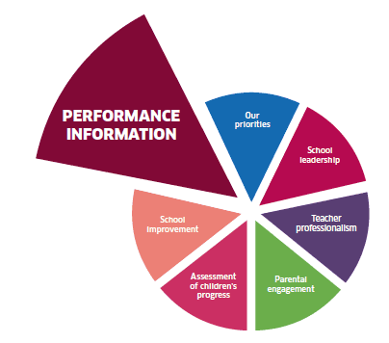  Use of data to measure progress | All staff understand the factors which influence children’s progress | Data spreadsheet used at tracking meetings | Monthly review of pupil performance data, attendance, lateness and participation
 |  | Equity is planned to provide opportunities for identified learners | Timetable of HWB activities planned for identified groups and impact tracked
 |  | A wide variety of lunch time and Friday clubs are planned P1-7 | Timetable of clubs planned P1-7 and participation tracked
 |  | Attendance and lateness data are tracked and followed up | Contact parents to discuss contacted promptly

Grange Primary School Measurement Plan 2018-19
3.1 How well can we demonstrate improved attainment for groups and individuals facing barriers to learning, including poverty?
3.2 How well are our approaches to raising attainment improving outcomes for children and young people?
3.2 How well are we removing barriers to learning and ensuring equity for all?
Measure | Concept | Operational Definition | Data Collection | Chart
Outcome  Number of children each month who are not yet making expected progress in numeracy and writing | Raising attainment  Are we getting closer to our aim of reducing by 50% the number of children who are not yet making expected progress? | Numerator:  The number of children from the denominator who are still not yet making expected progress  Denominator:  The number of children identified in June 2018 as not yet making expected progress | Each month ASN team and DHT will meet to review progress and count number of learners still not yet making expected progress | P
Process  Weekly review of ASN and teacher meetings | Staff collaboration  Are staff working collaboratively to improve outcomes for learners? | Every week the number of scheduled collaborative planning meetings are counted | ASN teacher will share data with DHT | C
Process  Monthly sampling of learner experience | Learner experience  Are our approaches to raising attainment improving learner experiences? | Each month carry out a review of one learner’s experience to include class work, interventions, homework and targets | DHT will meet with one learner each month to gather qualitative data about their experience of additional support | Case studies
Process  Monthly review of staff confidence in delivering interventions | Interventions  Do staff feel confident in delivering interventions? | Each month conduct a staff confidence survey linked to the interventions being delivered | DHT to gather data using a rating scale for confidence – count number of staff rating 4 or 5 | C
Process  Monthly review of participation numbers | Equity  Are we increasing equity by providing additional opportunities for identified groups? | Each month count the number of children participating in/ out with school opportunities | Mr Findlay to gather class data from teachers for participation each month using a register | P
Balancing  Monthly review of children’s views using a rating scale | Well-being  Are our approaches to raising attainment and equity having a positive impact on wellbeing? | Each month sample one learner and use wellbeing web as a rating scale | DHT to gather during the case study sample | C

Grange Primary School Improvement Plan 2018-19
Aim | Primary Drivers | Secondary Drivers | Change Ideas | Measures
By May 2019 95% of parents will be at level 3 or above on a scale of parental engagement | Collaborative planning | Activities and events are arranged at suitable times | Create a calendar of Community Engagement opportunities for the year including PC, GG, NN | Create a scale of parental engagement used to measure the planned activities
 |  | Arrangements are in place for childcare for younger siblings as required | Plan a variety of days, times and locations
 |  | Activities are short and on offer regularly at different times of the day/ week | Make contact with MOOSCC and MHS to arrange childcare provision
 |  | Activities are planned well in advance with ‘save the date’ notice | Use school blog, iCal and Facebook page to create events and share with nurseries and community groups
 | Engaging learning experiences | Family events are fun, exciting and varied | Link the events to topics, playground zones and MAD groups | Measure using a rating scale for enjoyment at each event and count attendance
 |  | A range of activities at class, school and community levels on offer | Outdoor education worker to provide sessions in forest
 |  | Parents understand all of the different ways they can be involved | Post case studies to show different ways parents can get involved
 | Home learning | Parents and children are motivated to carry out home learning activities | Flipped learning which does not involve written tasks | Count number of likes on Class Dojo for one class (flipped learning)  Parent confidence scale for supporting numeracy
 |  | Parents understand how numeracy concepts are taught in school | Create ‘How to’ videos archived on the blog for numeracy
 |  | Parents understand how to support learning at home | Information on blog about spelling, number and Big Writing

Grange Primary School Measurement Plan 2018-19
2.5 To what extent are we sure of what meaningful engagement with families looks like?
2.7 How well do we enable parents, carers and families and the local community to contribute to the life of the school and be involved in school improvement?
Measure | Concept | Operational Definition | Data Collection | Chart
Outcome  Number of families each month who have achieved level 3 or above on a scale of parental engagement | Parental engagement  Are we getting closer to our aim of achieving 95% of families reaching level 3 or above? | Numerator:  The number of families from the denominator who have achieved level 3  Denominator:  The total number of families in the school | Each month Parent Council count number of parents who have achieved level 3 | P
Process  Register taken at each planned event | Participation  Are we engaging all families and identifying those who are more difficult to reach? | At every event the number of children represented is counted | Parent Council take a register at events | P
Process  Rating scale of family enjoyment at each event | Enjoyment  How much are families enjoying the events we have organised? | Rating scale used to evaluate levels of parental enjoyment at each event | Parent Council create a chart with rating scale for use at each event | Bar
Process  Weekly count of number of ‘likes’ for Flipped Learning for one class | Home learning  Are our approaches to home learning engaging parents? | Each week one class teacher counts number of likes for ‘flipped’ home learning | Weekly count of ‘likes’ gathered by HT | R
Process  Monthly sampling of two parents to evaluate use of numeracy videos | Numeracy  Are our approaches to home learning increasing parent confidence? | Each month carry out a review of parents’ experiences of using the ‘how to’ videos to support their child’s learning | Each month HT analyses qualitative data to evaluate | Case studies
Balancing  Monthly review with same parents time spent on reading at home | Reading  Are the numeracy videos taking time away from reading at home? | Qualitative data gathered during case study review | Each month HT gathers the data during case study | Case studies

