

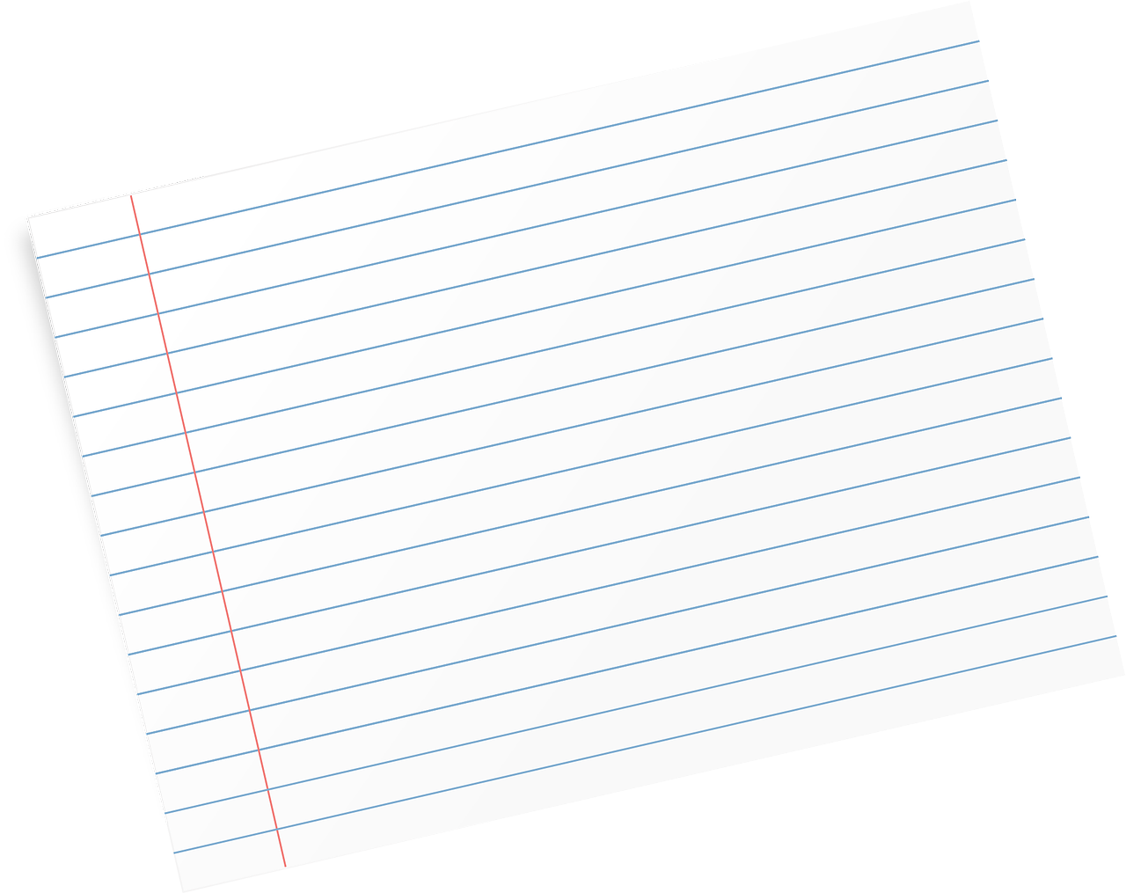******P7 Pupil Profile**

Name:

**Me as a learner**

I learn best when

What I like doing in school

Teacher:

Primary School:

Add your selfie here!

Date of Birth:

Age:



Favourite Colour:

**My personal achievements, awards and certificates**

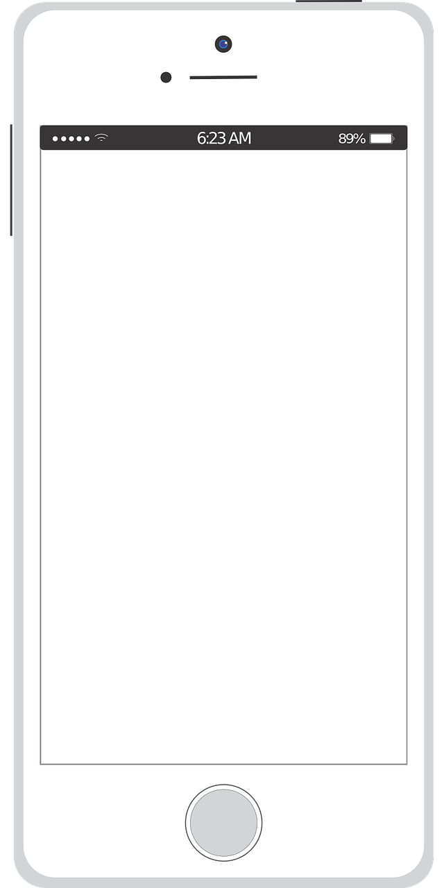

**All About My Family**



**My Friends**

**My Hobbies and Interests**

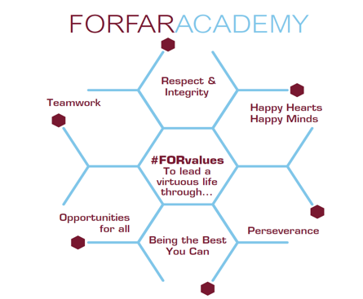

Use the hashtags and write 3 words that best describe you!

**#**

**#**

**#**

Draw a picture of yourself in your dream job.

**Me in the future**