S2 CfE Business Education and Computing Technologies

Do not write in this booklet.

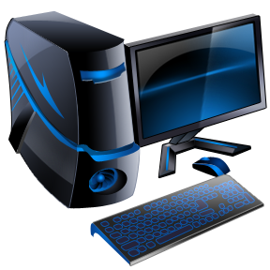
Homework Booklet

Welcome to the S2 CfE Business Education, Computing and Technologies homework booklet.

The aim of this booklet is to reinforce what you have learned during your ICT lessons in S2 and to give you some flexibility and choice over what type of homework you complete.

During each unit of work your class teacher will give you a homework deadline. This will usually be one week.

Choose which homework activity (a, b, c…) you want to complete depending on what topic you are covering in class.

Complete a mixture of written and creative tasks!

- The mouse icon shows that you need a computer to complete that task.

- The pencil icon shows that you need to write out your work on paper. Always write in sentences.

- Both icons mean that you can choose how you display your work.

Spreadsheet

- Create a spreadsheet to show how you will be spending your pocket money. Print showing formulae.
- Create a poster all about the benefits of using a spreadsheet.
- Give “how-to” instructions to: create a bar chart, add a range of cells and calculate the average from a range of cells.
- Write down 5 different formula and explain the purpose of each.
- Give “how-to” instructions to: merge cells, wrap text or change the size of a column.
- Create a 10 question quiz all about Spreadsheets.

Desktop Publishing

- List ten different documents that you can create using Microsoft Publisher.
- Create a birthday card for your form tutor using Microsoft Publisher.
- Create a business card with your personal details using Microsoft Publisher.
- Create a CD cover for your favourite album using Microsoft Publisher.
- Explain some of the differences between Microsoft Word and Microsoft Publisher.

Photo Plus

- Find three pictures from magazines which you think have been digitally altered and explain what you think has been changed.
- Explain the following changes that can be made to an image: Red Eye Removal, Mark Removal, Adding/Changing Colour and Adjusting Colour Depth.
- Explain the following criteria for a good photo: Extraction. Sizing. Positioning and Lighting.
- Create a word search with at least 10 different Photo Plus terms.
- Search the internet to find a job advert for a Photo Editor. Copy and paste the advert into a word document then explain whether or not you think you would enjoy that type of job.
- Create a 10 question quiz all about photo editing.

Top Trumps

- Write 6 different themes of top trump cards.
- Design a Scottish themed Top Trumps card.
- Write 100 words about another famous card game.
- Create a 4 slide powerpoint all about Top Trumps.
- Design a website to sell your Top Trumps Game.
- Design a Forfar Academy themed Top Trumps card.

