

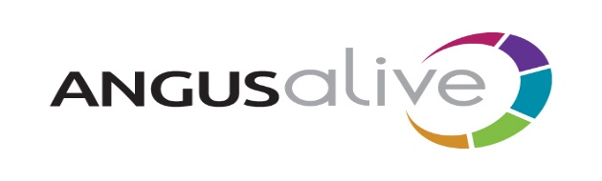

## Job Vacancies List No 8

**Apply on-line at** [**www.myjobscotland.gov.uk**](http://www.myjobscotland.gov.uk)

Alternatively phone the ACCESSLine on **03452 777 778**

or e-mail [**accessline@angus.gov.uk**](mailto:accessline@angus.gov.uk) quoting the job reference number, your name, address, postcode and where you saw the job advertised.

*You can also register for Job Alert e-mails to be sent to you when jobs matching your search criteria are added to the website – visit* [***www.myjobscotland.gov.uk***](http://www.myjobscotland.gov.uk) *for more information.*

**Health Walk Co-ordinator (Angus)**

**£20,110 - £21,017 ANG03326**

Based at Monikie Country Park, Monikie.

This job is temporary for up to 12 months from date of appointment.

Help us change lives in Angus by inspiring Healthy, Active and Creative lifestyle choices.

Our business is everything to do with people and that's why our staff are so important to our success.

Are you adaptable and resilient, innovative and enthusiastic, ambitious and high performing, customer and results focused, hardworking and willing to learn?

This could be the job for you to make a difference to your local community. You'll find working with our customers is interesting and varied with never a dull moment.

What's more, ANGUSalive offers a rewards package with generous holiday allowance, pension and discounted membership across all of our facilities.

If you can commit to working with us for the people of Angus and are interested to joining the team we'd love to hear from you.

Please refer to job outline, person specification and information sheet for further details and requirements for this job.

We offer a guaranteed job interview to the following people who meet the essential criteria on application for a job:

Those with disabilities, recognised caring responsibilities and care experienced young people. This also applies to our own employees with caring responsibilities, young people on apprenticeships and placements who meet the essential criteria for the job.

**Closing Date: Friday 27 August 2021**