

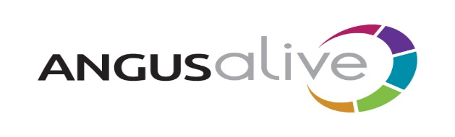

## Job Vacancies List No 6

**Apply on-line at** [**www.myjobscotland.gov.uk**](http://www.myjobscotland.gov.uk)

Alternatively phone the ACCESSLine on **03452 777 778**

or e-mail [**accessline@angus.gov.uk**](mailto:accessline@angus.gov.uk) quoting the job reference number, your name, address, postcode and where you saw the job advertised.

*You can also register for Job Alert e-mails to be sent to you when jobs matching your search criteria are added to the website – visit* [***www.myjobscotland.gov.uk***](http://www.myjobscotland.gov.uk) *for more information.*

**Customer Advisor (2)**

**£4,869 - £5,161 ANG03231**

Based at Monikie Country Park.

You will work a minimum of 10 hours per week.

These jobs are temporary until no later than 30 September 2021.

Applications from ANGUSalive employees on a secondment basis will be considered. You must have the approval of your line manager.

Help us change lives in Angus by inspiring Healthy, Active and Creative lifestyle choices.

Our business is everything to do with people and that's why our employees are so important to our success. It's crucial our customer advisors give our customers a warm welcome.

The ability to smile and get along with people, are two fundamental qualifications. If you have a friendly attitude and you understand the importance of excellent customer service, this could be just the job for you. Are you adaptable and resilient, innovative and enthusiastic, ambitious and high performing, customer and results focused, hardworking and willing to learn? This could be the job for you to make a difference to your local community.

You'll find working with our customers is interesting and varied with never a dull moment. What's more, ANGUSalive offers a rewards package with generous holiday allowance, pension and discounted membership across all of our facilities.

If you can commit to working with us for the people of Angus and are interested to joining the team we'd love to hear from you.

Please refer to job outline, person specification and information sheet for further details and requirements for these jobs.

**Closing Date: Friday 9 July 2021**