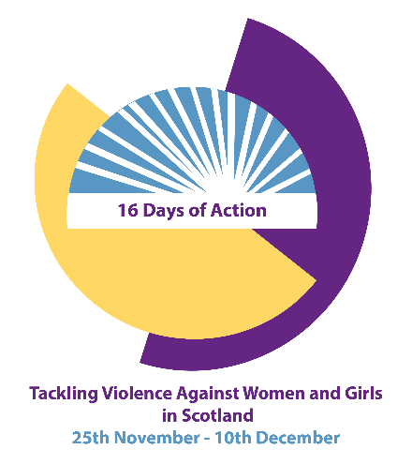
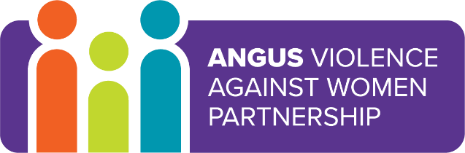

16 Days of Action - Events 2019
From 25 November, the International Day for the Elimination of Violence against Women, to 10 December, Human Rights Day, the 16 Days of Activism against Gender-Based Violence Campaign is a time to galvanize action to end violence against women and girls around the world. The international campaign originated from the first Women's Global Leadership Institute coordinated by the Center for Women's Global Leadership in 1991.
Date and Time | Event | Venue
Monday 25 November  12:30 -14:00 | Domestic Abuse: Starting the conversation. Launch of Domestic Abuse Prompt Cards  This event is for Multi Agency staff in Angus  To book a place email: AVAWP@angus.gov.uk (Please name the event in your email and give names of those attending and organisation details) | Training rooms A,B &C  Angus House  Forfar
Wednesday 27 November  09:00 – 13:00 | Tayside Multi Agency Risk Assessment Conference (MARAC) Development Event  This event is for Violence Against Women Partnership members; MARAC representatives and their managers and MARAC Chairs and their managers. This event is by invitation only. | Deaf Hub Dundee
Thursday 28 November  09:00 -12:00 | Young People, sexting and pornography (Women’s Rape and Sexual Abuse Centre)  This event is for Multi Agency staff in Angus  This workshop focuses on discussions around pornography and sexting by building on concepts of consent, sexualisation and sexual communication and the ways in which pornography can affect how individuals think they should behave sexually. There will be a key focus on how pornography might influence relationships and will give professionals the necessary tools to have conversations with young people around what is healthy and unhealthy.  https://www.eventbrite.co.uk/e/young-people-sexting-and-pornography-tickets-76775883735 | Training rooms A,B &C  Angus House  Forfar
Thursday 28 November  12:30 – 14:00 | Launch of a Template Policy regarding gender based violence for Employers in Angus  This event is for all employers in Angus (Lunch will be provided)  Gender Based Violence affects not only victim-survivors but can also impact their colleagues, the wider workplace, and ultimately the effective running of a business or organisation. As well as promoting economic and business benefits, Angus Violence Against Women Partnership have developed a template Gender Based Violence Workplace Policy to encourage local businesses and organisations to create a supportive and responsive workplace culture where anyone subjected to gender based violence feels safe and perpetrators are managed in line with best practice.  To book a place email: AVAWP@angus.gov.uk (Please name the event in your email and give names of those attending and organisation details) | Training rooms A,B &C  Angus House  Forfar
Monday 2 December  09:30 – 16:30 | Domestic Abuse Conference (Angus Women’s Aid)  This event is for Multi Agency staff in Angus  https://www.eventbrite.co.uk/e/awa-conference-tickets-76786537601 | The  Meadowbank Inn  Arbroath
Wednesday 4 December  09:00 – 12:00 | Domestic Abuse Risk Assessment & Safety Planning Workshop  (Angus Women’s Aid)  This event is for Multi Agency staff in Angus  This workshop will enable attendees to: have an understanding of Domestic Abuse/Coercive Control risk factors; be more confident in contributing to safety planning within a Domestic Abuse context and develop an awareness of multiagency responses to Domestic Abuse/Coercive Control.  https://www.eventbrite.co.uk/e/domestic-abuse-risk-assessment-and-safety-planning-tickets-76786100293 | Training rooms A & B  Angus House  Forfar
Thursday 5 December  09:00 – 12:00 | Impact of Rape and Sexual Assault (Women’s Rape and Sexual Abuse Centre)  This event is for Multi Agency staff in Angus  This workshop will Look at different forms of sexual violence; the concept of consent; discuss the myths which surround sexual violence and look at interventions which can promote recovery  https://www.eventbrite.co.uk/e/the-impact-of-rape-and-sexual-assault-tickets-76778491535 | Training rooms A & B  Angus House  Forfar
Thursday 5 December | Presentation by Angus Violence Against Women Partnership to Angus Council Elected Members | Council Chambers
Monday 9 December  09:00 – 12:30 | Commercial Sexual Exploitation (Women’s Rape and Sexual Abuse Centre)  This event is for Multi Agency staff in Angus  This workshop will look at what sexual exploitation is and the needs of those involved.  https://www.eventbrite.co.uk/e/commercial-sexual-exploitation-tickets-76782964915 | Training rooms A,B &C  Angus House
Monday 9 December  14:00 – 16:00 | Trauma: The Impact of Gender-Based Violence on Mental Health (Councillor Julie Bell and Alison Hendry, Justice Services)  This event is for Multi Agency staff in Angus  To book a place email: AVAWP@angus.gov.uk (Please name the event in your email and give names of those attending and organisation details) | Training rooms A,B &C  Angus House
Tuesday 10 December  13:00 – 16:00 | Banaz: A Love Story (Angus Women’s Aid)  This is an open event for anyone to attend  This is possibly the most documented case in the U.K. This film, directed by Deeyah Khan, chronicles the honour killing of Banaz Mahmod, a young British Kurdish women, killed by her own family for choosing a life for herself. There will be a question and answer session after the film.  https://www.eventbrite.co.uk/e/banaz-a-love-story-tickets-76785362085 | Angus Carers Centre Arbroath
For more information please contact
Duncans@angus.gov.uk or ProtectingPeopleAngus@angus.gov.uk

