For more information please contact:

Claire Wilson
Children Services Manager
Tel: 01241 873146

Lorna Stevens
Project Worker
Tel: 01241 873146

email: angus.office@barnardos.org.uk



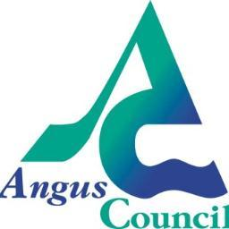

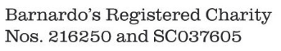

Barnardo’s
Hopscotch Service
Angus
A partnership between Barnardo’s and
Angus Council

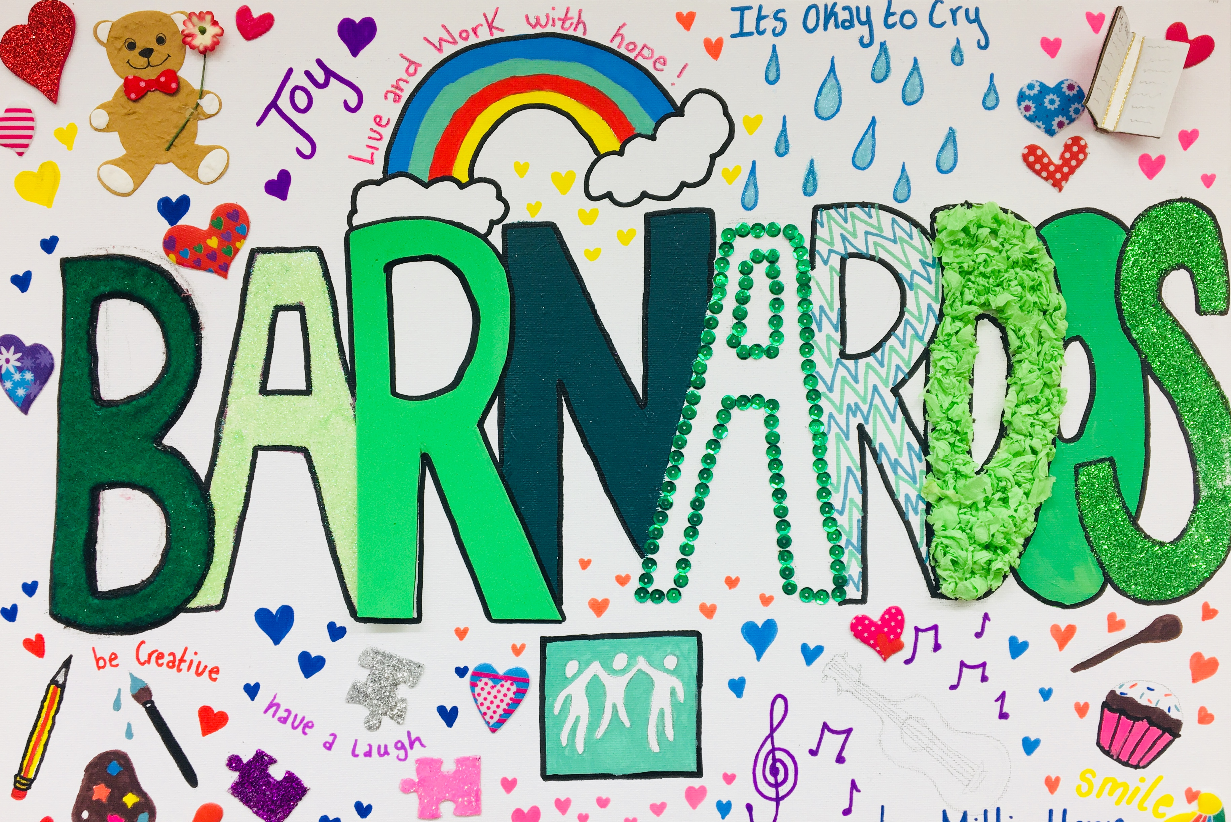

Information Leaflet for Professionals
The Hopscotch Service in Angus is a partnership between Barnardo’s and Angus Council

Within our Hopscotch Service, Barnardo’s will work to support children and families impacted by parental/carer substance use. We will deliver work with young people aged 5-16 years and their families to address their needs and wellbeing.

The service will augment existing support plans and aims to:

- Engage with and support families affected by parental /carer substance misuse

- Support children and young people aged 5-16 to have a safe space, to be listened to, have their views and feelings heard, gain a greater understanding of their family situation, reduce isolation and increase self-esteem.

- Achieve a whole family approach offering support to parents and carers, building on strengths, helping to reduce risks and promote positive change.

- Provide a co-ordinated response to whole families to address the impact of harmful behaviours

- Acknowledge and respect the need for families at risk to access safe, non-judgemental support

What We Offer

Individual one to one emotional support – child-led individual sessions using play-based and talking approaches to promote emotional wellbeing

One to one activity based sessions to promote self-esteem building and social opportunities by linking children to activities in their community

Family work to strengthen family relationships and communication

Support to parents and carers offering emotional support and strengthening parenting capacity on issues linked to addiction and to help parents/carers feel less isolated and more confident in their roles.

Referral Process

Referrals will be made directly to Barnardo’s and can include referrals from the named person, social work, health, other agencies working with the family and voluntary organisations. Self-referrals can be made to the service by families and by any agency working with the family.

