Junior Boccia Development Programme
Scottish Disability Sport (SDS) is offering pupils within mainstream schools the exciting opportunity to be introduced to the fastest growing Paralympic sport by a Scottish or Boccia UK player.
This opportunity is about signposting players in schools to local opportunities to regularly engage in the sport of boccia.

Why boccia?
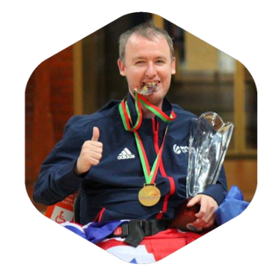
- Links to Curriculum for Excellence through:
Stephen McGuire, World No 1
  - Cross-curricular learning
  - Supports individuals to develop cognitive skills, physical competencies, personal qualities and physical fitness (Significant Aspects of Learning)
- Provides opportunities for individuals to access sessions out with curricular time
- Promotes active, healthy lifestyles

How will SDS support this?
- SDS will come to your school with current World No 1 Stephen McGuire (or other GB and Scottish Squad Players and national coaches to promote and introduce pupils to boccia).
- Signpost and support pupils to access local sessions
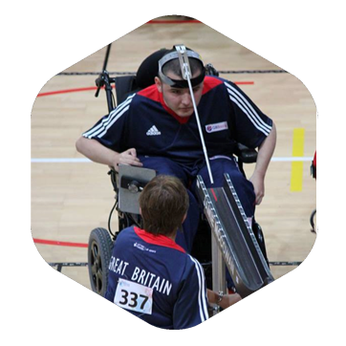
- SDS will provide one free place per school cluster on a Boccia Leaders workshop, including a free resource book
Jamie McCowan, World No 4
- Opportunity to enter a free prize draw to win a full boccia set with referee equipment
- Individual prize draw for players to win a visit (with carer) to the BISFed Boccia World Championships in Liverpool in 2018. This includes travel, accommodation and tickets.
What Happens Next?
If you have pupils in mainstream schools who are living with a physical disability and are wheelchair users, please contact your SDS Regional Manager to get the ball rolling.
This could be the start of the journey to access the health and social benefits associated with boccia. Additionally, this exciting opportunity could lead to individuals following the same trail as Stephen McGuire who became World Number One after 11 years.

Put sport in their hands and let the pupils make their decision to change their lives!

If you wish further information please do not hesitate to contact me on jennifer.scally@scottishdisabilitysport.com



