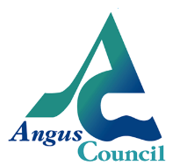[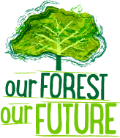](http://scotdectrees.users38.interdns.co.uk/index.php)

**Learning for Sustainability FREE COURSE for teachers – Our Forest Our Future**

* Looking to develop your own Professional Learning in a different and fun way?
* Want some ideas for a new Learning for Sustainability IDL topic next academic year?
* Need some inspiration and confidence to do more outdoor learning?

If you answered YES to any of these then this three-part course, based around online resource

[Our Forest, Our Future](http://www.ourforestourfuture.org.uk/) is for you! Set within the context of the Sustainable Development Goals, the course will give you a fresh look at the popular topic of FORESTS.

**We are offering a three-part twilight course to be held on**

**Thursdays 21st & 28th September, and 26th October 4.00 – 5.30pm**

**Northmuir Primary School, Kirriemuir**

Fairtrade refreshments will be provided. Some of this will take place outside so please bring appropriate clothing and footwear!

To book a free space, contact: [sally@oneworldcentre.org.uk](mailto:sally@oneworldcentre.org.uk) or phone 01382 454603

Our Forest our Future is an online resource funded by Forestry Commission Scotland, Oxfam and Scotdec, which explores the interdependence of people and forests, and the vital role they play in sustaining our environment, locally and globally. The resource is aimed at Level 2 and 3 pupils and could be a useful focus for transition.

The course will give teachers a range of classroom methodologies and outdoor learning activities to help pupils understand why our forests are under threat and the implications for our planet. Teachers will also have the opportunity to share and reflect on their professional practice with colleagues, in keeping with GTCS Standards.

