KODALY CPD FOR PRIMARY 3 TEACHERS
Tuesday 28th March, 4pm – 6pm

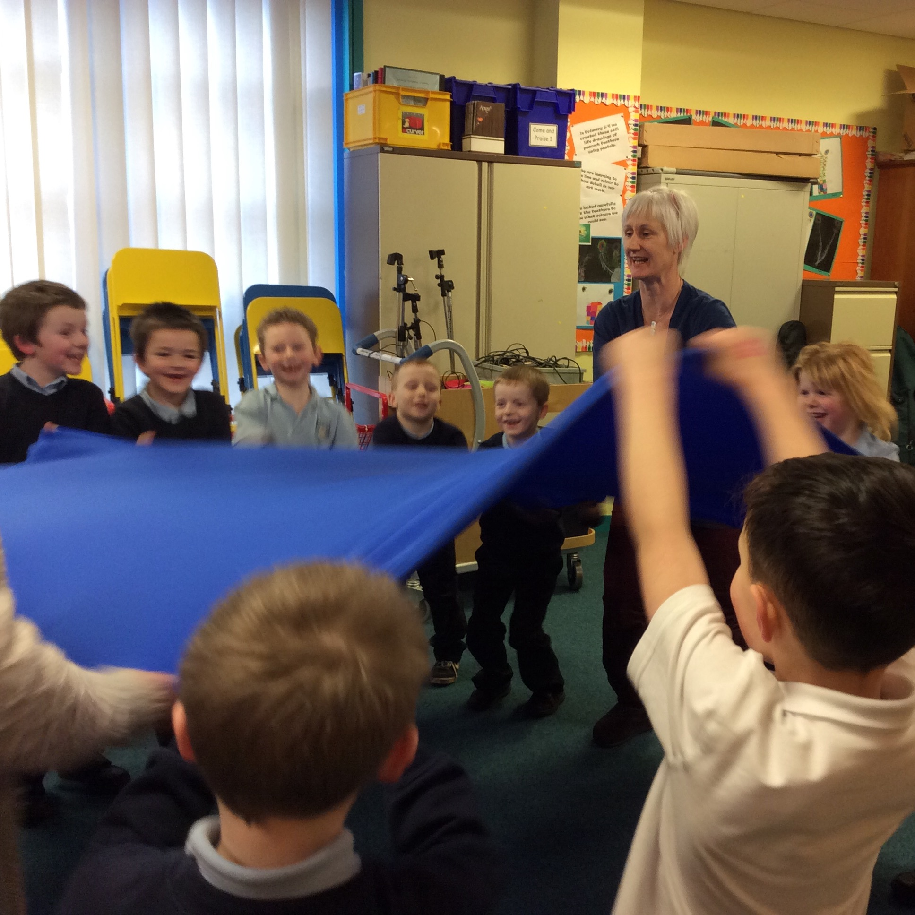

Who it’s for
For P3 teachers, or anyone interested in exploring Kodaly approach to teaching music to P3/4.

Approach
Always using games, songs and FUN we’ll explore material you can use with your class both in the classroom and in the hall. Delivered by Kit Ramsay

Aim of the session
Support for delivering follow-up sessions.
De-mystifying and building confidence in singing and understanding do, re, mi, so and la (the Pentatonic scale) and rhythm concepts ta, te-te, rest, ta-a and tiri-tiri.

Cost
This Session is Free!

When
Tuesday 28th March, 4pm – 6pm

Places must be booked via CPD online. (CPD code – LTG82 – 16/17)

