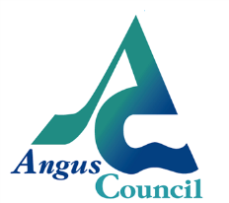
Angus Children and Learning Festival

Please complete one form per application

Your details:

Name:
Job Title:
Organisation:
Email:

What would you like to offer? Please tick one

Workshop
Creative Conversation
Marketplace

Please outline how your topic relates to the theme of reducing inequalities.

Tell us briefly about what you could offer:

Who is your audience? Tick all that apply.

Multi-agency |  | Health staff
School staff |  | Youth workers
Teachers |  | Early Years Practitioner
Social Workers |  | Social Care Staff
Other (please specify)

Do you require any equipment (e.g. projector, screen, presenter, etc.)?

(please note details of any equipment required here)

Applications will be collected until Thursday 31st August 2017.

Please send completed forms to Angela Duce at DuceAI@angus.gov.uk.

We will be in touch after the closing date to notify you of the outcome of your application.

