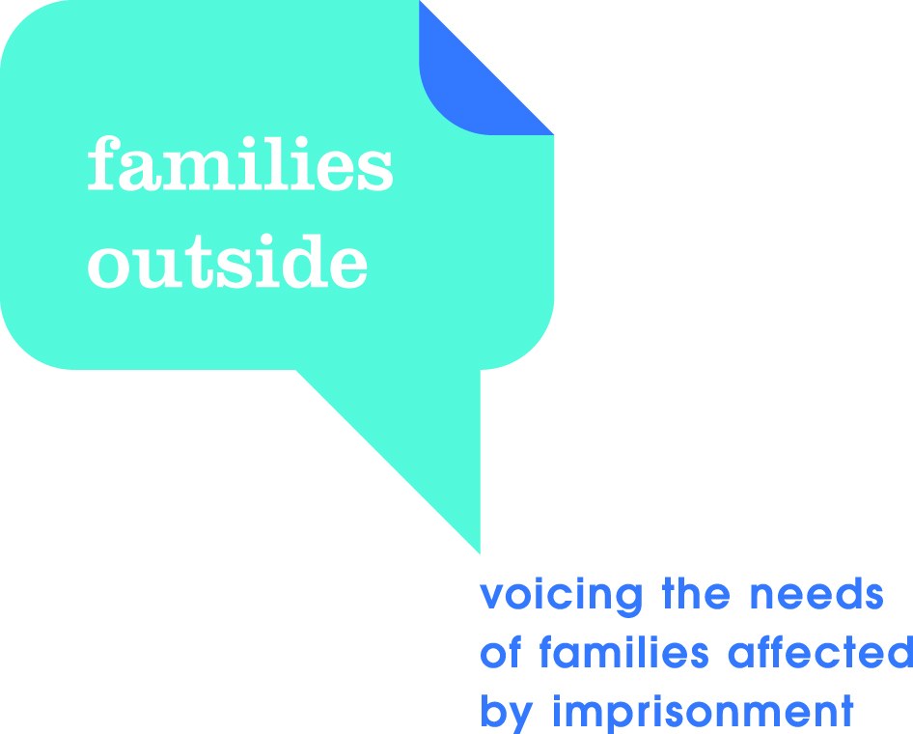

In-prison CPD course

14th September 2017 at HMP Perth 3 Edinburgh Road, Perth, at 16.30-18.30.

Content:
Children with a parent in prison face significant challenges including trauma (making it hard for them to learn) and stigma (which can lead to behaviour problems and bullying). They are more likely to come from families with complex needs and are less likely to meet child well-being indicators. This CPD course offers:

- an opportunity to visit a prison and to enter into the stories of children affected;
- an insight into the issues facing children and families who have a close relative in prison; and
- practical ways in which teachers and school communities can help families affected.

Aims and outcomes:
Aim: To explore the impact that imprisonment of a close relative can have on children and to learn how school communities can provide key support for them and their carers.

Outcomes: Participants will:

- be more confident in how to engage, and support, children and families affected by imprisonment;
- understand the complex situations that families affected often experience;
- have a knowledge of resources and support available for schools and for families; and
- understand the importance of links between prison, support agencies and schools.

Further information:
As the session takes place inside a prison, course participants must arrive by the specified time. Participants should have photographic ID (e.g. driver’s licence) and are asked not to bring mobile phones or any other electronic equipment into the prison, this includes fitbit devices. Additionally please do not carry change in your pockets as this will delay the process of getting through security. It will not be possible to leave the prison before the end of the session.
10 places have been allocated to Angus school staff

Please contact Alita Spink, Schools and Learning Support Officer, Spinka1@angus.gov.uk by Monday 4 September 2017 if you would like to attend.

