The Zombie World
The dead can wander through time,
Everywhere the living will scream,
A rotten world,
From mindless mobs,
To a creature plagued with evil.
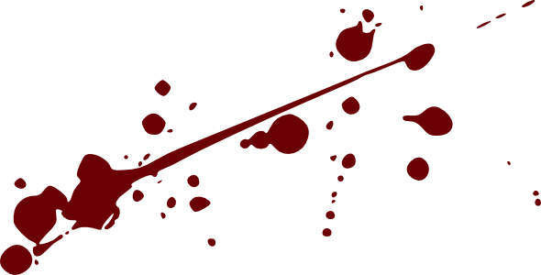
We’re all zombies in some way,
Soulless cadavers,
Looking for the next meal,
As we decompose into non-existence,
Slow and confused, we stumble across the world.

With only hunger for flesh,
And the thirst for blood,
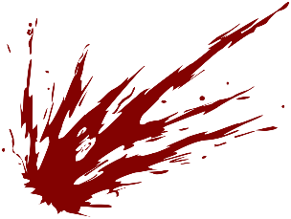
We infect each other with a single bite,
Only to create more monsters,
Until there’s nothing more.

Just flesh eating ghouls,
No heartbeats,
No breaths,
No thoughts,
Just kill and feast.

Lisa C (F7)

