EMAIL

EDUCATION
Director: Neil Logue

Angus House
Orchardbank Business Park
Forfar
DD8 1AE

T: (01307) 461460
F: (01307) 461848
Chief Executive
Richard Stiff
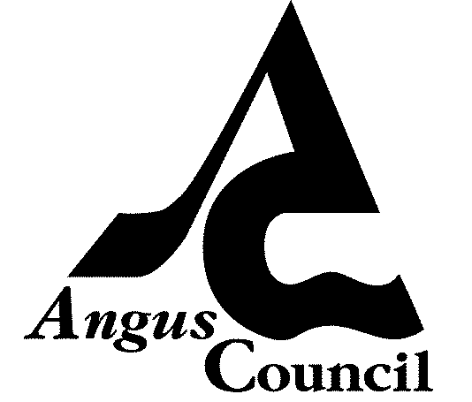

www.angus.gov.uk

NL/AM

29 June 2011

To All Parent Council Chairpersons

Dear Sir/Madam

MEETINGS WITH PARENT COUNCIL REPRESENTATIVES, OCTOBER/NOVEMBER 2011

I wish to thank Parent Councils for the strong support for last month’s meetings.

Senior Management Team colleagues and Quality Improvement Officers greatly appreciate the very thoughtful and helpful feedback which we received in the course of what we felt were very positive and productive discussions at each of the meetings held respectively on 25, 26 and 31 May 2011.

I will issue under separate cover the overall summary of the key issues explored at these events. Please note that the summary will also be posted on the Parent Council Blog.

It is our intention to hold the next round of meetings of Parent Council representatives in late October/early November. The meetings will follow the same pattern used for the May meetings. That pattern seemed to meet with the general approval of representatives who attended the May meetings. The arrangements for the forthcoming meetings are as follows:

1 Brechin, Forfar, Montrose and Kirriemuir Primary School Parent Councils – Tuesday 25 October 2011, 7.15 – 9.30pm, Strathmore Primary School, Forfar

2 Arbroath, Carnoustie and Monifieth Primary School Parent Councils – Wednesday 26 October 2011, 7.15 – 9.30pm, Woodlands Primary School, Carnoustie

3 All secondary school Parent Councils – Wednesday 2 November 2011, 7.15 – 9.30pm Carnoustie High School

2

29 June 2011

Parent Council Chairpersons

I will write to you early in the new session to request suggestions for agenda/workshop items. In the meantime, I wish to place on record the education authority’s gratitude for the enthusiastic and diligent support which Angus Parent Councils give so readily to our schools. That support is always gratefully received and is a major boost to staff and pupils at a time of major change in school education. Many, many thanks to each Parent Council.

Yours sincerely

Neil Logue
Director of Education

cc Primary Head Teachers
Secondary Head Teachers
Craig Clement, Senior Education Manager
Susan Duff, Senior Education Manager
Maxine Cottiss, Quality Improvement Officer
Ken Edwards, Acting Principal Quality Improvement Officer
Lisa Heald, Acting Quality Improvement Officer
Colin Nicol, Quality Improvement Officer
Gregor Robson, Quality Improvement Officer
Gillian Strachan, Principal Officer, School & Family Support Service
Angela Dunlop, Administrative Officer

