18 May 2011

To Parent Council Secretary

Dear Colleague

DEVOLVED SCHOOL AND PARENT COUNCIL BUDGETS

Following informal discussions with parent council members and requests to provide more information in relation to schools budgets I have attached a copy of the schools Devolved Budget for 2011/12. It would be helpful if you could arrange for this to be circulated to your Parent Council Members and discussed, as appropriate, at your next council meeting.

The devolved budget consists of budget heads to cover the different types of expenditure incurred by the school. A number of factors are used to determine how the budget is calculated, with the school roll being a key factor (the September 2010 Census has been used in determining the 2011/12 budget).

I have also attached the following documents for information:
- Parent Council Budget/Actual Expenditure 2010/11
- Parent Council Budget 2011/12

Due to the savings targets, the Parent Council expenditure budget has been reduced slightly for 2011/12. As in previous years any unused portion of the expenditure budget will be added to the school Per Capita budget in the next financial year.

The administrative procedures and blank expense claim forms can now be downloaded from the documents section on the Parent Council Blog at: https://blogs.glowscotland.org.uk/an/AngusParentCouncilGroup/
or through the link to the blog on the main Angus Council website at http://www.angus.gov.uk/ParentsAsPartners/default.htm

If you have any queries on the enclosed budgets or would like a member of the Education Financial Services team to attend a Parent Council meeting to provide further detail please do not hesitate to contact Kim McAully on 01307 476316 or myself on 01307 476333.

Yours sincerely

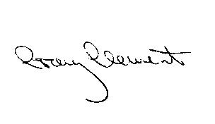

Craig Clement
Senior Education Manager

