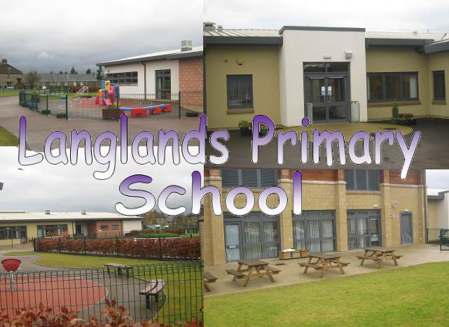

Handbook 2016-2017



**Address** Glamis Road, Forfar, DD8 1JY

**Telephone Number** 01307 473230

**Website** [www.langlands.angus.sch.uk](http://www.langlands.angus.sch.uk)

**Email Address** LanglandsPS@angusschools.org.uk

**This document is available in alternative formats, on request**

**(Please contact the Head Teacher)**

**CONTENTS**

* Angus Council Information:
  + Contact Details:   
       
    Angus Council People Directorate   
    Angus House   
    Orchardbank Business Park   
    FORFAR   
    DD8 1AN   
    Tel: 01307 476337   
    Fax: 01307 461848   
    Email: People@angus.gov.uk

**Angus Council Contents page to be inserted by HQ**

**CONTENTS (cont)**

* School Information:
* Welcome
  + - School Information
    - Contact Details
* Langlands Staff Team
* Visits of Prospective Parents/Carers
* School Uniform/P.E. Kit
* Parental Concerns
* The Complaints Procedure
* Parental/Carer Involvement – Becoming Involved in School
* School Ethos
* School and Community Links
* Positive Behaviour Management
* Celebrating Achievement
* Extra-Curricular Activities
* Pupil Council / Pupil Involvement
  + - What Do Our Pupils Think Of Our School?
* Learning Opportunities
  + - The Pupils and Parents/Carers Voice
    - The Curriculum at School, Local and National Level
* Liaison with Secondary School
* School Improvement
  + - Main Achievements
    - Improving Standards
    - School Improvement Plan
* Health Care

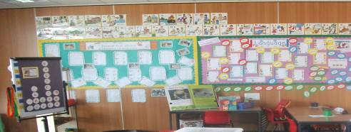

**Welcome to Langlands Primary School**

Dear Parents/Carers and Families

Welcome to Langlands Primary School. I am delighted to have your child join us and hope that he/she will enjoy being a pupil here. It is our aim to provide a safe, happy, supportive and welcoming learning environment. Our priority is to provide a high quality educational experience for our pupils.

Langlands is a modern, attractive school with excellent facilities. The staff take pride in promoting and encouraging a positive and inclusive ethos where pupils’ good behaviour, effort and achievements in and out of school are recognised and celebrated. As a specifically resourced school, we provide facilities for pupils with additional support needs.

We wish to work in partnership with you for the benefit of your child so that they can make progress socially and in their learning. Effective home/school communication is extremely important so please contact the school if you have any concerns. We prefer to deal with any issues which arise at as early a stage as possible.

I hope that you will find this handbook helpful and informative about Langlands school. If, however, you have any questions or require further explanation or guidance, please do not hesitate to contact me.

Once again, on behalf of the staff, I extend a warm welcome to you and your child.

Yours sincerely,

Karen Tough

Acting Head Teacher

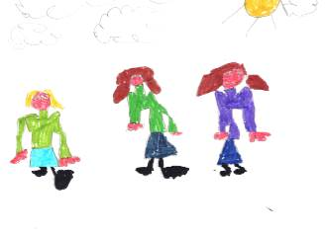

**CONTACT DETAILS**

**School Name :** Langlands Primary School

**Address:** Glamis Road, Forfar, DD8 1JY

**Telephone Number:** 01307 473230

**Website:** <https://blogs.glowscotland.org.uk/an/langlandsprimaryschool/>

**Twitter:** @LanglandsPS

**Email Address:** LanglandsPS@angusschools.org.uk

**Head Teacher’s name:** Mrs K. Tough (acting)

**Class Stages:** Nursery/ Primaries 1 - 7

**Present Roll:** Nursery 59

P1-7 432

**Parent Council:** Chairperson: Mrs Leanne Urquhart

**School Hours:**

Morning session Nursery 8.45am – 11.55am

P1 – 2 9.00am – 12.20pm (interval 10.30 – 10.50am)

P3 – 7 9.00am – 12.30pm (interval 10.30 – 10.50am)

Afternoon session Nursery 12.20pm – 3.30pm

P1 – 2 1.30pm – 3.10pm

P3 – 7 1.30pm – 3.20pm



**Langlands Staff Team**

**Head Teacher:** Mrs K. Tough (acting)

**Depute Head Teacher:** Mrs L. Allardice (acting)

**Principal Teachers:** Mrs K. Reid

Mrs J. Carlin (acting)

**Teachers:** Mrs C. Allan (part time) Miss M. Barrie

Mrs L. Brown Mrs L. Christie (part time) Miss M. Cochrane Miss K. Coulthard Mrs R. Crabb Miss A. Dewar (part time) Miss C. Feeney Miss A. Ferrie Mrs J. Henderson (part time) Miss K. Hosie Miss A. Jamieson Mrs C. McIntosh Mrs G. Mayes Mrs L. Paterson (part time) Miss A. Robertson (part time) Mrs K. Smith Mrs S. Stewart (part time) Mrs K.Whyte Miss J. Young

**Additional Support** Mrs J. Batchelor (part time) Mrs C. Donnachie (part time)

**Needs Teachers:** Mr D. Patterson Mrs F. Douglas (part time) Mrs K. Ferguson (part time) Mr E. Nicoll

Miss C. Thomson (part time)

**Visiting Teachers: Art:** Ms Rae

**Kodaly:** Mrs Branney

**Music:** Miss Boyle

**Physical Education:** Mrs Ford

**Senior Clerical Officer:** Ms J. Fenty

**Clerical Assistant:** Mrs L. Aitken

**Senior Early Years Practitioner:** Mrs L. Tyrie

**Early Years Practitioners (pre-school):**           Mrs M. Milne

                    Mrs L. Watson     Mornings only

                    Mrs M. Forbes     (Supply)

                    Mrs K. Skinner      (Supply)

                    Mrs K. Gray               fulltime

**Early Years Practitioner (Nurture):** Mrs S. Menzies

**Early Years Assistant (pre-school):**             Mrs A. Findlay

**Modern Apprentice (Early Years):** Miss K. Roy

**School and Pupil Support Assistants:** Mrs F. Beaton, Mrs N. Cattanach

Mrs G. Colquhoun Mrs G. Chalmers

Mrs I. Craske Mrs L. Cromar Mrs P. Dalgarno Mrs T. Davidson

Miss S. Doig Mrs D. Hood Mrs M. Menzies Mrs L. Robertson Mrs A. Ross Mrs S. Smith, Ms M. Szymaszek Ms C. Tavendale

Mrs A. Thomson Mr. K. Walling

Mrs A. Walker (First Aider)

**Instrumental Instructors:** Violin: Mrs Grant

Brass: Mrs Hendry

**School Chaplain:** Rev. Maggie Hunt

**School Crossing Patrol:** Mr R. Clark

Mrs H. Forbes

**Janitors:** Mr D. Murray

Mr N. Conley

(employed by Robertson Facilities Management)



**VISITS OF PROSPECTIVE PARENTS** – see link below:

http://www.gov.scot/Publications/2010/11/10093528/0

Once your child has been allocated a place you will be invited along to meet the staff and children, to find out more about the curriculum and to share information about your own child. Please telephone the school office beforehand to arrange a suitable time for your visit. When you arrive at school you will be asked to sign in at the school office for security reasons.

**SCHOOL UNIFORM**

We encourage pupils to wear school uniform as we feel it has a positive impact on school ethos and pupil behaviour. From time to time pupils will be asked to wear casual, fancy dress or sports clothes for fun, charity or sporting activities.

The school sweatshirts are purple with the school badge which was designed by a former pupil for the new school. School trousers are black or grey and shirts or polo shirts are white. The school tie is striped in black, yellow and purple. The uniform can be bought from J.P. Whyte in Forfar and is also available online from Tesco’s website [www.tesco.com/ues](http://www.tesco.com/ues).

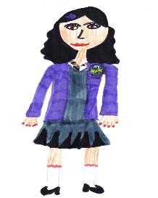

# PE Kit

Pupils have PE sessions every week and should have a gym kit available in school. This should consist of a white t-shirt, black shorts and gym shoes within a named bag. A drawstring type which can be hung from a peg is ideal. We also make use of the playground for PE sessions and joggers and a sweatshirt would be advised when the weather is colder!

**All** clothing brought to school should be named or marked in some way, as it can be difficult for children to distinguish their own clothing from others. Lost property is kept in school for a month in a specified area for pupils and parents/carers to check. Any valuables found e.g. watches & jewellery are held in the school office. Children should check immediately if they have lost any clothing or other property. You can help by encouraging your child to be responsible for looking after his/her belongings.

**PARENTAL CONCERNS**

We encourage all parents/carers to contact the school immediately if they have a cause for concern or complaint. It is our wish to deal with all matters as early as possible to prevent them from growing into significant concerns. Please contact your child’s class teacher in the first instance or, if you would prefer to discuss the issue with a member of the management team, please contact the school office and someone will get back to you to arrange a suitable time for a meeting. If it is more convenient the matter can be discussed by telephone.

The staff will listen to your concern and agree a way forward with you. They will follow-up the initial conversation with a telephone call approximately one week later to ensure all matters have been resolved satisfactorily.

**THE COMPLAINTS PROCEDURE** – also see link below:

https://www.angus.gov.uk/council_and_democracy/complaints_and_comments/making_a_complaint_or_comment_about_our_services

For further information please see the Angus Council Information section or contact the school.

**PARENTAL INVOLVEMENT**

**BECOMING INVOLVED IN SCHOOL**

The school values the important part that parents/carers play in their children’s education and sees partnership with parents/carers as an effective way of enhancing children’s achievements and promoting better school ethos and communication. Opportunities for parents/carers to become involved include:

* Open mornings/afternoons
* Volunteers to help with activities e.g. swimming, paired reading
* Making resources
* Helping in classrooms e.g. games
* Assisting with clubs
* Fundraising events
* Parent Partnership groups



* Trips e.g. sporting events, educational visits

**If you wish to be a regular helper, PVG (Protecting Vulnerable Groups) checks have to be completed. Please discuss this with staff.**

All parents/ carers are invited to attend two Parents’ Evenings during the year, generally in November and March. Parents’ nights for Primary 1 classes are usually a little earlier in the school year, in September. At these meetings parents/carers will have the opportunity to meet their child’s class teacher for a 10 minute interview and hear about their child’s progress. This is also an opportunity for parents/carers to hear how they can best support their child’s learning. Parents/carers are also encouraged to look at their child’s Learning Log with their child and support as appropriate the completion of homework tasks as advised by the school.

Parents/carers of children in the nursery class are given several planned opportunities over the session to discuss their child’s progress and development. Information about children’s learning activities can also be found on the nursery display board and in regular newsletters.

The parents/carers of pupils requiring extra support, who have their education delivered through an Individual Education Plan (IEP), are offered meetings with teaching staff to agree suitable learning targets.

We also have a very active Parent Council which:

* Represents the views of all parents/carers
* Encourages links between the school, parents/carers, pupils, pre-school groups and the wider community
* Helps to raise funds through social events for children and families
* Supports the school in its work with pupils
* Plays a role in the appointment of head teachers and depute head teachers

Recent fund raising events have included discos, raffles, a candle party and a bingo tea. Donations from our Parent Council have supported a wide range of school activities including school trips, playground equipment, sports strips, workshops and the buying of new laptops.

Our current Chairperson is Mrs Leanne Urquhart. If you wish to contact her, this can be arranged through the school office. New members are always welcome to the regular meetings.

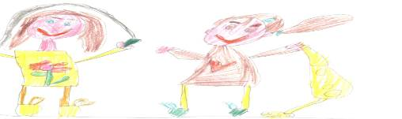

**SCHOOL ETHOS**

In our school we are committed to providing appropriate opportunities for the development of pupils’ spiritual, moral, social and cultural values through both the ethos and the curriculum. This will be undertaken in partnership with parents/carers and will take account of the individual needs of pupils and the views of parents/carers.

Our school welcomes and encourages diversity and individuality, while emphasising our common commitment to moral values such as honesty, respect for others, compassion and justice. It is a fundamental principle of our school that all who are involved in the life of our school both have the right to be respected as individuals and carry the responsibility to act in a considerate and respectful manner towards others. We implement Angus Council’s policy for Equal Opportunities and Racial equality and ensure that all pupils have access to the full range of educational experiences available within the resources of the school. We are firmly committed to the elimination of any form of discrimination on the grounds of race, religion, gender or disability.

The HMIE inspection carried out in May 2010 recognisedthe ethos in Langlands and the support given to pupils as a key strength. A Supported School Review visit by Angus Council was carried out in May 2015 with a follow-through visit in March 2016.

As a specifically resourced school, Langlands welcomes pupils with a range of complex learning needs including autism. Staff are committed to the inclusion of all pupils in quality learning opportunities within the school and out in the local community.

**SCHOOL AND COMMUNITY LINKS**

Langlands School is an integral part of the community in Forfar. Children develop skills and learn to be better citizens as they engage with and support the work of the local community. Our pupils participate in community events and competitions organised by the church, library, Rotary Club, community council, Meffan Museum and Art Gallery and local supermarkets including Tesco and Adsa. Some of our pupil groups visit residential care homes to entertain the residents and many pupils also participate in a wide range of sporting and cultural events throughout the school year.

The Community Police Officers and Fire Officers work with pupils in the areas of personal safety, drugs education and fire safety. Pupils with additional support needs have opportunities to visit the park, cafes, supermarkets, horse riding and swimming pool to develop their life skills and independence as part of the curriculum.

Senior pupils from Forfar Academy visit the school to work with pupils in class and to support swimming sessions, sports’ days and trips outside school.

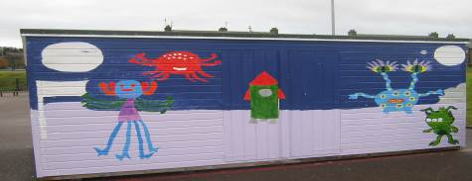

**POSITIVE BEHAVIOUR MANAGEMENT**

https://www.angus.gov.uk/schools_and_young_people/parent_and_pupil_guidance/anti_bullying_policy

Good behaviour is essential to good learning. The general aim of the school is to provide an atmosphere of mutual respect and collective responsibility. Pupils, parents and staff all have an important part to play in producing and sustaining this positive ethos. The rules of the school are of a common sense nature, bearing in mind the interest and safety of all concerned.

Children are required to be respectful to others in school including fellow pupils, to display good manners and to ensure that work and behaviour are such as to allow the teacher time to work with all children. We believe that everyone has the right to be safe and happy within Langlands Primary School.

Research carried out by and for the Scottish Government indicates that Restorative Approaches help schools to create peaceful learning environments in which children are Successful Learners, Confident Individuals, Responsible Citizens and Effective Contributors. Langlands Primary School uses Restorative Approaches to improve relationships and to promote positive behaviour. We encourage individuals to take responsibility for their actions and, when an action has caused harm, for those involved to have a responsibility to put things right. As a restorative school we place emphasis on making things better and moving forward rather than the traditional approaches to discipline such as blame and punishment.

On occasion we may draw your attention to a problem concerning your child’s behaviour in school in order that we can work together to improve the matter.

Class teachers award group and individual points, stickers, star of the day/week and other rewards to promote and recognise positive behaviour in the classroom. Class Dojo is also used as an electronic means of communication between home and school and points are awarded to pupils on the class Dojo for positive behaviour, effort and attitude.

Pupils who display positive behaviour in class and the playground are rewarded with Golden Time on a Friday afternoon. All pupils who have demonstrated good behaviour in the playground all week also have an extended playtime on a Friday.

P7 pupils act as ‘Playground Buddies’ to support the younger pupils in the playground and during breaks. Langlands Primary School has also implemented Peer Mediators to help pupils when minor conflicts arise and to support pupils in making good choices with regard to behaviour and attitude.



**CELEBRATING ACHIEVEMENT**

Children work hardest when they know their work will be appreciated and praised. All staff encourage pupils at all times and in all activities to give their best. Their effort may be rewarded verbally by praise, or non-verbally by a smiley face or sticker. Teachers also use group and individual points in class to promote and reward achievement and effort. Pupil of The Week certificates are awarded at assemblies and Pupil of the Month certificates are awarded at whole school assemblies for effort and commitment in an area of the curriculum monthly.

The whole school celebrates achievement at regular school assemblies. A “Read All About It” board is situated in the school where photographs and press cuttings are displayed. Monthly newsletters can include information about pupils’ achievements and parents/carers are encouraged to include wider achievements the termly Learning Logs which are sent home with each pupil.

Pupils are allocated to one of four houses, Glamis, Guthrie, Cortachy or Airlie. Prizes are awarded for sporting events, both team and individual and in P7 for effort and all round distinctive work. House points are also awarded to pupils who get Pupil of the Week certificates and to classes who demonstrate good behaviour and respect in the playground. We also award house points for using coloured bins in the playground to encourage the pupils to keep our playground tidy and to look after the environment.

The annual prize giving at the end of each academic year celebrates senior pupils’ achievements over the session with trophies for expressive arts, mathematics, writing and all-round excellence. A child from every class is nominated for a citizenship award, donated by St Margaret’s Church, and these are also awarded at the end of year prize giving.



**EXTRA-CURRICULAR ACTIVITIES**

There is a range of extra-curricular activities available for your child/ren to participate in at different times of the school year. These include:



* Athletics
* Basketball
* Coding Club
* Choir
* Cross country
* Dancing
* Football
* Library clubs
* Netball
* Rugby
* Sports Club
* Sewing Club

Pupils in P7 are given the opportunity to participate in a residential weekend at Dalguise, near Pitlochry, during the summer term each year.

**PUPIL COUNCIL**

There is an active Pupil Council at Langlands Primary School including representatives from all classes from P2-7. The Pupil Council members are elected by their class peers and they hold office for the duration of one year. Throughout the year they will meet regularly with a member of staff. They will be involved in taking forward school improvement priorities, giving feedback on policies reviewed and addressing emerging issues as they occur.

The Pupil Council have suggested a number of novel ideas for charity fund raising events, have been consulted on the school aims and also on improvements they would like in school. They are responsible for bringing any pupil’s concerns or suggestions to the attention of the school staff by making and encouraging their peers to use a class suggestion box.

In addition to the Pupil Council, pupils are also able to be involved in the life and work of the school through the eco and health groups. Every class can be represented and they, along with staff, are involved in taking forward developments and initiatives relating to the promotion of healthy lifestyles and environmental education.

Pupils in Primary 7 also have the opportunity to apply to be House Captains and Vice Captains. Senior pupils are encouraged to support younger children in the school and playground.





I like the Pupil Council because we get to try to sort things out and make things better. – P7 pupil

Our boys and girls try to be healthy. We learn about having good health and how to keep active – P5 pupil

I like learning to be more responsible. I like helping in the dinner hall and with the certificates. – P7 pupil

I like the clubs after school because they are fun and there are lots of different sports you can try. – P6 pupil

There are always people with smiles on their faces in our school. – P4 pupil



The teachers help us. –P3 pupil

I like the playground. – P3 pupil

I like that the Primary School Assistants help us when we are hurt or upset. – P2 pupil

**LEARNING OPPORTUNITIES**

Your child will learn in a variety of different contexts and groups including ability, co-operative and social. Teachers will share information about your child’s learning and progress through newsletters, class information sheets and pupil reports. Learning logs are sent home the second last Friday of every term and we would encourage you to discuss these with your child and add comments. Open mornings/afternoons are organised to allow you to see the work your child has been involved in. You will also have the opportunity to comment on the school during these open mornings/afternoons, should you so wish.

**THE PUPILS AND PARENTS VOICE**

We asked what our parents/carers want from our school. Their responses included ….

…to enjoy learning new topics and integrating with their peers.

….to do well at school and be safe.

….the chance to make good friendships

…to leave Langlands with lots of great memories.

…to be happy and make friends and to feel safe.

..a happy educational environment which allows pupils to thrive and enjoy their school experience.

Personalisation and choice is one of the seven principles of curriculum design and children and young people throughout their education will have the opportunity to discuss with their teacher the context in which they learn and how they will approach the learning. Teachers will share Learning Intentions and share or create Success Criteria with their classes for the majority of lessons. Staff will discuss new learning with the children at the beginning of a new topic and plan together the areas of specific focus e.g. World War 2 – The Battle of Britain. This will be shared with parents through class newsletters and homework diaries. Parents will be invited to support the learning by sharing resources from home e.g. ration book or visit the school to share a talk. Parents are also encouraged to add comments to their child’s Learning Log each term and to class comments boards during open mornings and other events.

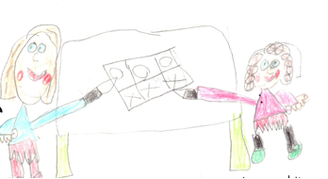

**THE CURRICULUM AT SCHOOL, LOCAL AND NATIONAL LEVEL**

**The Curriculum for Excellence**

The curriculum aims for all children to become:

**CONFIDENT**

**SUCCESSFUL LEARNERS**

**CONFIDENT INDIVIDUALS**

**EFFECTIVE**

**CONTRIBUTORS**

**RESPONSIBLE**

**CITIZENS**

**INDIVIDUALS**



**EXPRESSIVE ARTS**

**TECHNOLOGIES**

**HEALTH & LITERACY, SOCIAL STUDIES**

**WELLBEING ENGLISH &**

**MODERN SCIENCES**

**LANGUAGES**

**RELIGIOUS &**

**MATHEMATICS MORAL**

**EDUCATION**

Teachers will share information about your child’s learning and progress through learning logs, newsletters, class information sheets and pupil reports. Open afternoons and curricular evenings are organised to allow you to see the work your child has been involved in.

The school website, Twitter site and Dojo are also sources of information, illustrating the work of all classes across the school.

More local information can be found out from the school or local council and national information from the numerous sources listed at the back of this handbook.



**LIAISON WITH SECONDARY SCHOOL**

The school maintains close links with Forfar Academy (01307 475900) and other Primary Schools within the Angus area. A programme of activities are arranged to ensure a smooth transition from primary to secondary. Our teachers and in some cases our pupils visit other schools and establishments and other teachers and pupils visit us. This process is necessary for the professional development of staff, reciprocal understanding and the establishment of curricular consistency. Forfar Academy May be contacted by telephoning 01307 475900 or via email (ForfarAcademy@angusschools.org.uk).

It should be noted that opportunities for enhanced transition is available for children as

required. Should you feel your child may benefit from enhanced transition, please speak to a member of the school management team.

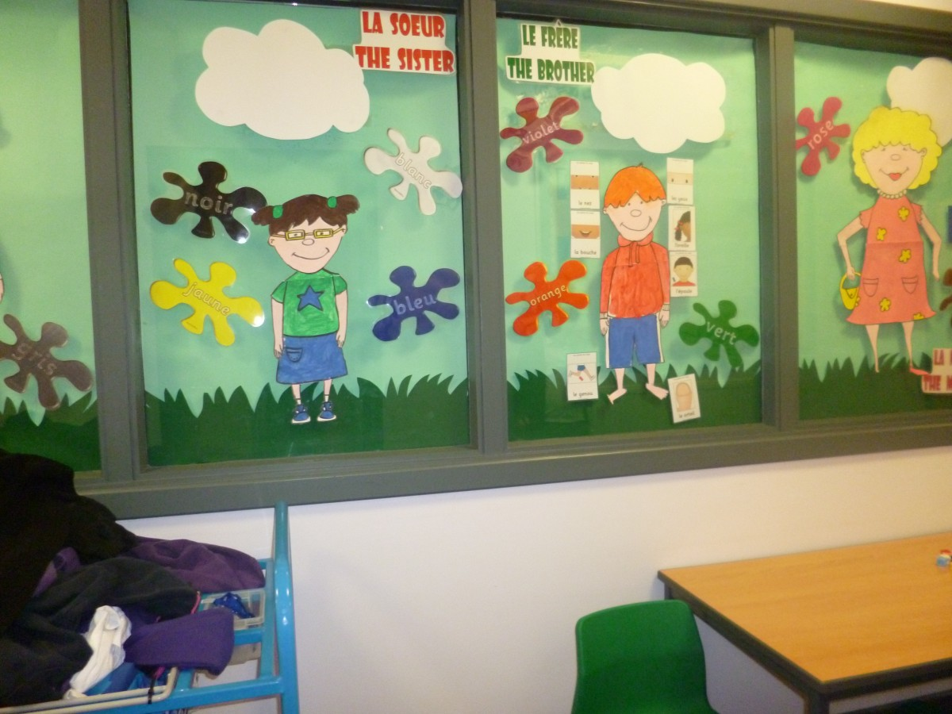 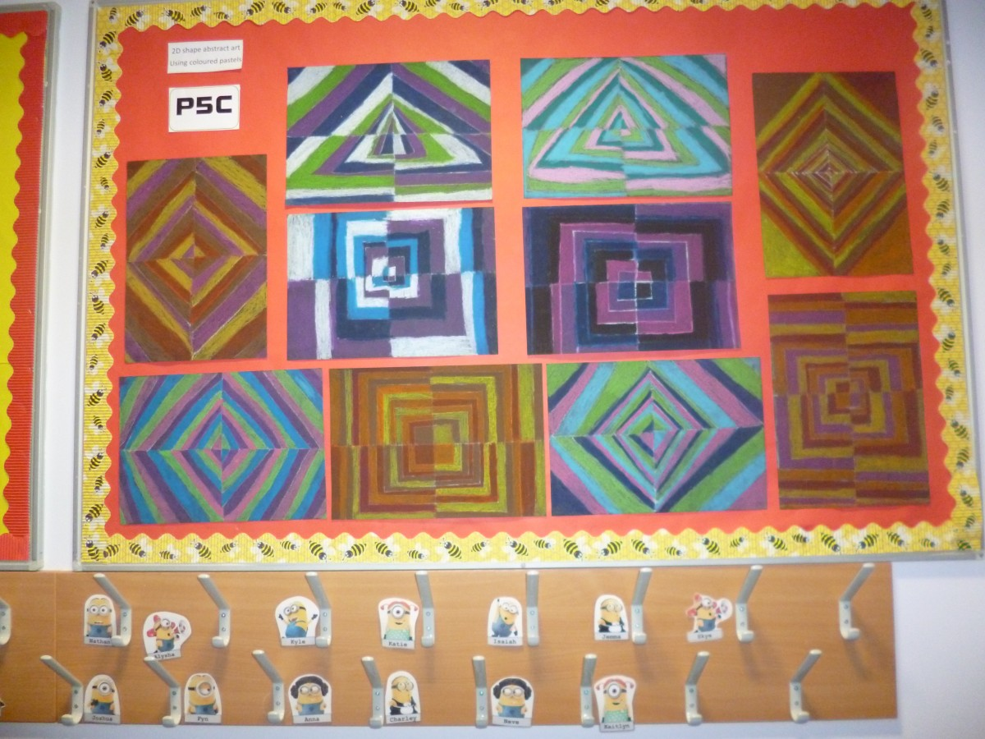

**SCHOOL IMPROVEMENT**

**MAIN ACHIEVEMENTS**

* Positive relationships are evident at all levels in the school and there is a welcoming and supportive ethos. Having a Growth Mindset is promoted at all stages to encourage pupils to view mistakes as a key part of learning and to undertake more challenging learning tasks.
* Staff are engaged in professional learning and discussion using current research. Staff have undertaken training in Visible Learning to improve the feedback they give to pupils and to support them in setting their own learning goals.
* Extra-curricular clubs in football and athletics have been set up for pupils in P2-4 with input from older pupils.
* Consistent teaching approaches are used in all classes and joint planning has improved transitions between stages. Through rigorous assessment and monitoring procedures we look to continue to raise attainment for all pupils and use targeted support for identified pupils when required. Targeted support has been provided using teaching strategies such as paired reading, maths buddies and Precision Teaching.
* The management team work well together to promote effective teamwork amongst staff and to provide support and challenge in taking the school forward. A three year strategic plan is in place to guide school development. Self-evaluation is used regularly and effectively to review and improve the work of the school.
* The Angus Standards and curriculum pathways are used during professional dialogues and attainment meetings to identify pupils who are on target to become secure at the end of a level. Promoted staff carry out learning visits to classes to monitor the quality of learning and teaching.
* Space is organised flexibly to meet the changing needs of pupils and the expanding school roll. Support staff are deployed effectively to meet the needs of groups and individuals. Langlands promotes an inclusive ethos and staff work effectively with other professionals to support individuals and families. Individualized Education Plans (IEPs) targets are specific and provide challenge.
* Staff working groups have taken forward developments in various curriculum areas. The school budget has been used effectively to provide teaching resources to support numeracy and literacy developments.
* The Parent Council has organised a range of successful events and has recently contributed funds to assist with the purchase of additional laptops to assist pupils’ learning and have made substantial contributions to school trips. They have regular fund raisers such as school discos and support the school throughout the year.

**IMPROVING STANDARDS**

* The management team has high expectations for the children of Langlands and is focused on improving outcomes for all learners. Staff are encouraged to take leadership roles in aspects of school improvement. They have led development projects in numeracy, literacy and PE.
* Teaching and support staff work well as a team and are committed to the work and life of the school. There is a strong sense of collaboration and staff work with partners and other professionals to support pupils and families.
* PIPS & INCAS and professional discussions about pupil attainment with staff are used to identify learners who require targeted support.
* Paired reading, buddy reading, number partners have had a positive impact on pupils’ attainment.
* Some staff have been trained in ‘Precision Teaching’ which has resulted in improved outcomes for identified pupils in phonics, spelling, and aspects of numeracy.
* Pupil focus groups have been set up to allow pupils to discuss their learning with promoted staff.
* Class dojos are used to recognise effort and achievement in some classes and blogs and Twitter share pupils’ learning with parents.
* ‘LALA’ maps (Learning Anywhere, Learning Anytime) and learning logs are used to celebrate wider achievement and parents are invited to P1-3 assemblies to see pupils receiving certificates.
* The P6 classes have set up and run community cafes.
* Good links have been established with Forfar Removals, Tesco, Care homes, library, Yoga Space and Riding for the Disabled.

For more information, copies of the current School Standards and Quality Report are available on request.

**SCHOOL IMPROVEMENT PLAN**

Priorities for inclusion in our 2016/2017 School Improvement Plan include:

* Raise attainment in functional writing and technical skills
* Further improve teachers’ feedback to pupils about their learning
* Involve parents, carers and partners more in the work of the school through participation in the ‘Partnership Schools’ project
* Review the school aims in consultation with staff, pupils and parents
* Develop the school grounds to provide opportunities for outdoor learning
* Review and improve communication with parents and carers about pupils’ learning and the work of the school
* Increase pupils’ engagement in learning through Growth Mindset and Visible Learning approaches
* Introduce the ‘Early Years Reading Toolkit’ at nursery and Primary 1

Further priorities identified for the next three years include:

* Involve pupils in contributing to the School Improvement Plan.
* Develop strategies to involve pupils and parents in self-evaluation and inform school improvement through ‘Partnership Schools.’
* Further training for staff in Visible Learning and current research.
* Introduce pupils to the ‘Developing Young Workforce’ initiative.
* Develop strategies to involve pupils and parents in self-evaluation and inform school improvement through ‘Partnership Schools.’
* Target funds to develop outdoor learning opportunities.
* Involve local businesses and organizations in developing outdoor learning.
* Review and improve communication between home and school.

# HEALTH CARE

**You can contact your school health staff at: -**



Whitehills Health and Community Care Centre

Station Road

Forfar DD8 3DY

Telephone 01307 475265

The school nurses for Langlands Primary School are:

Carol Paterson, telephone 01307 475274, [carolpaterson@nhs.net](../Staffhome/LANReidK/2015.16%20session/Handbook/carolpaterson@nhs.net)

Susan Mercer, telephone 01575 577016, [s.mercer@nhs.net](mailto:s.mercer@nhs.net)