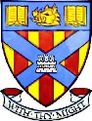

EXTRA CURRICULAR ACTIVITIES

Day | Activity | Adult and Information
Mondays | P5-7 Football | Mr Kelly  3.15pm – 4.15pm in the gym
 | Choir | Miss Callaghan/Miss Donkin  In Room 13 until 4.15pm  Please pick up your child
Tuesdays | P3 Tennis  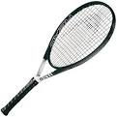 | Professional Coach from Give It Your Max charity  3.15pm – 4.15pm in the gym
Wednesdays | P5-7 Netball | Miss Carle/Miss Story  3.15pm – 4.15pm in the gym
Thursdays | Cross Country training | Mrs Gray  3pm – 4pm starting in the gym

