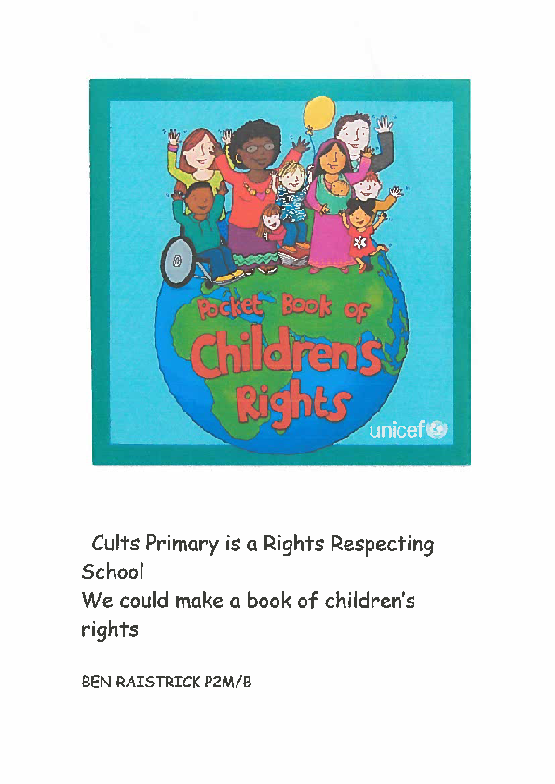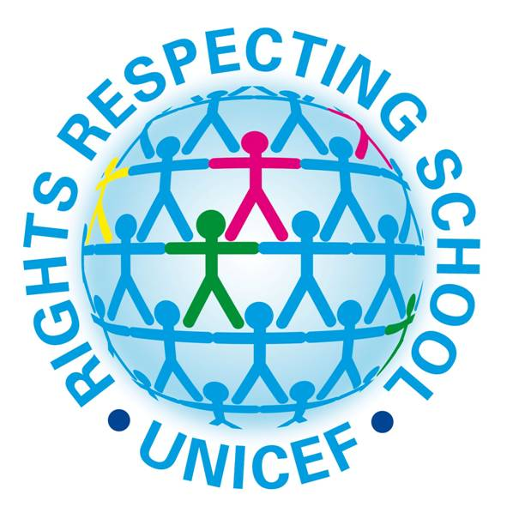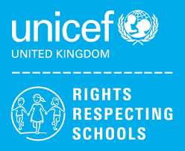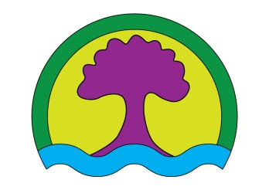<EMPTY>

Cults

Primary School

Our Aims

• to share the Rights Respecting School information with our class

• help everyone to understand their rights

• learn how everyone can access their rights

• Share UNICEF’s work