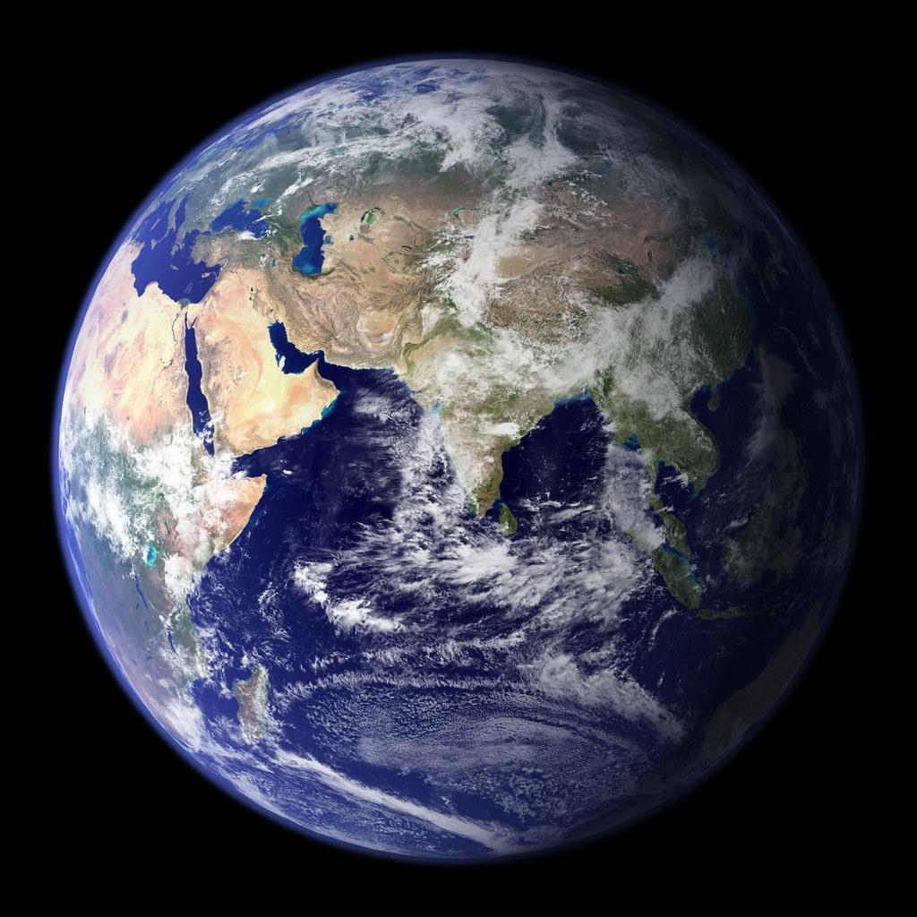
Focus-  - Earth's Materials- rocks  - Cross Section of Earth  Having explored the substances that make up Earth’s surface, I can compare some of their characteristics and uses. SCN 2-17a  Keywords-  Rocks  Minerals  Igneous  Metamorphic  Sedimentary  Fossil  Core  Mantle  crust |  | Abbotswell Primary School  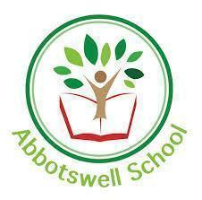  Natural  Topic Grid  Week 4- Earth’s Materials
Monday:  Earth's Spheres.  Lesson video  Workbook  Outdoor  learning activity | Tuesday:  Earth’s Structure  Lesson video  Workbook  challenges |  | Wednesday:  Rocks & Fossils  Lesson video  Workbook  experiments | Thursday:  Soil  Lesson video  Workbook  Experiment | Friday:  EARTH  Research and produce a factsheet

