I can identify and classify examples of living things, past and present, to help me appreciate their diversity. I can relate physical and behavioural characteristics to their survival or extinction. SCN 2-01a  I can use my knowledge of the interactions and energy flow between plants and animals in ecosystems, food chains and webs.  SCN 2-02a  By observing and researching features of our solar system, I can use simple models to communicate my understanding of size, scale, time and relative motion within it. SCN 2-06a |  | Abbotswell Primary School  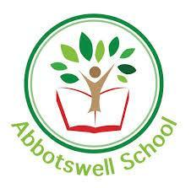  February ‘Natural’ Topic Grid  Week 5.
Monday:  Introduction to classification.  House and garden safari and creation of living thing factbook with:  Animal/plant/micro-organism, vertebrate/invertebrate, next level, name etc. | Tuesday:  Classification continued. Use the zoo webcams and pick 3 animals to complete factsheets on. |  | Wednesday:  Ecosystems and food web introduction and creation of a simple food web. | Thursday:  Ecosystems and food webs continued. Creation of larger food web. | Friday:  Venus.  Research and produce a factsheet, model, poem/song/rap or video including facts about Venus.

