Focus- Inheritance  - lifecycles  - characteristics  Learning Intention-  - To recognise the features of a life cycle  - To understand inheritance of characteristics  - To observe the features of the planets of our solar system |  | Abbotswell Primary School  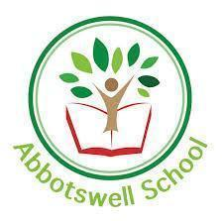  Natural  Topic Grid  Week 1 |  |  | What will you do?  Each day you will do a very quick research task into the topic of the day.  Then, using your creative skills and the resources you have you will show what you have learned or you may need to complete a quiz or a check up or have a chat with your family!
Monday:  KWL  Mindmap / Jamboard | Tuesday:  Life Cycles of animals  Create a diagram of the life cycle of one of the animals |  | Wednesday:  Life Cycles of plants  Watch the video  Ordering task  Quiz  Answer the question: | Thursday:  Inheritance -  Watch PowerPoint  Look at the poster  Prediction worksheet  Track the eye colour of your family |  | Friday:  Space - Mercury  Research and produce a fact sheet, model, poem, song, rap or video including facts about Mercury

KWL grid  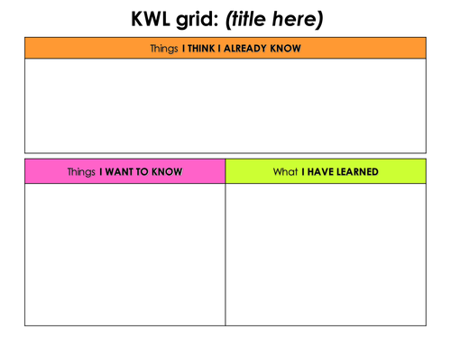Jamboard 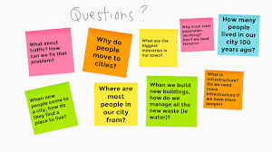 | Life Cycle 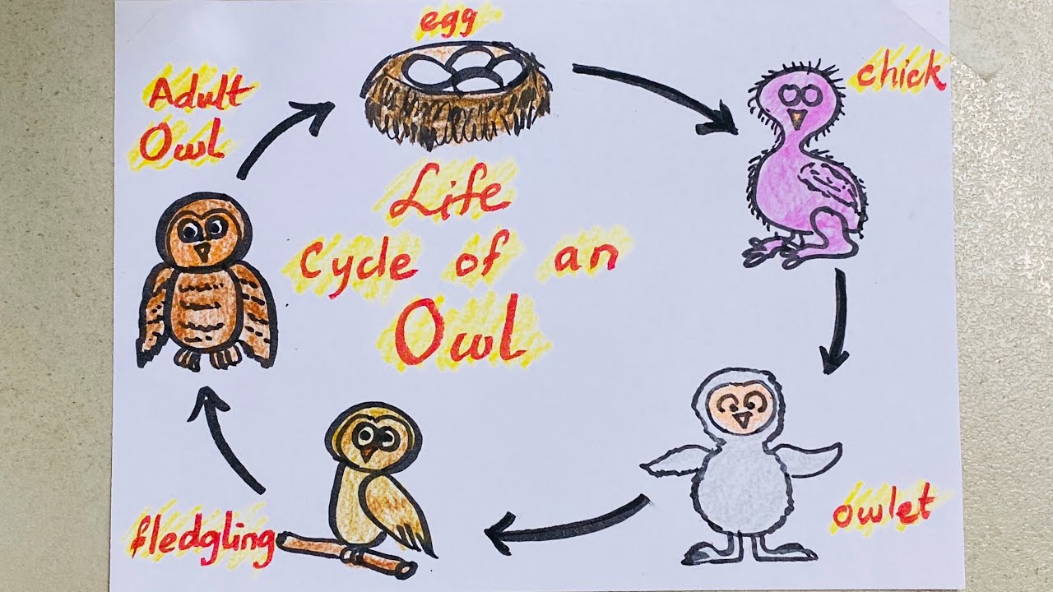
Mnemonic for the order of planets in space  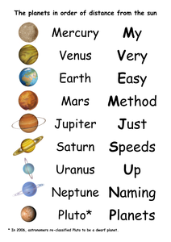 | Fact File Template  