Activity 1 Monday  Make your country’s national flag.  Use items from around the house to make your country’s flag design. You could also use art materials to draw or paint it. | 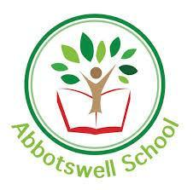  Abbotswell Primary School- P5  January ‘Around the World’ Topic Grid  Week 3  I can display my knowledge of my chosen country creatively | Activity 4- Thursday  Make a famous building from your country.  Find a famous building or landmark in your country and make it out of materials around the house. Take a photo and send it in.
What will you do?
Each day you will do a very quick research into something related to your country. Then, using your creative skills and the resources you have you will show what you have learned.

You could draw, paint, sculpt, build (Lego, blocks, stones etc.) make transient art, sew, video, sing, write, collage, cook – whatever you are able and allowed to do at home.

Activity 5 Friday-

Make your country’s national animal.

Find out what the national animal of your chosen country is and draw or make your own version. Send in your pictures.
Activity 2 Tuesday-.
Make a famous piece of artwork from your country.

Research a famous piece of art from your country and recreate it as closely as you can.
.
Activity 3 Wednesday-

Make a version of your country’s national dress.

Find out about the national dress of your country and try to make your own version.

