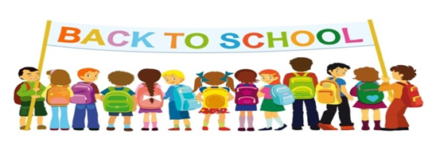
Primary 3 Newsletter
Welcome to P3! I hope you all had an enjoyable holiday and are looking forward to the year ahead. This is what we will be learning about this term.
Topic
Our topic this term is based on the novel ‘George’s Marvellous Medicine’ by Roald Dahl. This term our curriculum focus is Literacy. However we will also be looking at the underlying themes within this novel such as friendship, feelings and safety. We will be working within the First Level of Curriculum for Excellence.
Maths
This term in Maths each group will be focusing on number work including place value, addition and subtraction, multiplication and division. In practical Maths we will be learning about 2D and 3D shapes and their properties. The class will also use ‘Big Maths’ throughout the week to improve mental calculations. A list of ‘Learn Its’ for the year will be sent home. Please use this to help practise the Learn Its.
Language
In spelling we will be following the Active Literacy programme. We will learn a new phoneme and be given common words each week. In writing we will be learning how to improve our writing by using vocabulary. We will also learn how to set out a set of instructions and how to use bossy verbs. We will complete reading comprehensions in class based on your child’s reading book.
Timetable
We have a very busy timetable this term! Mrs Mathieson will be in class on a Monday for RME. This term’s focus will be on Judaism. Gym will be on a Monday, Wednesday and Thursday. Please ensure gym kits are in school on these days and are named.
Homework
Spelling homework will be set on a Monday and be collected on a Thursday. For spelling homework the children will have to write out their words three times and complete an activity with their spelling words which you will find at the front of your child’s homework jotter. Reading will be heard in class on a Tuesday and Thursday for the Gold and Orange reading groups. The Red, Yellow, Blue and Green reading groups will be heard on a Monday, Wednesday and Friday. Homework pages will be set on these days. Your child should bring their reading book to school every day. The Red, Yellow, Blue and Green reading groups will also have Word Walls sent home to practise. These should be taken to school every day. The reading records are an ideal place to make any comment on how you felt your child read. The children may also receive topic related homework throughout the term.
Please do not hesitate to contact me through the school office if you have any concerns, queries or something you would like to discuss.
Thank you
Mrs Stephen

