Primary 1 Newsletter
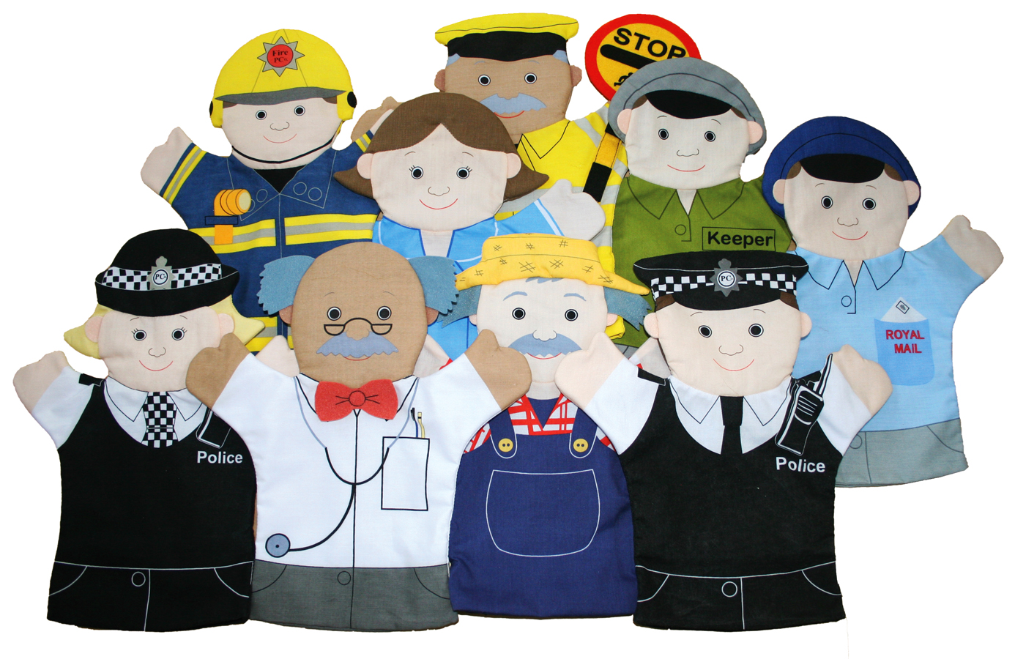

Dear Parents/Guardians, November 2018

I hope you have had a lovely and restful holiday. Welcome to Term 2 in Primary 1. We have another busy term ahead of us.

Our topic this term is ‘People Who Help Us’. Through this topic we will be developing our knowledge and understanding of our local community and the different roles people play within it. In this topic we will also be learning about shopkeepers and money. We will be learning what the money is used for and developing our skills in identifying coins and calculating coin collections.

Within Language and Literacy we will be continuing to develop our knowledge and understanding of sounds, following the Jolly Phonics Programme. We will be learning to identify the sound in words and how it is formed. The children’s sound book will be updated after each new sound. Please take time at home to go over the sound, action and formation. The songs associated with each sound can be found if you google ‘Jolly Phonics songs’. We will also be starting to learn common words.

This term we will be starting reading. Your child’s reading will be heard three times a week and they will get two reading books a week. Please ensure you take time to read the book with your child. You may also add comments regarding their reading in their reading record.

In Maths and Numeracy we will continue to be developing our understanding of numbers to 10: how they are formed, ordering numbers, counting and calculating one more and one less. We will also be developing our knowledge and understanding of 3D shapes and measurement.

In Primary 1 we will have P.E. on a Tuesday and Thursday. Please ensure your child has a named P.E. kit for these days and ensure that earrings are either covered or taken out.

Mrs Matheson will be taking the class on a Tuesday and will be teaching Literacy, Maths, P.E. and Music.

This year we will continue with using the Interactive Learning Diaries (ILD). The ILDs are a great way of sharing your child’s learning with you. They are online and therefore can be accessed at home. Those not already set up with an account to access them will receive a letter soon detailing how.

If you have any questions, please do not hesitate to contact me

Mrs Torrens

