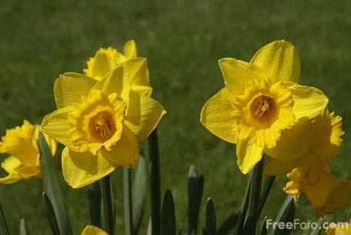

Dear Parents/Carers, April 2018
All the children have come back rested and ready to learn this term. It seems unbelievable that this is the final term of Primary One! There is a lot to look forward to this term, including Sports’ Day and the Primary One assembly. More information about these events will follow nearer the time.
Numeracy
This term some children will begin working on addition to 10 and other pupils will be moving on to subtraction from 10. We will also be exploring larger numbers and matching, ordering and reciting the numbers to and from 20. Please continue to help your child to practise recalling and reciting the addition number bonds which were handed out last term.
Literacy
This term we will continue to revise our initial sounds and practise using these to help us word build three and four letter words. Some children will also continue to increase the range of joined sounds that they are familiar with, using these to sound out to spell and read unfamiliar words. All pupils will continue to increase the range of common words that they can sight recognise when reading. All children will be developing their ability to locate specific words or pieces of information within a text and to summarise the main idea from a given section of their reading book.
Topic
This Term we will be exploring features of the Spring and Summer seasons. We will also be learning some of the names for parts of our body, how these parts work and how we can keep our bodies healthy. As part of our topic work each pupil will create a timeline of their life so far, using a range of evidence (e.g. certificates, photos, drawings) to show how they have grown and changed since they were born. Please provide 4-6 pieces of evidence for your child to stick onto their timeline by the week beginning 28th May. Please do not hand in your items before this week or provide items that are particularly large as we will be storing them in the children’s trays until we make the timelines.
We will also be exploring the five senses. As part of our work on the sense of hearing we will be making a model instrument from junk materials. Please provide a few junk items in a plastic bag which could be suitable to make an instrument e.g. tissue boxes, kitchen roll or toilet roll tubes, plastic tubs, cups or yogurt pots. Please bring in these items by 30th April.
If you have any questions please just ask,
Many Thanks
P1C and P1M

