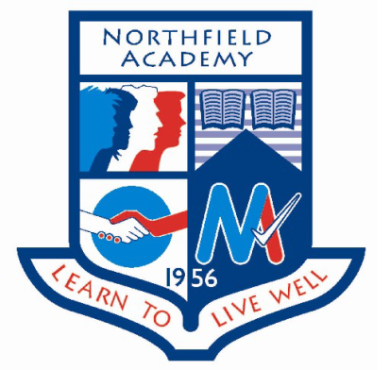

**Dates for the diary:**

**Wednesday 3rd May:** S2 Northern Lights group visit the RGU campus for the final time.

**Thursday 4th and Friday 5th May:** S3 SkillForce group residential

**Update on previous events:**

**Career Ready Graduation:** On Wednesday 19th April 7 S6 pupils graduated from the Career Ready Programme at a ceremony held in Perth. The graduation is the final part of a two year programme in which pupils get a mentor from industry, attend master classes and complete a paid summer internship all in preparation for the world of work. Congratulations to Robyn, Rianne, Cameron, Elisha, Dylan, Shannia and Shannon.

**Duke of Edinburgh Expedition:** On Thursday 20th and Friday 21st April 7 senior pupils took off on their final Bronze Duke of Edinburgh expedition to Bennachie. Whilst applying map reading, camping and outdoor cooking skills the group were also exploring team work and friendship, periodically opening envelopes with team building tasks set by teachers from across the school. Each member of the group was successful in passing this assessed expedition. Congratulations to Flynn, Robyn, Megan, Derryn, Travis, Jack and Gillian.

**Easter Revision School 2017:** Easter Revision School 2017 was a resounding success with 40% of S4-S6 pupils attending workshops to support their revision for the final exams. A huge thank you to the Parent Council who provided support in the form of stationery packs and snacks.

**Events happening this week:**

**Tuesday 25th April:** Aspire North Parent Drop in event for parents of S5/S6 pupils. This event will allow parents and pupils to ask the Aspire North team anything about going on to Higher or Further Education from applications to accommodation and funding.

**Tuesday 25th April and Thursday 27th April:** S1 Northern Lights workshop period 2 both days. In the final workshop of the year S1 pupils will reflect on their first year at Northfield Academy and set themselves future goals.

**Spotlight on Achievement**