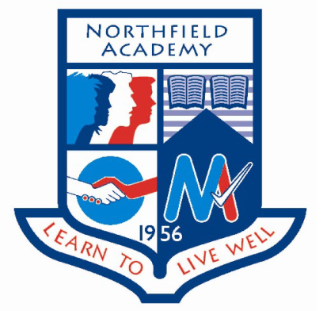

**Dates for the diary:**

**Wednesday 29th March:** S3 ASPIRENorth Try it out day at the University of Aberdeen

**Update on previous events:**

**S6 AspireNorth:** The S6 pupils had a workshop about study skills and finances. Pupils had the opportunity to learn how to apply for student loans and ask any questions about paying for further education.

**Easter School:** An assembly was held for all S4-S6 pupils to tell them about Easter School. Each pupil should have a letter to take home to parents and tutor teachers were issuing timetables and sign-up sheets last week. Pupils are asked to sign up by Friday 24th March to allow snacks and other resources to be organised. Spare letters, timetables and sign-up sheets can be collected from Miss Dean.

**Science in the library:** As part of British Science Week the library became a science lab at lunchtime on Wednesday 15th March. Pupils participated in a number of experiments not normally done in class.

**S5 Career Ready Students and Mentor meeting:** On Thursday the S5 cohort of Career Ready students met with their mentors to discuss their summer internships, references and application forms.

**BBC School Report day:** Headed by Miss Yule a group of pupils took part in BBC School report day writing a number of stories on a variety of issues. You can read their reports here <https://blogs.glowscotland.org.uk/ac/bbc2017/>

Particular highlights include an exclusive interview with Adam Rooney and Graeme Shinnie from Aberdeen Football Club, an interview with former head teacher Mr Hendry and student opinions on mental health and music.

**Events happening this week:**

**Friday 24th March:** Deadlines for pupil sign up for Easter School

**Spotlight on Achievement**