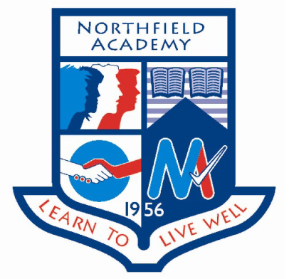

**Update on previous events:**

**S3 Careers in Health Event:** Four S3 pupils attended this event at RGU. They attended a number of workshops which explored different career opportunities working in the health professions. Favourite workshops included nursing and radiography.

**S5 AspirNorth:** The group had the opportunity to research courses and institutes to begin planning for leaving school.

**Go4SET Celebration and Assessment Day:** The team of five S2 pupils presented their final design for an island school, having worked on the project since November. The team designed a new school, researched building materials and sustainable energy and water sources and then made a model of their design, wrote a report and completed a presentation on the day of the CAD. Unfortunately the team did not win any of the awards this year but have completed a silver crest award.

**S1 Achievement Assembly:** An Assembly was held for S1 pupils to share some of their achievements so far at Northfield Academy. Certificates were given out for Maths round the stations, the famous Scottish Scientists project and John Muir Discovery Awards were presented to those pupils who completed the award during the visit to Loch Eil. All S1 pupils will have another opportunity to complete a John Muir Award at Discovery level in school.

**Dates for the diary:**

**Wednesday 1st March:** Career Ready Assembly for S4 pupils who are thinking about staying on for S5.

**Thursday 9th March:** S6 AspireNorth periods 2 and 3, the S6 group’s final workshop with the AspireNorth team.

**Spotlight on Achievement**