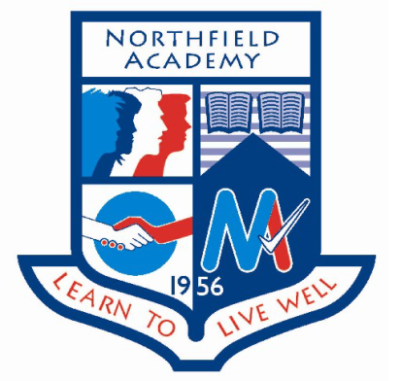

**Dates for the diary:**

**Thursday 9th February:** S3 Careers in Health Event: Four S3 pupils will attend an event focused on careers in health, the event is being jointly hosted by RGU and the University of Aberdeen.

**Thursday 16th February:** S5 AspireNorth periods 2 and 3 in C11.

**Thursday 16th February:** Go4SET CAD event. The final of the 2017 Go4Set project.

**Events happening this week:**

**Tuesday 31st January:** S1 Northern Lights workshop part 1 period 1 GP room. Part 1 of the next workshop for S1 looking at what makes a student.

**Wednesday 1st February:** Easter School Committee meeting 12.45pm Boardroom. A chance for the organising committee for the Easter Revision School to start planning for Easter Revision School 2017.

**Thursday 2nd February:** S1 Northern Lights workshop part 2 period 1 GP room. Part 2 of the next workshop for S1 looking at what makes a student.

**Update on previous events:**

**S2 Northern Light Campus visit:** The S2 Northern Lights Group visited RGU for the second time this year. This time they visited the computing faculty and participated in an Arduino workshop, where they programmed microcontrollers to complete specific tasks, a board game workshop and a workshop on digital painting. The group’s favourite was the digital painting. The S2 Northern Lights group have one more campus visit to the Health Sciences Faculty at the start of May.

**S4 AspireNorth workshop**: Pupils took the opportunity to think about what comes next including studying, senior school, college and employment opportunities.

**Great Scottish Scientists project:** Last term during their extra Science periods S1 classes completed research into a Great Scottish Scientist, they then turned their research into a graphic story of the scientist’s life. Mrs Wilson and Mrs Shaw judged the final pieces and a winner was selected from each S1 class. On Thursday 26th January Metaphorg presented the winners with signed copies of their book The Red Shoes and other tales. Congratulations to Ellie (1M1), McKenzy (1S1), Cerys (1W1), Nikkita (1S2) and Caitlin (1M2). The winning pieces are displayed with some others in the library.

**Spotlight on Achievement**