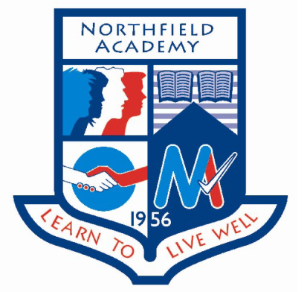

**Dates for the diary:**

**Tuesday 31st January:** S1 Northern Lights workshop part 1 period 1 GP room. Part 1 of the next workshop for S1 looking at what makes a student.

**Wednesday 1st February:** Easter School Committee meeting 12.45pm Boardroom. A chance for the organising committee for the Easter Revision School to start planning for Easter Revision School 2017.

**Thursday 2nd February:** S1 Northern Lights workshop part 2 period 1 GP room. Part 2 of the next workshop for S1 looking at what makes a student.

**Thursday 9th February:** S3 Careers in Health Event: Four S3 pupils will attend an event focused on careers in health, the event is being jointly hosted by RGU and the University of Aberdeen.

**Events happening this week:**

**Wednesday 25th January:** S4 AspireNorth workshop period 2 GP Room: Planning ahead workshop looking at subject choices and post school options with an introduction to the AspireNorth residential excursion.

**Wednesday 25th January:** S2 Northern Light Campus visit periods 2-6: An opportunity for the S2 Northern Lights cohort to visit the campus and participate in activities run by the computing department.

**Spotlight on Achievement**