P5/6 Newsletter

May 2017
Dear Parents,
Summer term is here already! What a quick year it has been in Primary 5/6
Health and Wellbeing
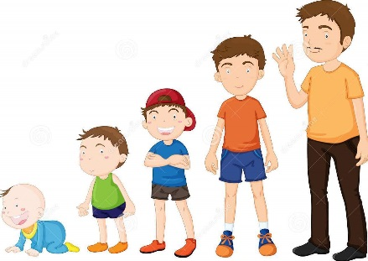
For this term the class will be studying living and growing. Primary 5 will be focusing on unit one. This will be looking at the differences in females and males. We will also be looking at how we got here and the changes from a baby to an adult.
In Primary 6 we will be focusing on unit two. We will be recapping what we learned in Primary 5 and furthering this by learning about how babies are made along with how babies are born. We will develop an understanding of what new-born babies need and discuss how these needs are different from us now.
We will be comopleting a short topic learning about the Global Goals and the link these have to the rights of the child.
Further in the year we will be developing an understanding of smoking and alcohol and the dangers that each can have.

Language
This term we will be developing our instructional writing. We will also be looking at persuasive language to persuade the reader about our views. We will continue to focus on our expression and fluency when reading.
We are continuing to focus on our novel ‘First aid for fairies and other fabled beasts’ by Lari Don. The children are finding it very exciting and are finding out about a variety of fabled beasts as the story progresses. In reading and spelling we will be following the Active Literacy Programme combined with the Reflective Reading strategies to improve understanding of a text.
Maths
This term in maths we will be focusing on measurement, area, and volume along with shape and pattern. We will continue to use the ‘Big Maths’ Programme to improve our mental maths. Every Friday the pupils will complete CLIC challenges and Total Recall Challenges and aim to improve on their personal best scores.
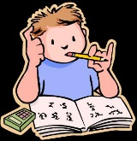
Homework
Please remember that your child will receive homework on a Monday due in for a Thursday. Please could you sign each page of your child’s homework to acknowledge that you are aware what homework your child has.
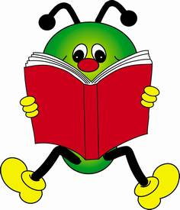
Our library slot is now every second Friday where children are encouraged to select a book for ERIC time in class and also to enjoy reading at home.

Physical Education
Please ensure that your child has their P.E kit in school all week. As they have P.E twice a week and it is getting warmer I will encourage the children to take their kits home with them to be washed at the weekend. Please remember a spare top and gym shoes or a change of shoes for P.E as many are forgetting these.

Timetable
Monday - P.E – Miss Jackson
Tuesday – Singing – Mr Thomson
Wednesday – Music – Mrs Brown
Thursday - P.E – Mrs Lamb

As always if you have any questions do not hesitate to get in touch.

Miss Jackson

