P5/6 Newsletter

January 2017
Dear Parents,

Welcome back from the winter break. Here in P5/6 we are all ready for an exciting term 3.

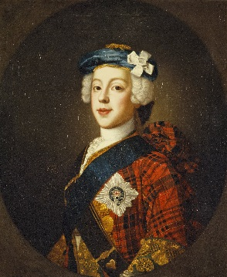
This term we will be learning all about the Jacobite’s.
We will be focusing on:
- The key figures involved during the Jacobite rebellions
- Chronological ordering and family trees
- The main events throughout the period of the Jacobite rebellion and the causes leading up to them. E.g. Killiecrankie, Culloden.
- Scottish culture in the 18th century.
Language
This term we will be developing out reporting skills by creating newspaper reports linked to our topic. We will be looking at persuasive language to persuade the reader about our views. We will also focus on diary entries looking at the lives of the key figures in the Jacobite’s history. We will look at presentation skills and developing knowledge of leaflets and booklets.
Our novel this term is ‘First aid for fairies and other fabled beasts’ by Lari Don. The children have started to read this and are finding it very exciting. In reading and spelling we will be following the Active Literacy Programme combined with the Reflective Reading strategies to improve understanding of a text.
Maths
Initially this term in maths we have focused on whole numbers, looking at place value, reading scales and estimating and rounding to the nearer 10, 100 and 1000 Next we will be looking at decimals, measuring and investigating angles.
We will continue to use the ‘Big Maths’ Programme to improve our mental maths. Every Friday the pupils will complete CLIC challenges and Total Recall Challenges and aim to improve on their personal best scores.
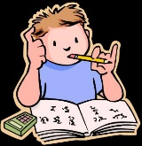
Homework
Please remember that your child will receive homework on a Monday due in for a Thursday. Please could you sign each page of your child’s homework to acknowledge that you are aware what homework your child has.
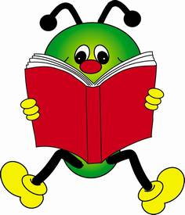
As before we have a library slot on a Monday afternoon where children are encouraged to select a book for ERIC time in class and also to enjoy reading at home.

Timetable
Monday - P.E – Miss Jackson
Tuesday – Singing – Mr Thomson
Wednesday – Music – Mrs Brown
Thursday - P.E – Mr Galbraith

As always if you have any questions do not hesitate to get in touch.

Miss Jackson

