P7 Newsletter

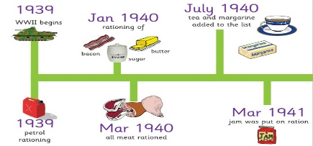
January 2016

Dear Parents,
I hope you have had an enjoyable and restful Christmas holiday. This term in P7 our topic is World War Two. Through this topic, we will be learning about: the causes of the war, major events that took place during the war and the impact it had on people in Britain and specifically Aberdeen. The children will be developing their skills in analysing both primary and secondary sources and learning about significant people within WW2. As part of this topic, the P7s will also be undertaking a personal project later this term in which they will create a WW2 folder from their research on different topics in WW2 and deliver a talk. This will be an extended homework task but some time will be set aside in class for research. The children will receive more information on this later in the term.
Towards the end of term the P7s, along with the P5s & P6s will be learning about natural disasters. For this mini topic they will be able to choose, from a selection, which natural disaster they would like to learn about, giving them personalisation and choice within their learning.
In maths we will be learning about money: how to determine best buys; profit and loss; different ways of paying for items and how to add and subtract money. We will also be developing our knowledge and understanding of fractions, decimals and percentages: how to convert between them and calculate a percentage of an amount with and without a calculator. The class will continue to do BIG Maths every morning and aim to move up a level and achieve a new personal best in the weekly Big Maths tests.
In language we will be developing our writing skills and will be learning to write newspaper articles, diary entries and poems as well as developing our skills in imaginative and information texts. In reading the class will be reading a new class novel: “The Chronicles of Narnia: The Lion, The Witch and The Wardrobe” by C.S. Lewis. We will use the active literacy and reflective reading strategies to develop our understanding of the text and comprehension skills.
Other key information
- P.E. is on a Wednesday and Thursday, please ensure your child has their P.E. kit for these days.
- Homework is handed out on Monday and is due in on Thursday, please ensure you have signed your child’s homework jotters.
- Reading homework will be set each time your child’s reading is heard. Their reading days are recorded in their reading record. For those who are working on Lime level and above homework is handed out on Tuesday and is due in, on the following Monday and should be completed in their Reading homework jotter.
If you have any questions, please do not hesitate to contact me.

Miss Hodge

