Green and Red Early Learning Newsletter

Dear Parents/Guardians, November 2018

Welcome to Term 2 in the Green and Red Early Learning Classes. So far this term the children have been very busy sharing their ’talking boxes’ with us and we appreciate your efforts in supporting this activity.
We have also learned about keeping safe around bonfires and fireworks.

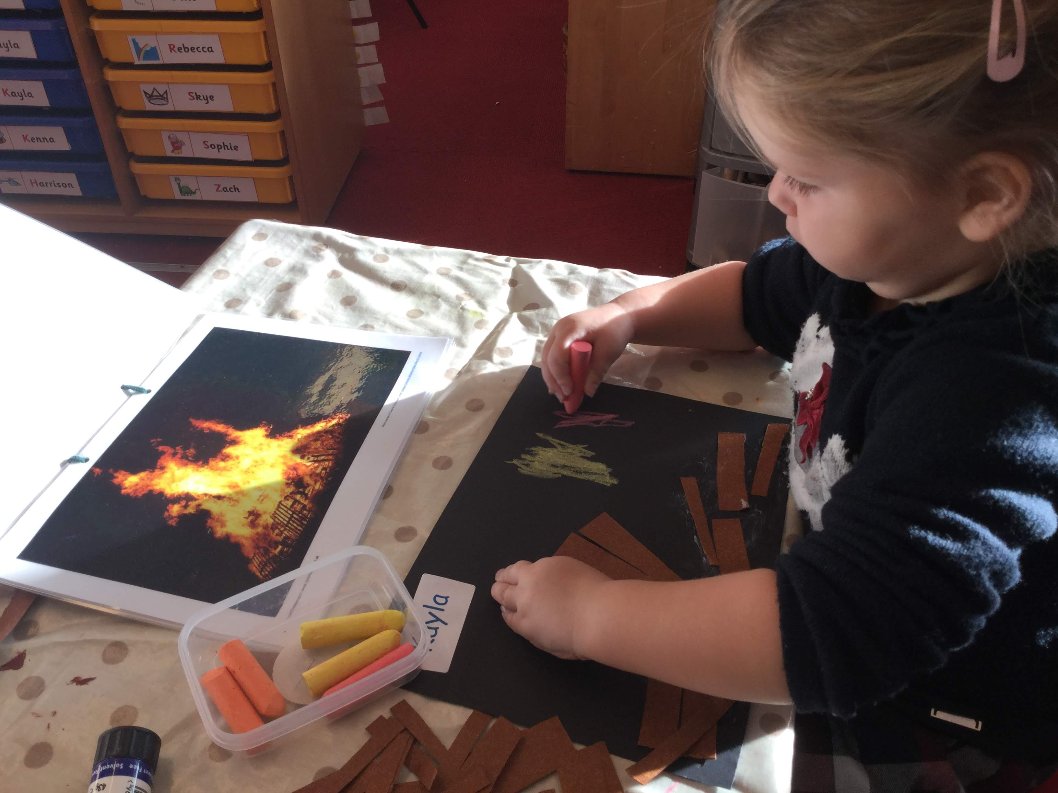
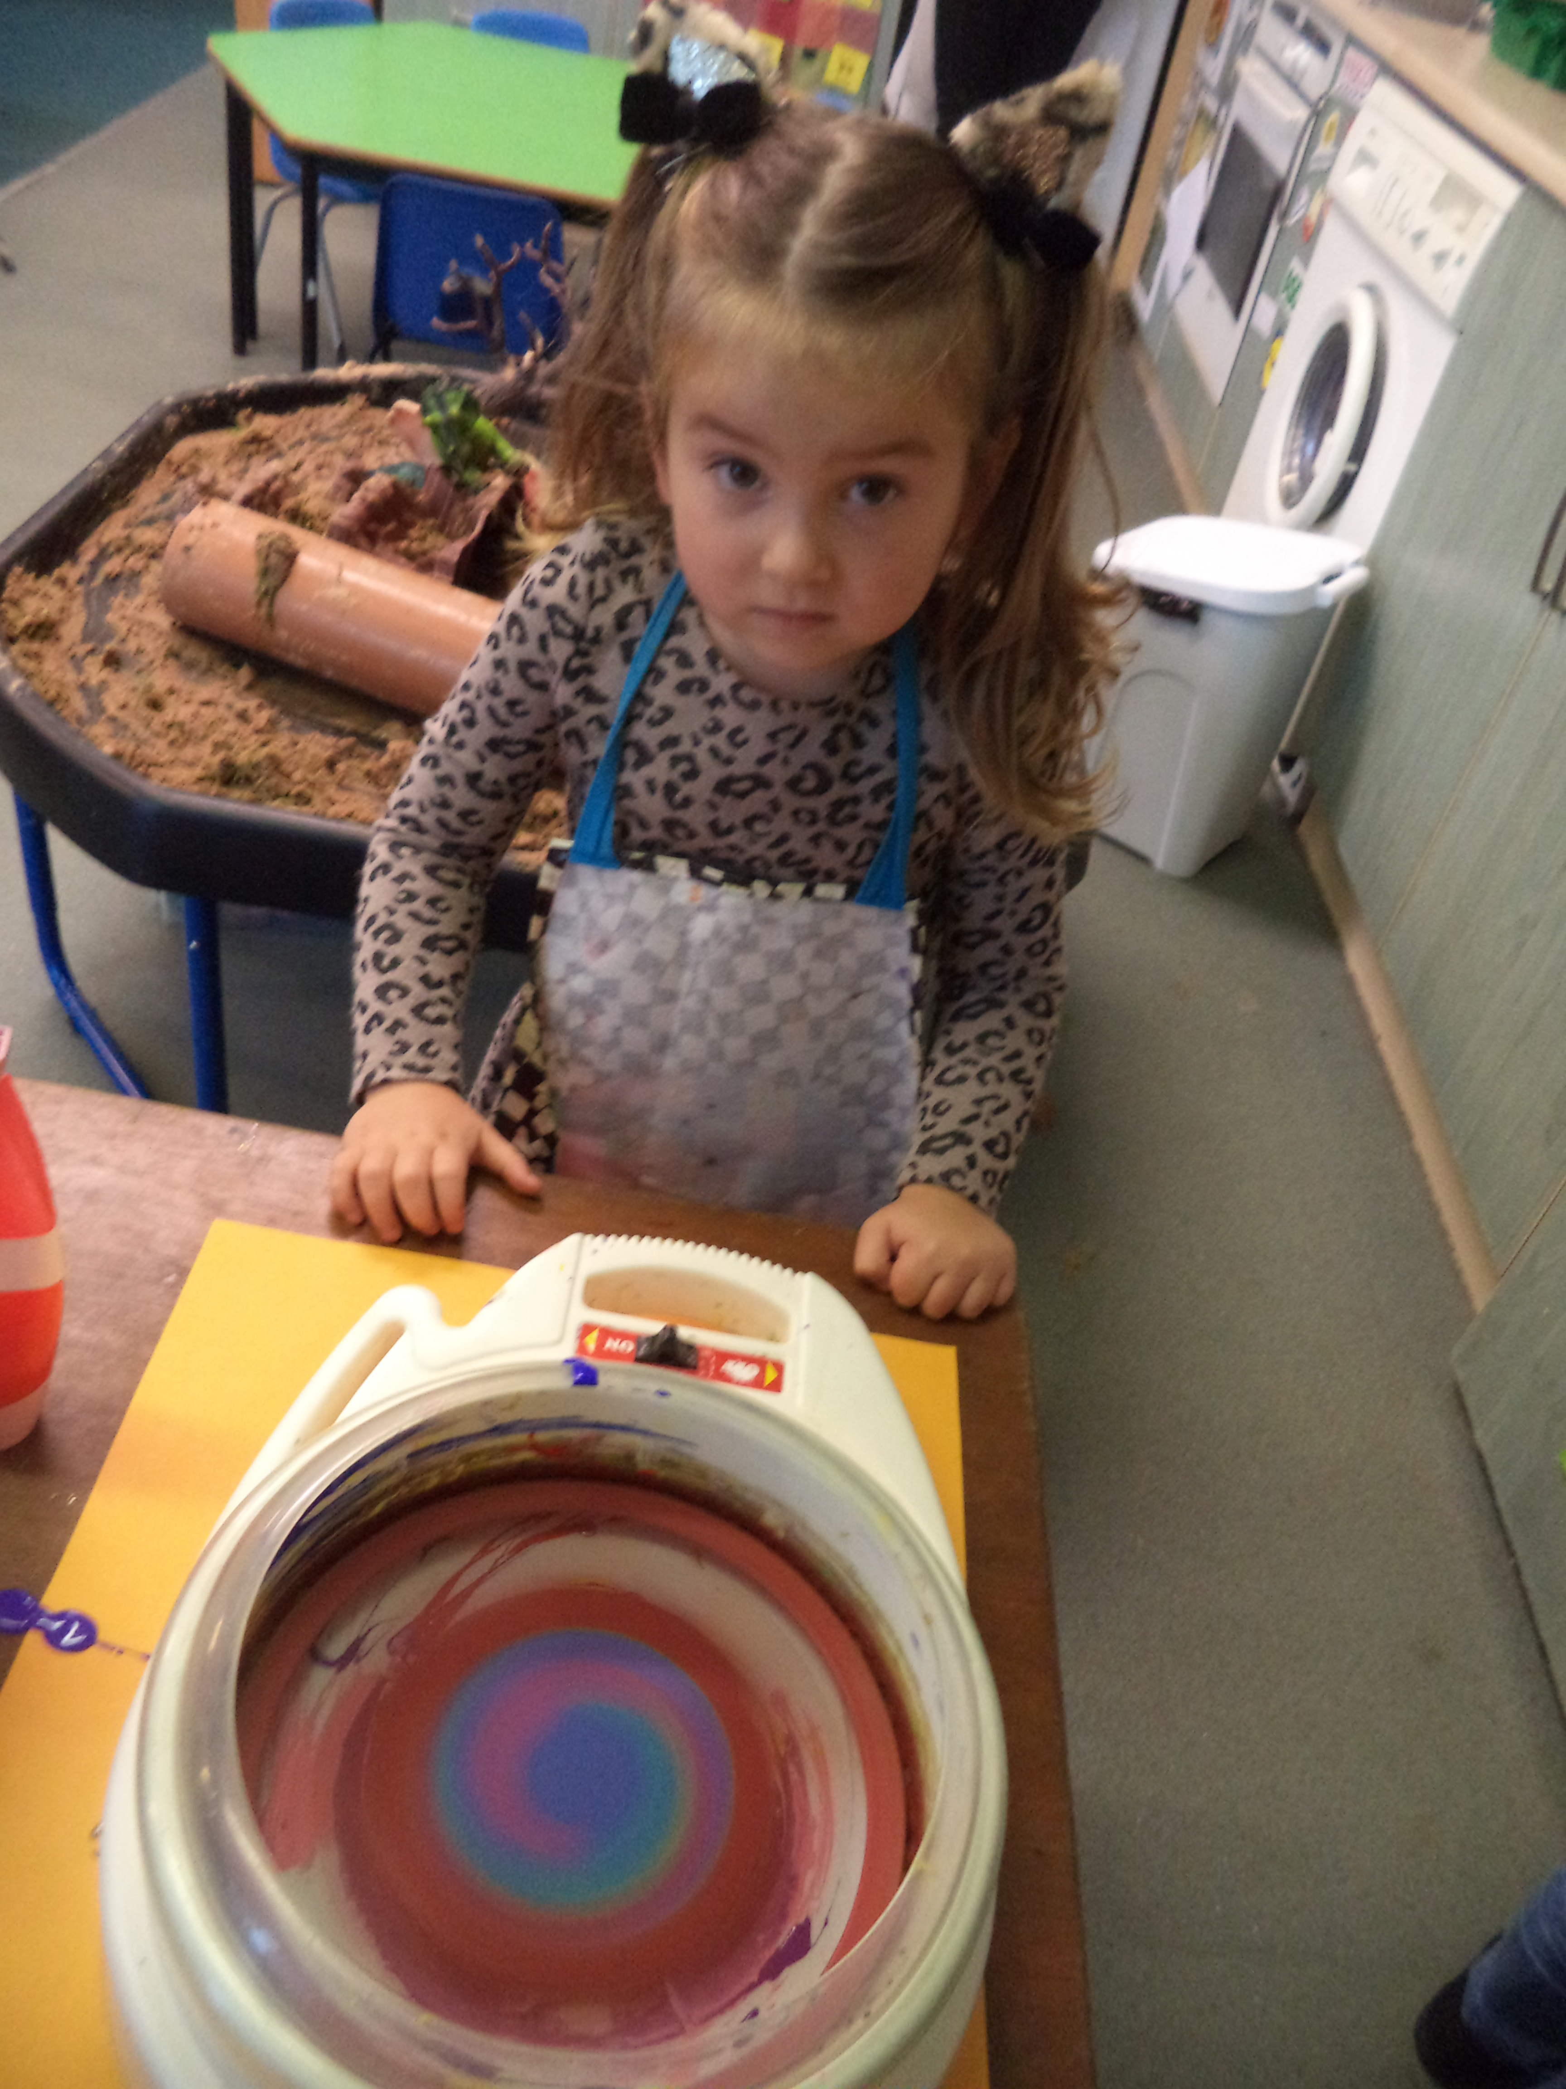

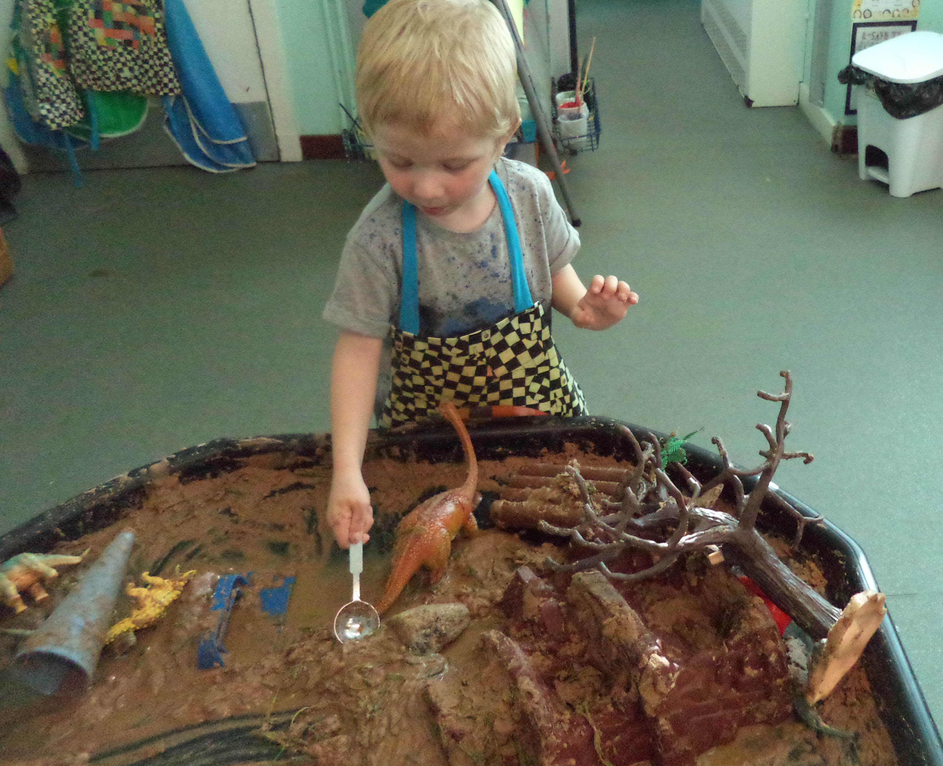
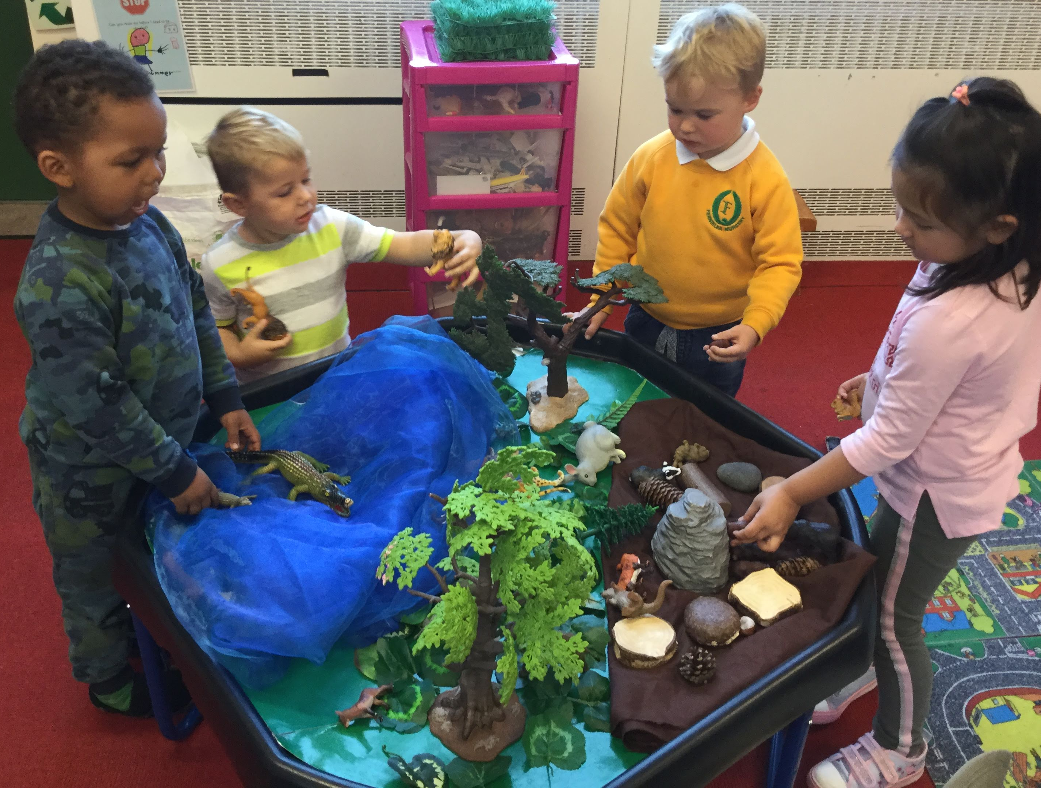
This term our topic is animals in the red ELC and dinosaurs in the green ELC. We will also be making Christmas decorations for the School Christmas fair and through this we will be learning all about money, shops and services within our local area. In addition to this, we will be learning about light and dark, noticing the changes to our environment as we move from autumn to winter.

Welly Wednesday
This term we have introduced ‘Welly Wednesdays’ where we will be exploring the area around the ‘Burnie’ in small groups. This will take place on a Wednesday around once per month (whatever the weather). We will be looking for volunteers to help escort the children and join in the fun.
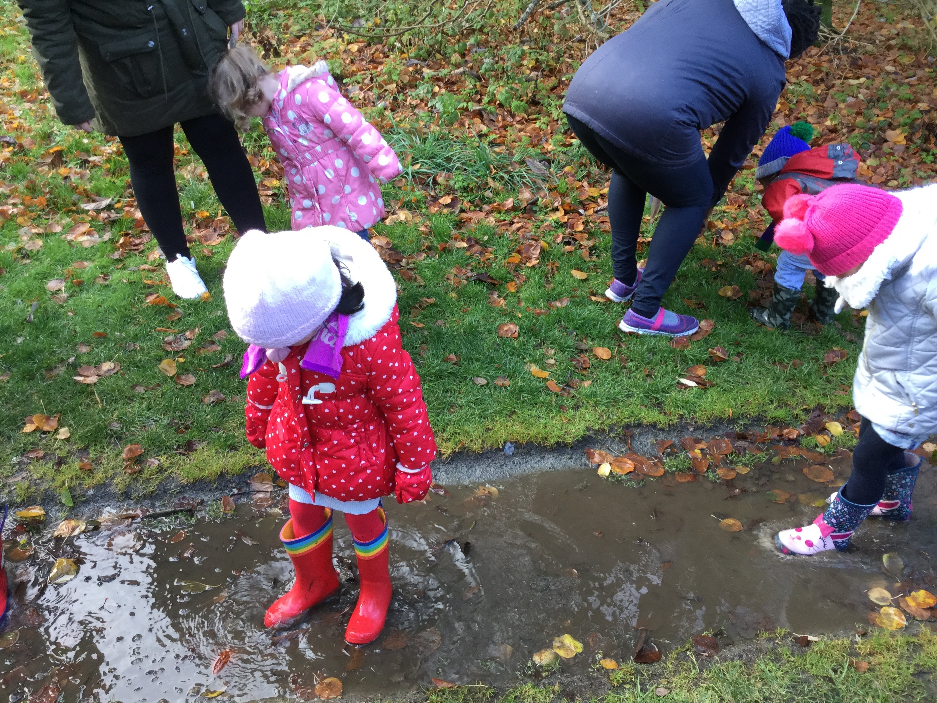
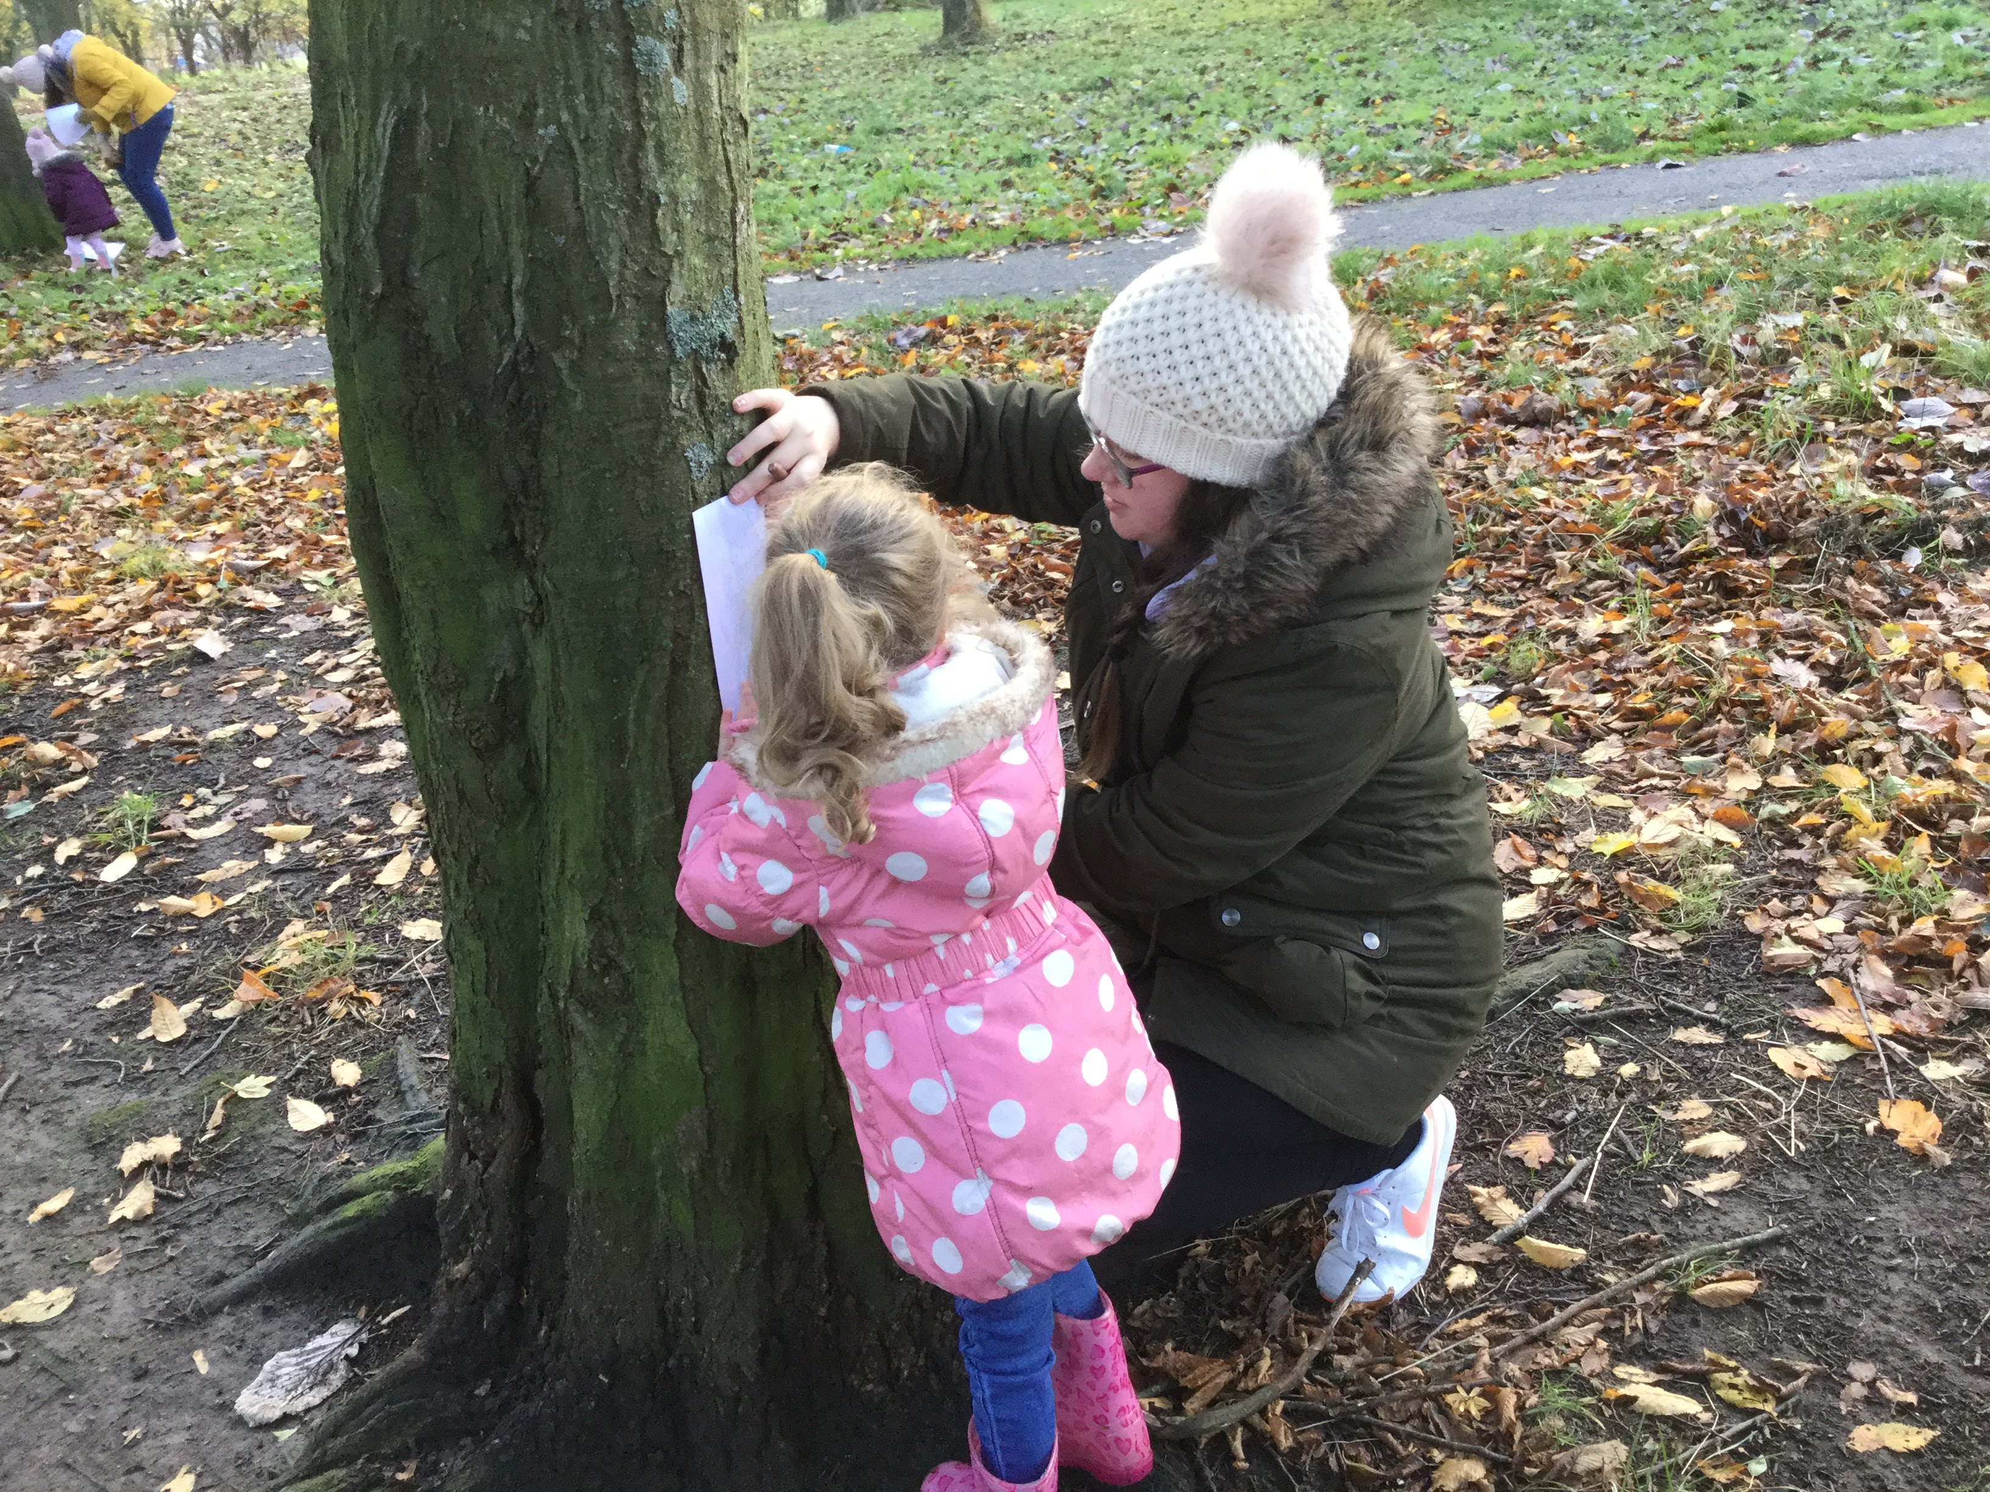

Clothing

Please ensure your child has indoor shoes, especially on gym days, and welly boots for wet days. It is also helpful if these are named for easy identification! Please do ensure your child has appropriate warm clothing as we still give the children a choice to go outside in this colder weather, ensuring they are warmly wrapped up!
Snack
Snack money is £2.50 per week or £19.50 for the term.

Library
Green Early Learning Class: Please return your library book on a Wednesday so that you can choose a new one.
Red Early Learning Class: Please return your library book on a Thursday (AM class) and Wednesday (PM Class) so that you can choose a new one.

Wednesday Wander
On a Wednesday parents are welcome to come into the Early Learning Class for the first half hour to wander round with your child, and look at what they have been doing. You could also read a story or play a game with your child.

Dates for your diary:
Children in Need – Wear something spotty and donate £1 – Thursday 15th November
In-service Day - Friday 16th of November
Christmas Fair - Thursday 6th of December
Christmas Concert - Wednesday 12th of December (AM -9.30-10.30, PM – 1.50-2.50)
Christmas jumper day – Thursday 13th December
Christmas party - Tuesday 18th December
Last day of term - Friday 21st December

ELC door
A quick reminder that our doors are open from 8.30am – 8.50am and 11.20am – 11.40am for the morning session and 12.20pm – 12.40pm then 3.10pm – 3.30pm for the afternoon session.
Out with these times our doors are locked and the Early Learning Class can only be accessed via the main entrance, with the exception of “Wednesday Wander”.

Working in Partnership
We are always looking for parent helpers to come in to assist with outings, art activities and read stories in small groups to the children. Please speak to a member of staff if you would like to help out in the ELC.
There is a sign-up sheet in each class for reading stories to small groups of children, at the start of each session.

ELC Blog
Please remember to look at our class blog to see all the exciting things we have been learning. Our blog is on the Fernielea website - www.fernielea.aberdeen.sch.uk
Finally thank you all for your support and please do not hesitate to approach us with any concerns, however small they may be.

Kind Regards,
Mrs Beedie, Mrs Bruce, Miss Laing, Mrs Ashton and Miss McKenzie

