Green and Red Early Learning Newsletter
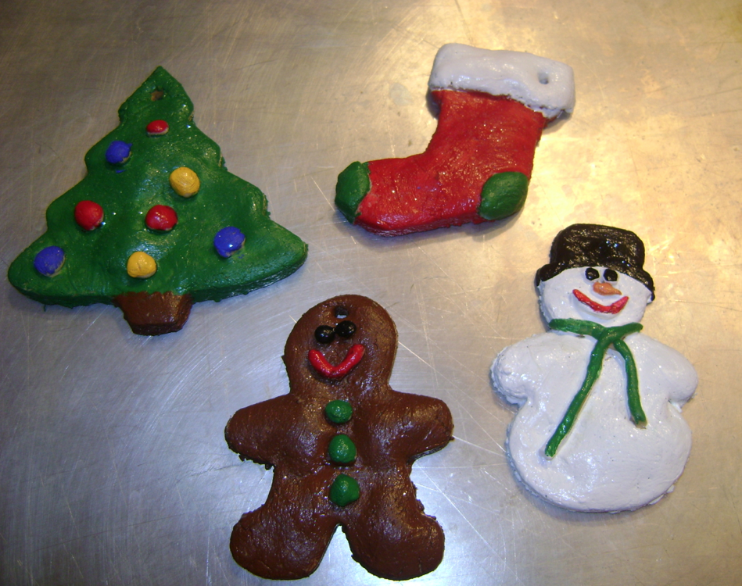

Dear Parents/Guardians, November 2017

Welcome back to Term 2 in the Green and Red Early Learning Classes, we hope you had a fun and restful holiday.
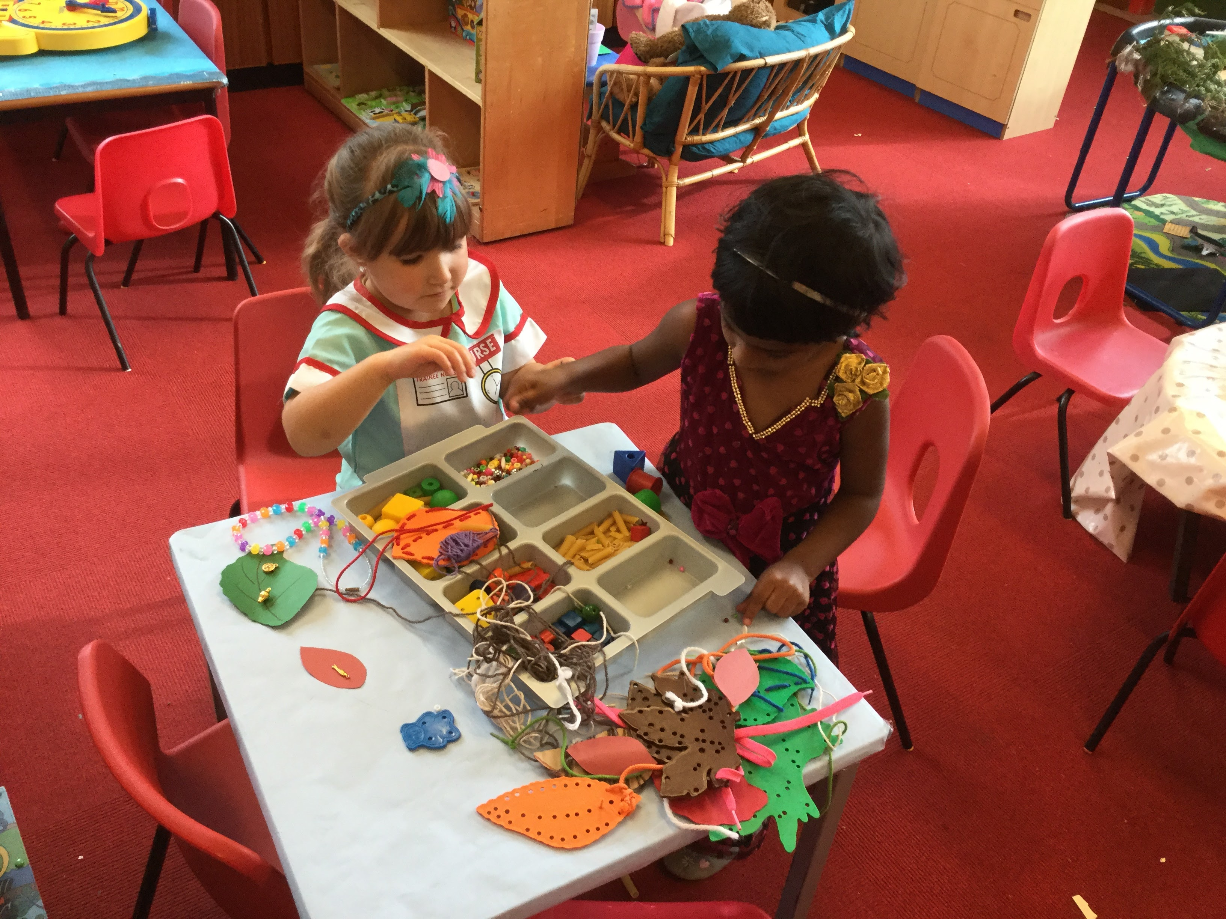
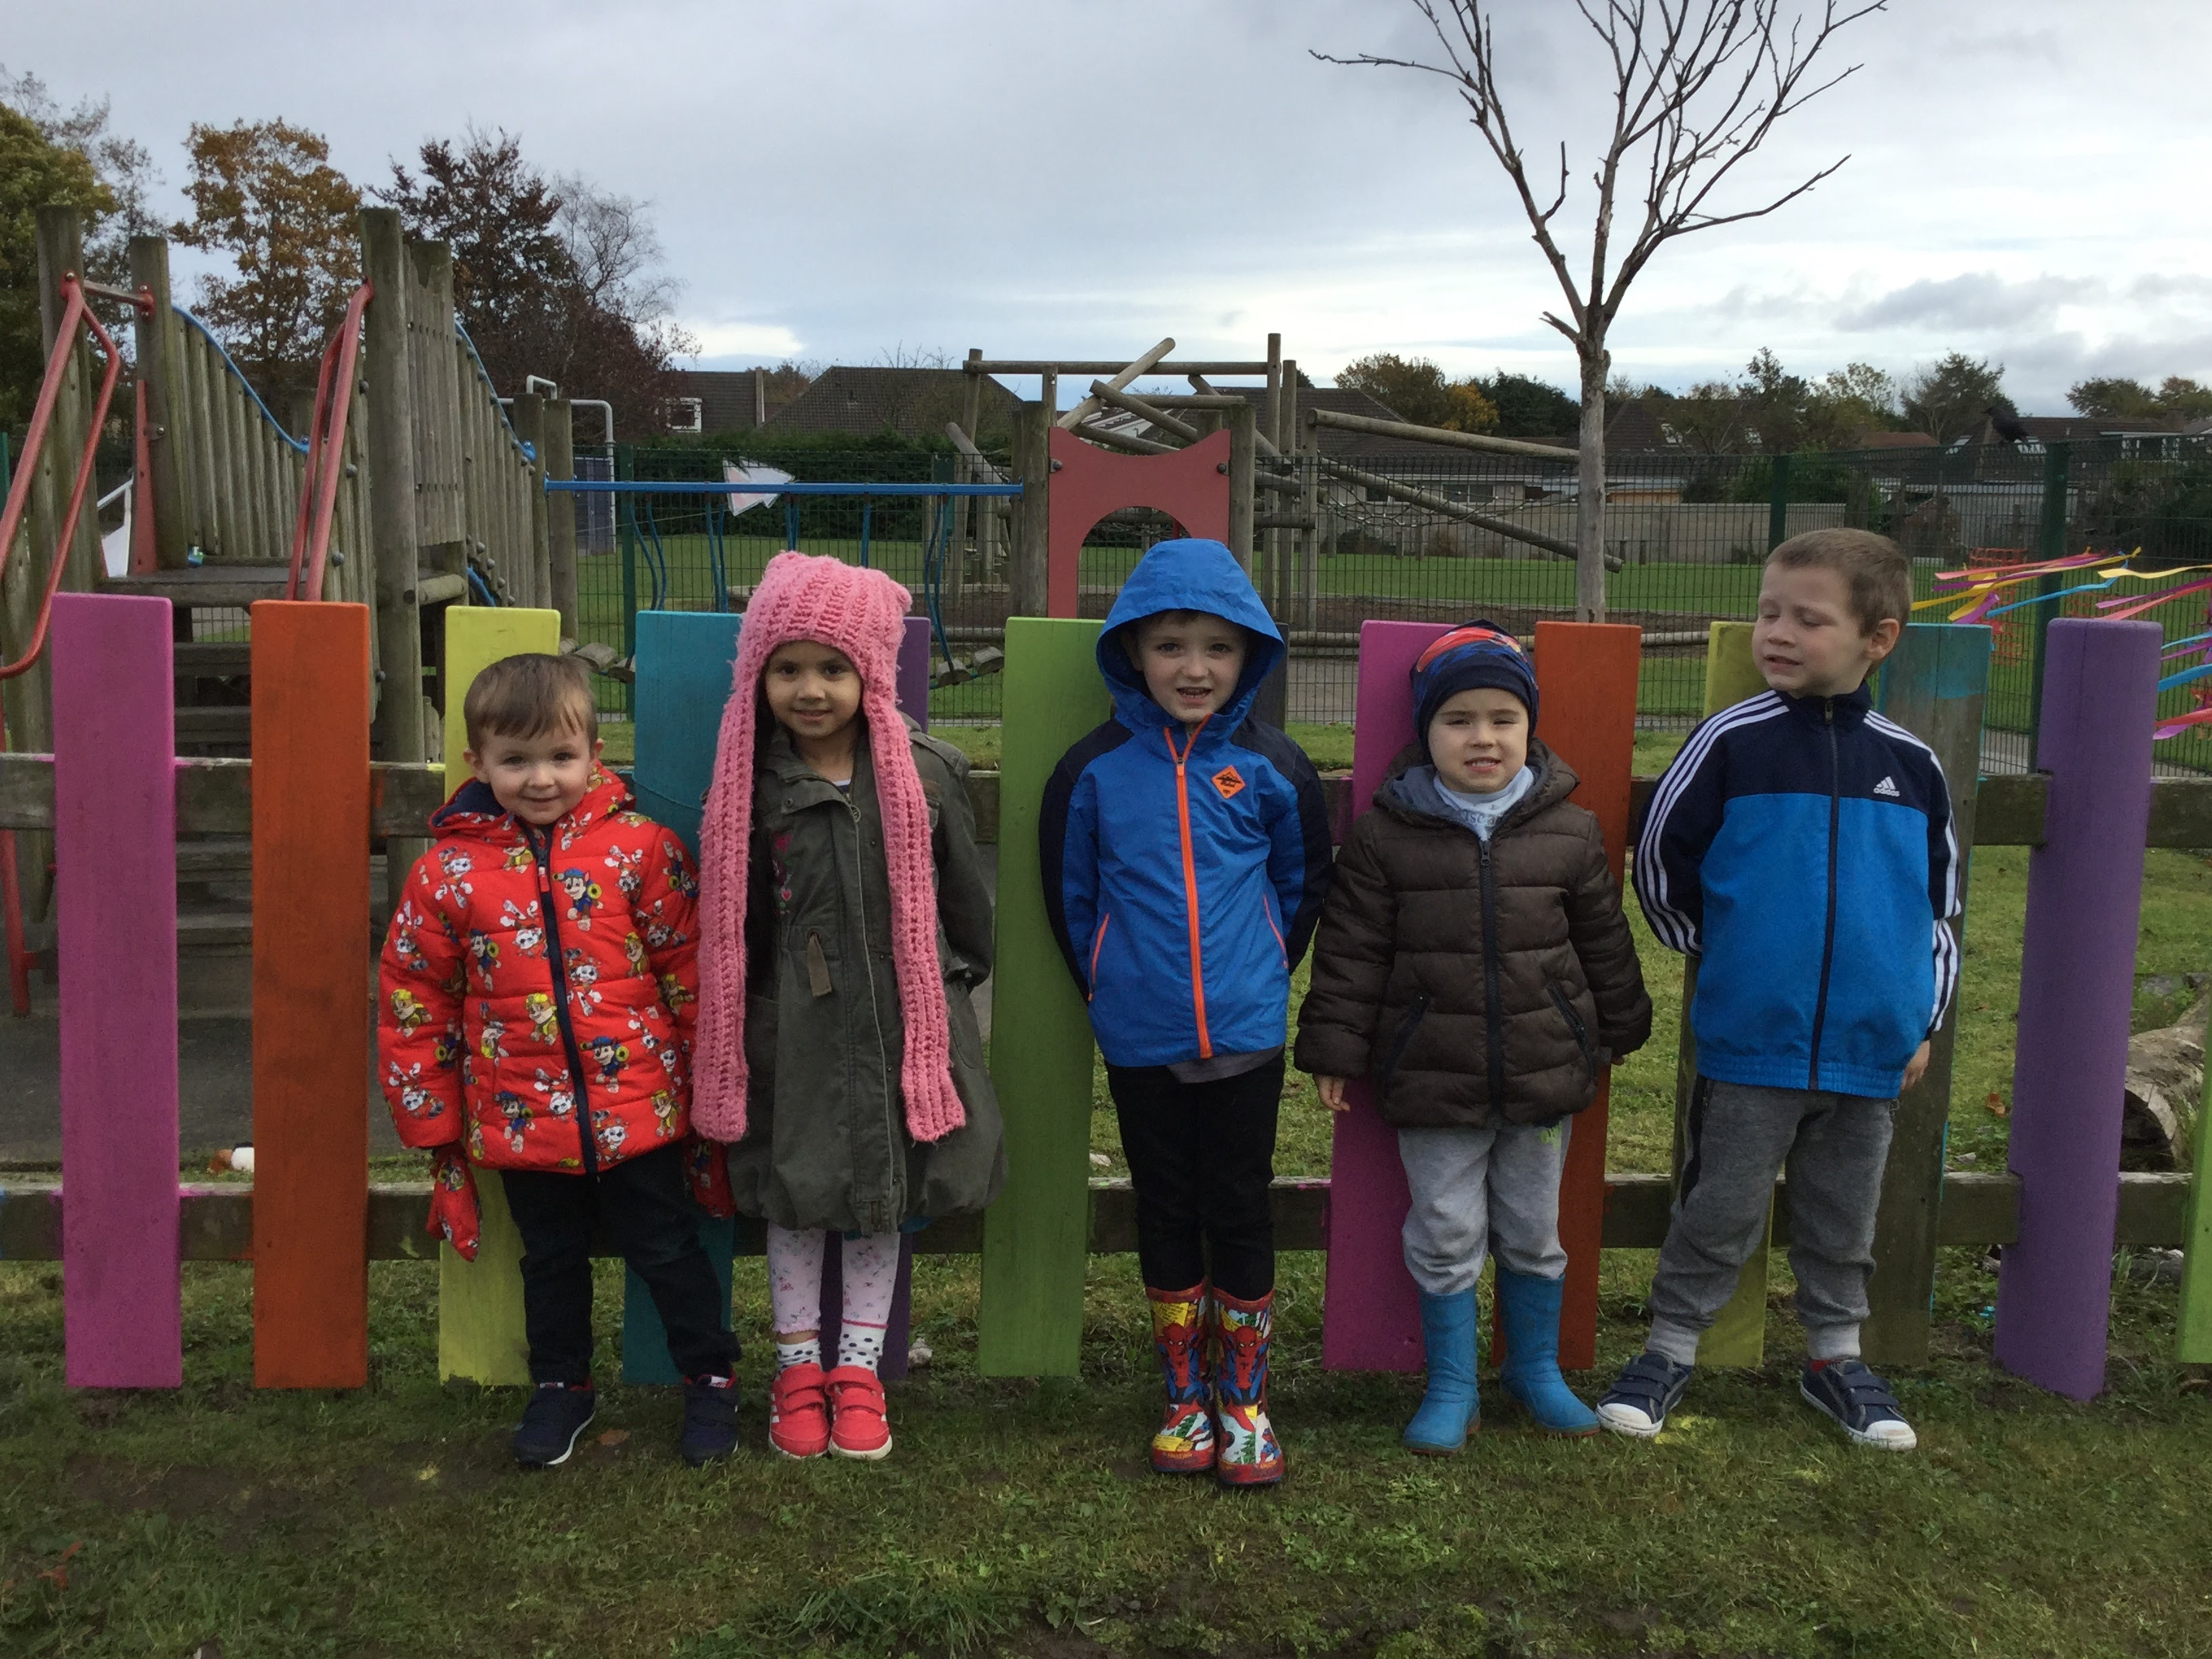

This term our topic is Enterprise. We are going to be making Christmas decorations for the School Christmas fair and through this we will be learning all about money, shops and services within our local area. This term we will also be learning about light and dark, noticing the changes to our environment as we move from autumn to winter.
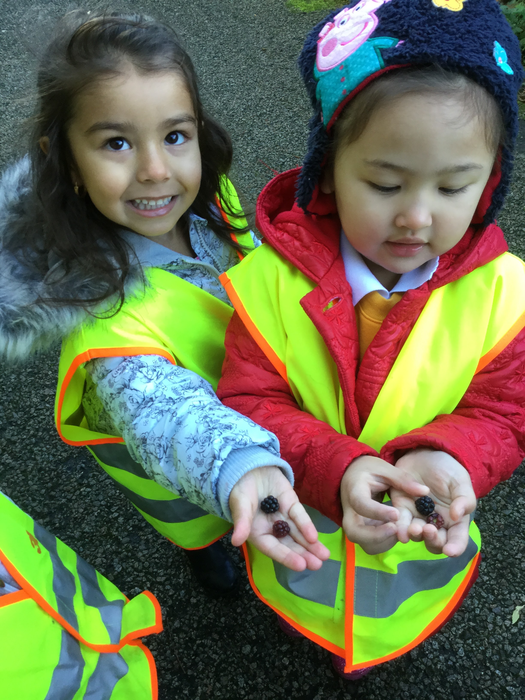
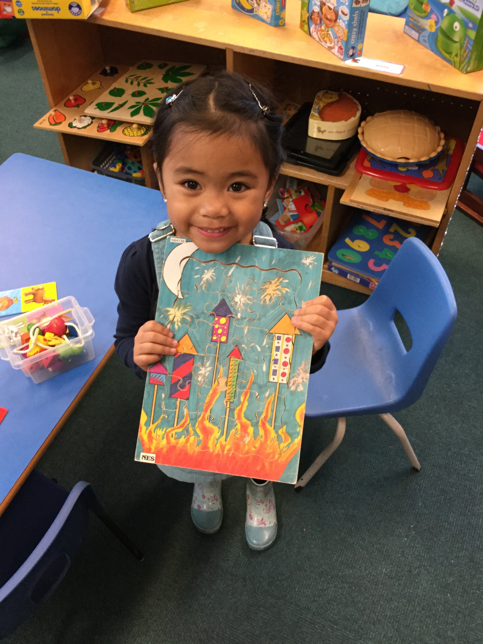
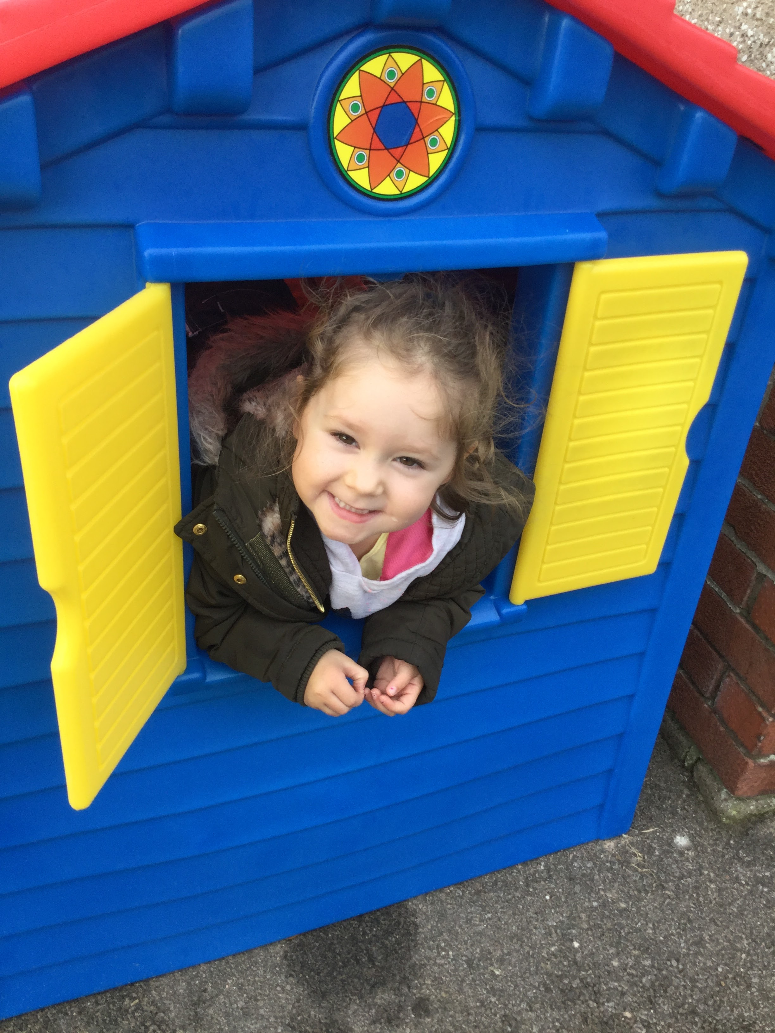

We will be going to different parts of the school for some of our activities.

The Green ELC Timetable is:
- Gym on a Tuesday am and Wednesday pm
- Library on a Thursday
- Hall for games on a Friday am and Tuesday pm

The Red ELC Timetable is:
- Gym on Monday am and Wednesday pm
- Library on a Thursday
- Hall for games on a Wednesday am and Tuesday pm

Please ensure your child has indoor shoes, especially on gym days, and welly boots for wet days. It is also helpful if these are named for easy identification! Please do ensure your child has appropriate warm clothing as we still give the children a choice to go outside in this colder weather, ensuring they are warmly wrapped up!

Snack money is £2.50 per week or £19.50 for the term. It would be helpful if snack money is paid on a Monday, if possible.

Library
Green Early Learning Class: Please return your library book on a Wednesday so that you can choose a new one.
Red Early Learning Class: Please return your library book on a Monday so that you can choose a new one.

Thursday Play and Stay
Wednesday Wanders are now going to be on a Thursday, to provide an opportunity for parents who are unable to attend on a Wednesday. On a Thursday parents are welcome to come into the Early Learning Class for the first half hour to wander round with your child, and look at what activities they have been doing. You could also read a story or play a game with your child.

Interactive Learning Diaries
Last term we launched the interactive leaning diaries which allow you to access online photos and written observations of your child’s learning. Every child has been issued with a letter containing a unique password to allow parents to set up their own username and ID to access their child’s site. Please let us know if you are having any difficulties with this. The site also allows you to submit observations from home. This is a great way to acknowledge children’s learning in all areas. It has been great to see photos and hear about what some of the children have been doing in their holidays.
On the Thursday Play and Stay we will have Ipads available so you can access your child’s ILD.
Dates for your diary:
In-service Day - Friday 17th of November
Christmas Fair – Thursday 7th of December
Christmas Concert- Wednesday 13th of December

A quick reminder that our doors are open from 8.30am – 8.50am and 11.20am – 11.40am for the morning session and 12.20pm – 12.40pm then 3.10pm – 3.30pm for the afternoon session.
Out with these times our doors are locked and the Early Learning Class can only be accessed via the main entrance, with the exception of “Thursday Play and Stay”.
Working in Partnership
We are always looking for parent helpers to come in to assist with outings, art activities and read stories in small groups to the children. We will have a calendar up in the cloakroom to provide you the opportunity to sign up for a day to help out in the ELC.
Nursery Blog
Please remember to look at our class blog to see all the exciting things we have been learning. Our blog is on the Fernielea website - www.fernielea.aberdeen.sch.uk
Finally thank you all for your support and please do not hesitate to approach us with any concerns, however small they may be.

Kind Regards,

Mrs Torrens, Mrs Beedie, Mrs Bruce, Miss Laing, and Mrs Ashton.

