Green and Red Early Learning Newsletter
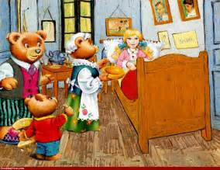

Dear Parents/Guardians, September 2017

Welcome to a new year in the Green and Red Early Learning Classes and welcome to all our new children and their families. We hope you have all enjoyed your summer. We are looking forward to the exciting year ahead of us. We have already made a great start and have been very busy painting, learning and making new friends.
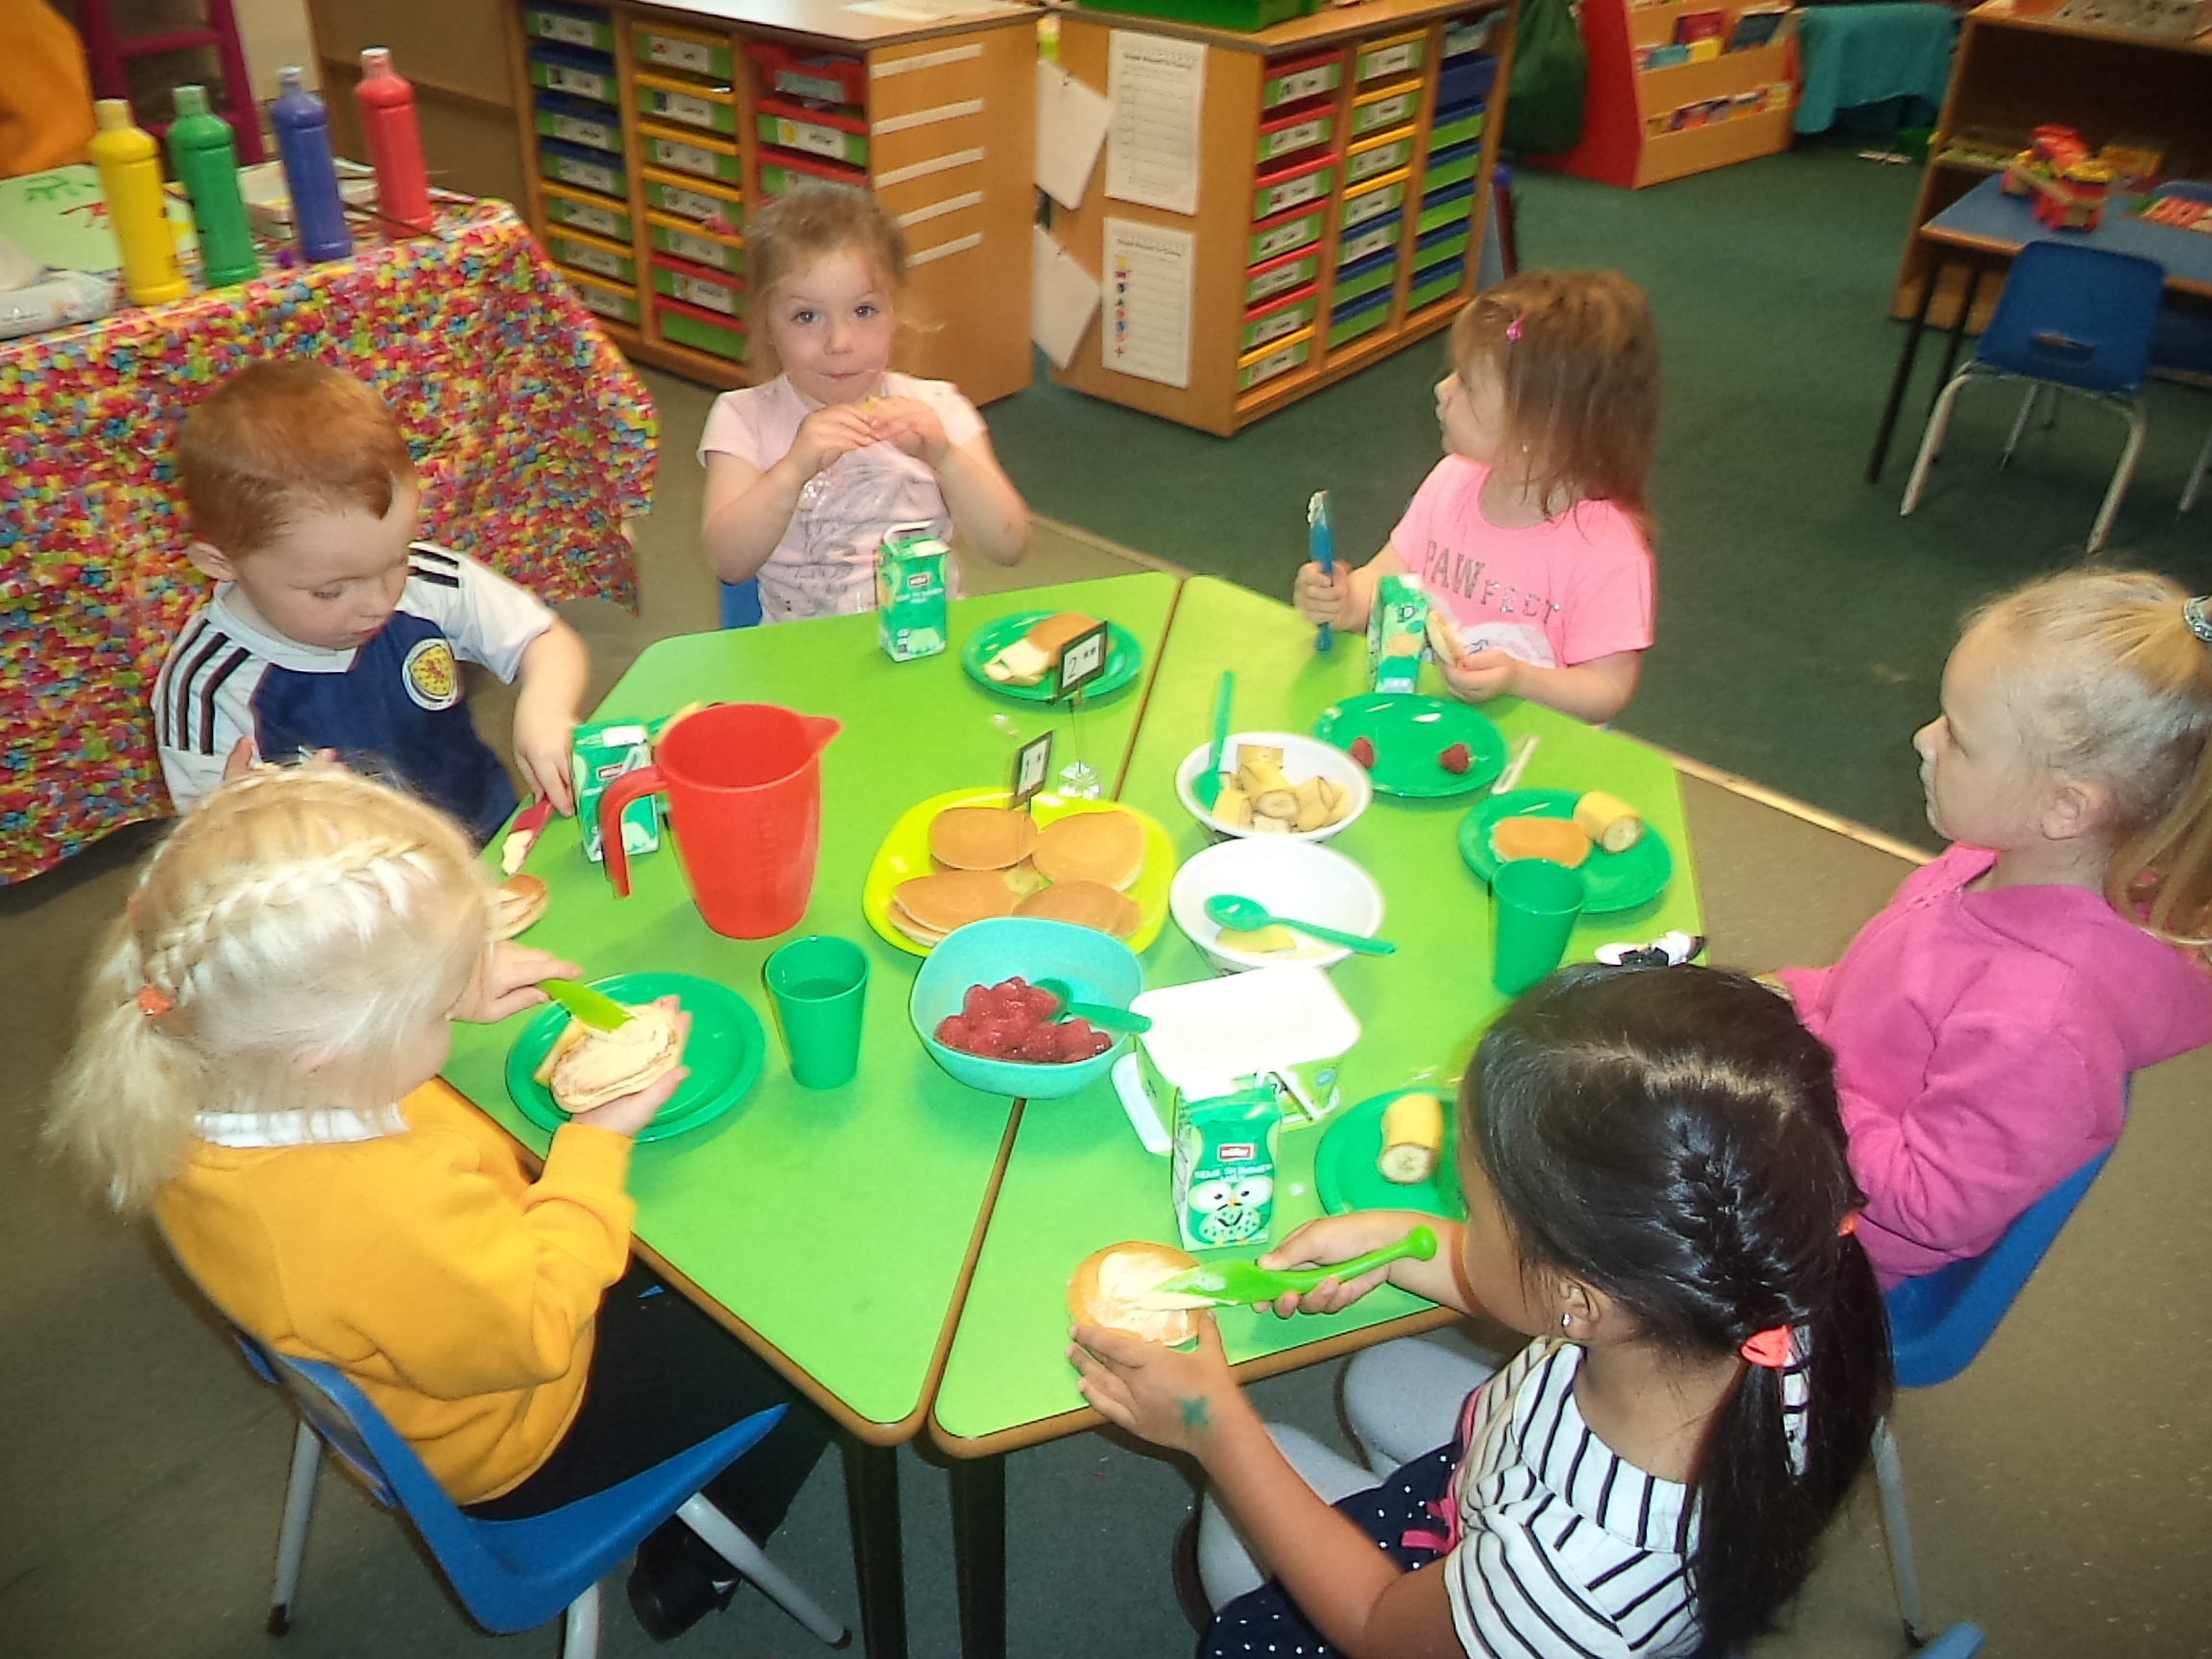
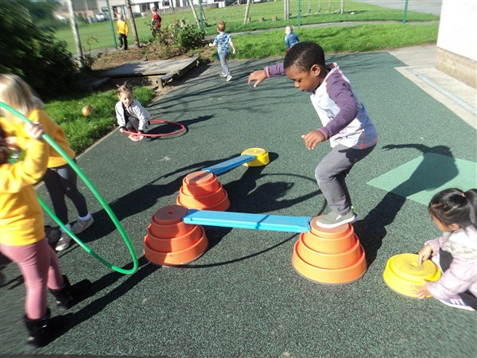

Our topic is Traditional Tales. We will be focussing on a variety of traditional tales this term and we will develop our Maths, Language and Health and Wellbeing knowledge and skills amongst others within this context.
The children in Red and Green Early Learning Classes will be exploring feelings and emotions, numbers and size and how to make porridge through the story of Goldilocks and The Three Bears.
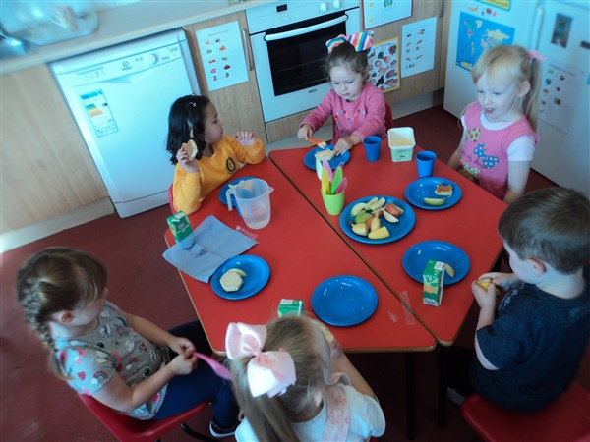
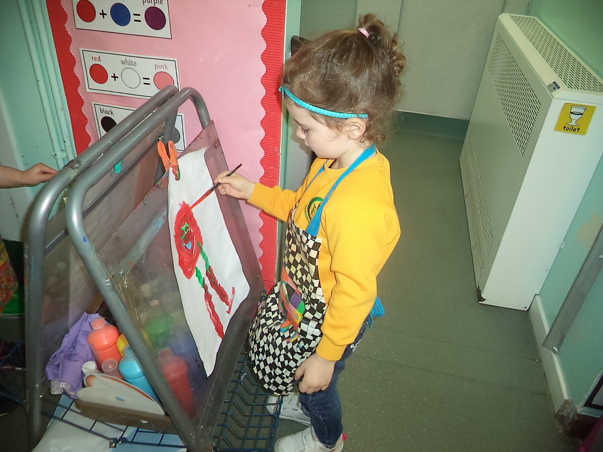
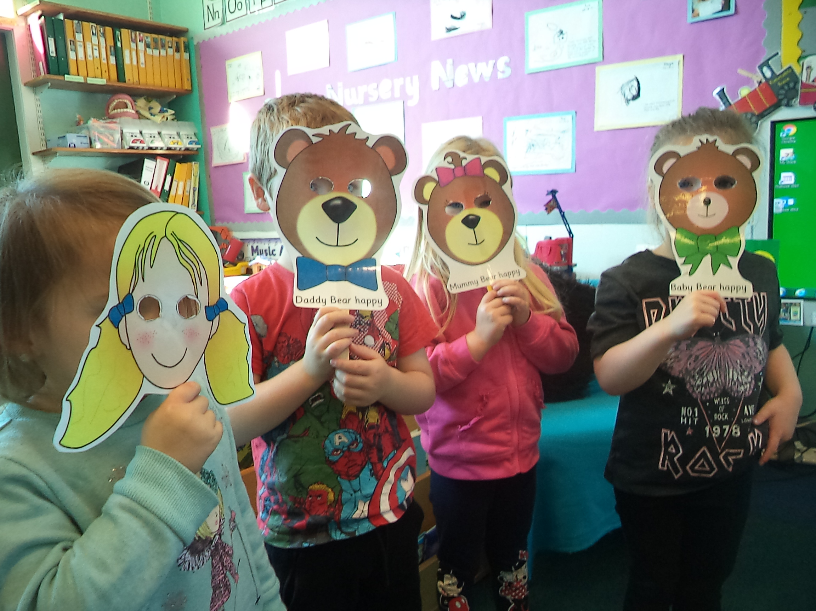

We will be going to different parts of the school for some of our activities.

The Green ELC Timetable is:
- Gym on a Tuesday am and Wednesday pm
- Library on a Thursday
- Hall for games on a Friday am and Tuesday pm

The Red ELC Timetable is:
- Gym on Monday am and Wednesday pm
- Library on a Thursday
- Hall for games on a Wednesday am and Tuesday pm

Thank you to everyone who has handed in a box or packet of tissues and a packet of baby wipes. We use these on a daily basis and it is always handy to have plenty! We were also pleased to see so many children with nice overalls and a change of clothes. Sometimes we get very messy in the Early Learning setting so a change of clothes is always useful. Please ensure your child has indoor shoes, especially on gym days, and appropriate outdoor wear for our ever changing weather! Please also remember to bring your welly boots into school. They can be stored on our new shelves ready for the wet weather. It is also helpful if these are named for easy identification!

Snack money is £2.50 per week or £18.00 for the term. It would be helpful if snack money is paid on a Monday, if possible.
Library
Green Early Learning Class: Please return your library book on a Wednesday so that you can choose a new one.
Red Early Learning Class: Please return your library book on a Monday so that you can choose a new one.
Wednesday Wanders
Wednesday Wanders are returning. Our first Wednesday Wanders will be taking place the 13th of September with a stay and play. On a Wednesday parents are welcome to come into the Early Learning Class for the first half hour to wander round with your child, and look at what activities they have been doing. You could also read a story or play a game with your child.
Dates for your diary:
Holiday - Friday 22nd of September and Monday 25th of September
Parents Information Evening – Thursday 28th of September

A quick reminder that our doors are open from 8.30am – 8.50am and 11.20am – 11.40am for the morning session and 12.20pm – 12.40pm then 3.10pm – 3.30pm for the afternoon session.
Out with these times our doors are locked and the Early Learning Class can only be accessed via the main entrance, with the exception of “Wednesday Wanders”.
Working in Partnership
We are always looking for parent helpers to come in to assist with outings, art activities and read stories in small groups to the children. Let a member of staff know if you would like to help.
Nursery Blog
Please remember to look in our class blog to see all the exciting things we have been learning. Our blog is on the Fernielea website - www.fernielea.aberdeen.sch.uk

Finally thank you all for your support and please do not hesitate to approach us with any concerns, however small they may be.

Kind Regards,

Mrs Torrens, Mrs Beedie, Mrs Bruce, Miss Laing, and Mrs Ashton.

