Highland Literacy
https://highlandliteracy.com/
Parents and Carers

This booklet has been created for you to support your child in their Literacy development at home.
Inside this booklet are a range of activities which can be used to develop your child’s skills in Literacy. Please note that all of these activities should be revised regularly to help your child.
We appreciate your support in this – please do not hesitate to contact your child’s teacher or the school if you have any questions.

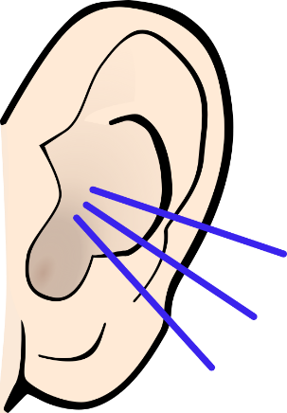
Hearing different sounds
During these activities remind your child about the things that make a good listener – keep quiet, have ears and eyes ready.
- Listening Walks
Go on walks inside or outside. Talk about the different sounds you can hear. Afterwards you could make a list of the things you heard.

- A Listening Moment
Remember all of the sounds you can hear when you listen for a minute. Ask your child what made each sound and if they can
- Favourite Sounds
Think about and talk about sounds you like and do not like and why. (E.g. storm, rain, barking dogs, baby crying, singing, etc)

- Clapping Rhythms
Clap a simple rhythm and ask your child to clap it back to you. Change this each time you do it. Try swapping over and get your child to clap a rhythm for you to copy.

- Same or Different?
Say or make two sounds, your child has to say if they are the same or different. (E.g. p...t; h…h)

- New Words to Old Songs
Take a song or rhyme your child likes and knows well. Try to think of new words to change the song. Try adding some actions or instruments to it.
Memory
- I –Spy
Try playing the game using colours as a clue instead of the first letter.

- What’s Missing?
Put a number of objects on a tray for a few seconds (start with 5 objects then add more as your child gets better). Cover them up and ask your child to remember them, or cover them up and take one away, asking your child to identify which object is missing.

- Spot the Difference

- What’s Next?
Make patterns with pegs, socks, beads or anything you have in your home and ask your child to continue the pattern.

- Here and There
Gather a range of objects from around your home. Place the items on one side of a room and sit at the other. Give your child the name of 1 object which they must go to collect and bring back. Then ask them to collect 2 things. As your child gets better the more objects they will be able to remember and bring back.

Hearing Words
- Hop, Skip and Jump
Say a sentence aloud: ‘Today is Tuesday’. Show your child a hop/skip/jump for each word that you say. Your child should copy. Give your child a sentence to try on their own then show them how many words there are by hopping, skipping or jumping for each word.

- Pat Pat
Say a sentence aloud: ‘Today is Tuesday’. Say the sentence aloud a second time, modelling a pat on their thighs for each word you say. Your child should tap their thighs each time they hear a word in the sentence. Talk about how many words.

Hearing Rhyme
- Sing Nursery Rhymes
Exaggerate the rhyming words.

- Read Rhyming stories
Find the words that sound the same at the end.
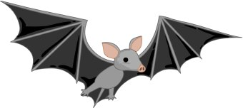
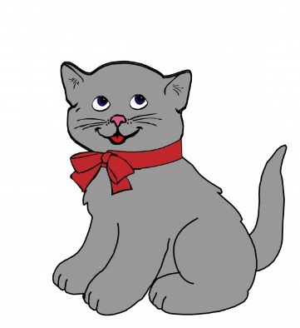
Beats in a Word (Syllables)
- My Turn, Together, Your Turn
Clap/stamp/move to mark the syllables in words are shown by the adult, practised together and then ask your child to do it themselves.

- Together, Your Turn
Clap the syllables together and then your child does this on their own.

- Child led
Mark the syllables using actions e.g. clapping but on their own.

Making Rhyme
- I-Spy
E.g. I-Spy with my little eye something rhyming with cat…

- Rhyming Name
Choose a name and make up words that rhyme with it. E.g. Dan – Ban, Can, Ran, Fan, Gan, etc.

- Rhyming Books
Make your own little rhyming book that has lots of words that rhyme.
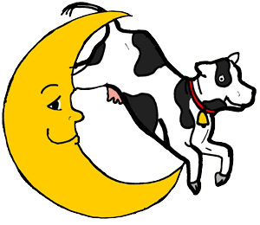
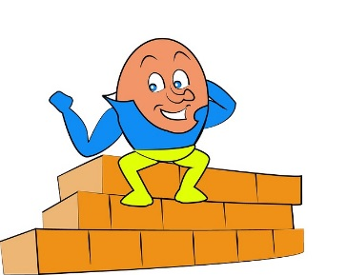

Onset and Rime
Onset = sounds before the first vowel, rime = all the rest
- Silly Sally
Try making rhymes by blending a single onset to a variety of words. E.g. Silly Sally where you take the s sound and add it to different words to change them. They may make nonsense words but this is ok – me, see; bite, sight; cup, sup; mouse, souse, etc). Other ideas Silly Billy – change the first sound to b; Silly Curly – change the first sound to c.

- One-Two Punch
As you say the onset, punch your left arm straight out in front of you. Then, leaving the left arm where it is, say the rime as you punch your right arm out in front. Then, say the whole word as you push both arms together. (p-at, b-at, r-at).

Hearing Sounds in Words

- Sound Spy
I spy with my little eye, something that begins with the __ sound. Take it in turns to spy.

- Odd One Out
Say three sounds (e.g. ‘sss’, ‘sss’ ‘mmm’. Repeat the sounds with your child. They then have to say which one is the ‘odd one out’. This can be played with words focusing on the beginning sound, e.g. sun, see, toy.

Alliteration

- Alliteration All Around
Find words that begin with the same sound.
Find objects beginning with the same sound.

- Odd One Out
Same game idea but with objects or pictures of things that begin with the same sound. Your child has to find the one that begins with a different sound.

- Name Play
Make a fun sentence starting with the first letter of a name. E.g. Tim has ten, tickly toes. Fiona found a fine, fat frog.

- Sorting Table
Sort objects or pictures of objects into their starting sounds. For this activity focus on two sounds.

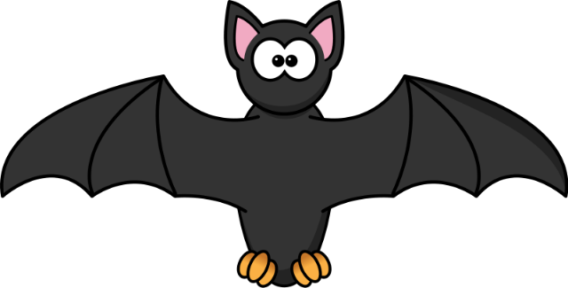

Blending and Segmenting

Blending = putting sounds together to make words e.g. h-a-t - hat
Segmenting = splitting words into sounds e.g. bat - b-a-t

- Modelled Blending (Focus on single-syllable words)
When giving a set of instructions break the last word into separate sounds, model the blending of these sounds together. e.g. ‘It’s time to get your b-a-g, bag!’ or Touch your t-oe-s, toes!

When sharing rhyming books, break then blend the last word in a rhyming couplet e.g. ‘I like the sun; outside we have f-u-n, fun!’.

- Word Split
Lay out a selection of objects (or use a selection of pictures) that contain three sounds, e.g. leaf, sheep, soap, fish, sock and bus. Talk about what each of the objects/ pictures are.

Choose one of the objects: e.g. ‘This is a duck; d-u-ck’.

Your child can then copy with another picture/object.

- Change the Name Game
Parent: "Say 'man'" Child: "man"
Parent: "Say it again, but this time say 't' instead of 'm'." Child: "tan"

- Snail Talk
Place a small number of picture cards in front of your child. Tell them you are going to say a word using "Snail Talk" a slow way of saying words (e.g., /fffffllllaaaag/). They have to look at the pictures and guess the word you are saying.

- I-Spy
Play ‘I Spy’ in saying a whole word e.g, “I spy with my little eye a jug”. The child has to segment the word into individual sounds: j-u-g.

