Kaimhill School

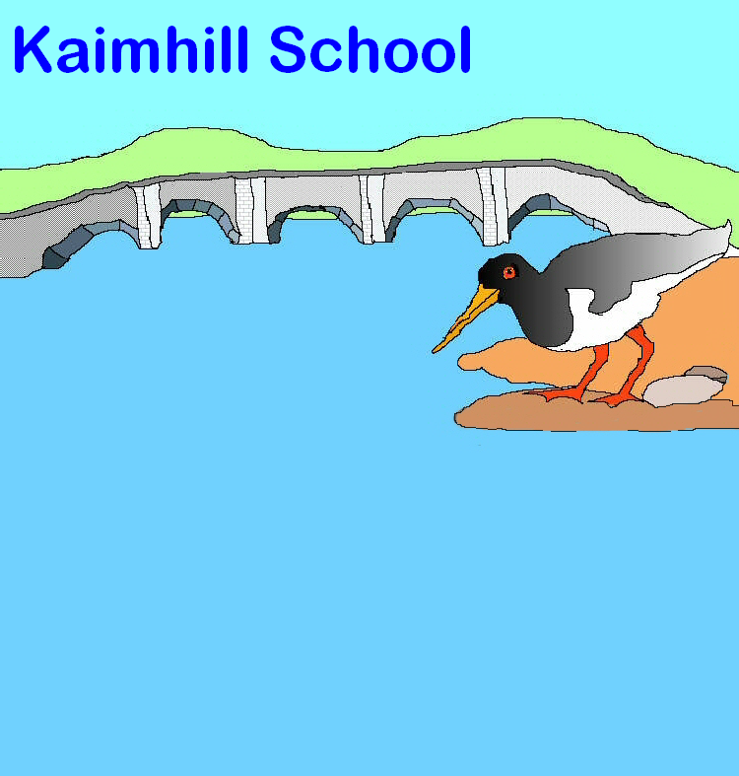

Standards and Quality Improvement Plan
(SQIP)

Session 2014 - 15



Contents page

- The school and its context

- School aims and vision statement

- How do we consult and engage with key stakeholders?

- How well do our children/young people learn and achieve?

- How well do we support our children/young people to develop and learn?

- How well do we improve the quality of our work?

- Our improvement priorities for next session

The school and its context
Kaimhill Primary School and Nursery serves the area of Garthdee to the south-western edge of the city of Aberdeen. The building was opened in April 2011 and was part of Aberdeen City Council’s 3Rs project. The school building also houses Community rooms and a Community Library that has part-time opening hours. The building is bright and spacious and fit for purpose. The fabric of the building is managed by the company Robertsons.
The catchment area is socially and economically diverse. Many of our learners have complex home lives and this presents challenges in both their learning and emotional development. Almost all our pupils live in the catchment area for the school. Since the new building was opened our school roll has risen and continues to sit over the official capacity. A new classroom is planned for 2015/16 which will enable us to increase current capacity. Occupancy this session has been 117% and the role is projected to continue to rise.

Our school roll for 2014-15.
Nursery | P1 | P2 | P3 | P4 | P5 | P6 | P7
60 | 36 | 41 | 44 | 40 | 39 | 29 | 30

19% of our learners have English as an Additional Language. This percentage has risen significantly in recent years and continues to rise, reflecting the diversity of our student population. Many of our overseas pupils have a parent studying at Robert Gordon University. There is a free school meal entitlement of 27% for children in P4-P7. All P1-P3 pupils are entitled to free school meals.

The current school roll is 259 P1 to P7 pupils and 60 Nursery children - staffing for the school is appropriate to meet this number. Due to ongoing vacancies this session, the Depute Head Teacher has been committed to teaching in the P7 class – this has had an impact on the rigour and pace of development work. Following the resignation of an ASN Teacher in February 2015, a nursery teacher was re-deployed into the school setting and additional nursery nurse cover provided in the nursery. We will benefit from an additional teacher next session in our P5/6 class and a newly appointed ASN teacher will take up post in August 2015. We look forward to being more fully staffed in 2015-16 and positively anticipate the impact this will have on leadership capacity and planned school development.

Scottish Index of Multiple Deprivation
Based on pupil census 2014-15, 71% of the current school roll is in deciles 1-4 of the SIMD, which are the most deprived deciles. This represents a 5% increase from the previous session.
SIMD Deciles | 1 | 2 | 3 | 4 | 5 | 6 | 7 | 8 | 9 | 10
Kaimhill School | 1% | 1% | 42% | 27% | 20% | 6% | 2% | 0% | 1% | 0%
Aberdeen City Schools | 7% | 13% | 9% | 11% | 6% | 6% | 5% | 5% | 11% | 26%

In addition to our 10 mainstream classes, 60 children are enrolled within our three nursery classes on a part-time basis (3 hours 10 minutes per session, 5 sessions a week). Nursery places are filled in accordance with a number of clearly defined criteria and are allocated by Aberdeen City Council Pre-School Team.
The Pre-School Additional Support Needs Service (PSASN) has a part-time unit for 10 children. Following Inclusion Review recommendations, these places will no longer be available at Kaimhill Nursery next session and children will be appropriately supported in their local nursery settings.

Kaimhill has two supported classrooms which provide targeted support for pupils experiencing additional support needs. In line with Aberdeen City Council’s current review of inclusion, we have been developing more flexible approaches to meeting the needs of our most vulnerable learners. These pupils are taught by two teachers and supported by four Pupil Support Assistants (PSAs). The pupils are integrated into their mainstream class(es) where possible. These pupils all have an Individual Education Programme (IEP) which is regularly updated and shared with their parents.
In addition, Kaimhill has a Specific Learning Difficulties (Dyslexia) Unit supporting fourteen learners from across the City. They are taught in two groups of seven and access the Unit on a part-time basis, attending Kaimhill School for two and a half days per week. The structure of this provision will change next session to enable staff to develop an outreach service and build capacity and expertise across our city schools.
The school has a good balance of experienced and recently qualified staff in school and a supportive, collegiate ethos permeates the school. A rigorous programme of self-evaluation and tracking ensures that all learners’ needs are being met and staff work with the Senior Management Team (SMT) to develop accurate predictions about attainment using PIPS, INCAS and Curriculum for Excellence data. Distributive leadership is increasingly embedded and all staff work together willingly to develop school priorities which support continuous improvements. Following the secondment of the Head Teacher in September 2014, an Acting Head Teacher will continue to lead the school next session supported by the Depute Head Teacher and recently appointed Principal Teacher who assumes responsibility for the Nursery.
School aims and vision statement

At Kaimhill School we engage in the pursuit of excellence
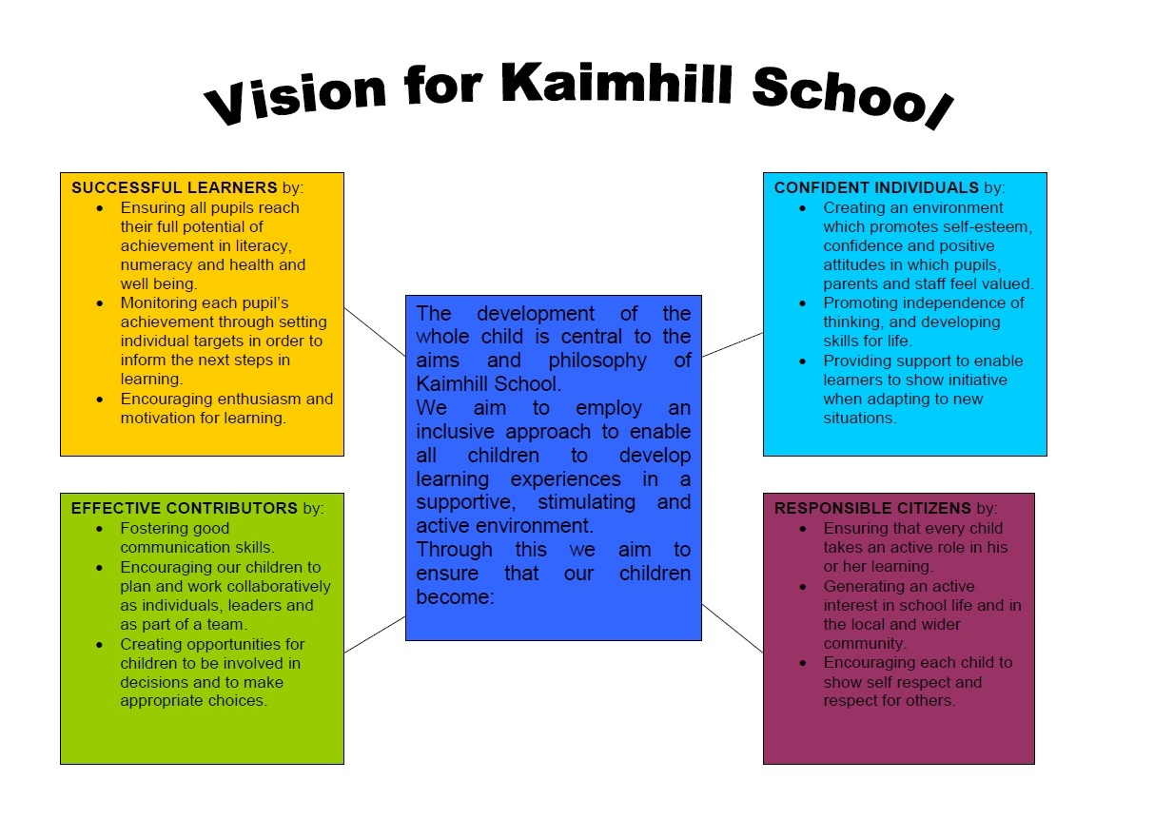

A review and update of our vision for Kaimhill will be undertaken next session which will consolidate the vision developed by the new management team and which will take account of School, ASG & Aberdeen City Council priorities and current trends in attainment and achievement.

Consultation opportunities will involve meaningful engagement with Pupil Voice and Parent Forum and will include feedback from views sought this session (Staff workshops and consultation with parents).

How do we consult and engage with pupils and parents?
The school has a range of processes to ensure pupils and parents are consulted with on a regular basis.
Pupil questionnaires are distributed annually and feedback is used to address areas of concern and to develop improvement priorities and initiatives. There is scope to improve children’s understanding of the impact of these consultation activities and to promote and value pupil voice as a conduit for positive change.
Following a reorganisation of pupil groups this session, all children have opportunities to regularly participate in a range of groups and to take some responsibility for leading aspects of school development. These groups require to be more focused on school development, with greater priority given to pupil participation and choice. Aims and objectives for most groups lack clarity and this will be addressed next session. There requires to be greater information sharing across the school community regarding the activities these groups undertake, their links with school developments and subsequent impact.
Almost all children are consulted and given the chance to have their say, for example, through pupil group audits/questionnaires. There requires to be further clarity around the impact of the work of the Pupil Council as aims and achievements are not clear. This will be addressed next session as the Pupil Council assumes responsibility for leading the development of the Rights Respecting School initiative at Kaimhill School.

Across the school, children have opportunities to make choices about aspects of their learning activities, for example, in choosing what they wish to find out about in topic work or the organisation of events to which their parents will be invited. In all classes, children are supported to review their own learning, and that of their peers, at the end of most lessons.
Homework is used well in all classes to reinforce and extend children’s learning and provides a meaningful home/school link, enhancing parental knowledge of their child’s learning. Feedback from parents indicates that some would appreciate more opportunities to develop a clearer understanding of the homework assignments set for their children.
Children benefit from enhanced consultation with class teachers about their learning and the setting of personal targets closely linked to their ability to develop as independent learners, specifically for writing. This approach needs to become more embedded across the curriculum. There needs to be a more robust mechanism in place for consultation with nursery pupils and to promote their engagement and participation in the wider life of the school. Nursery parents need to be given a stronger role in identifying their children’s wider achievements.

Our approach to parental involvement is increasingly planned and purposeful. We actively encourage parents to participate in their children’s education through our open afternoons, events and newsletters. Open events are well attended and there is a commitment to extend this effective approach next session to further involve parents and to promote active participation in their children’s learning.
Our parents, including those with vulnerable children, participate in relevant meetings and support school events. The Parent Council meets regularly and is supportive of school initiatives. There is scope to further involve the Parent Forum in meaningful development of school priorities and to ensure groups representing learners and parents have regular and informed opportunities to be involved in making decisions about the future work of our school.
Concerns are addressed promptly and most parents are satisfied that issues are dealt with fairly. All staff are committed to meeting with parents to resolve issues in a timely manner and to achieve positive outcomes.
Almost all our parents have stated that they are very satisfied with the quality of education we provide.

A Fundraising Committee is responsible for planning and organising whole-school fundraising events. Their work continues to be very successful and provides opportunities for parents and carers to take an active part in the life of the school. The work of this group therefore enables time at Parent Council meetings for focused discussion around school development priorities, policy and procedures.

Most parents/carers attend our interview appointments. A variety of times is offered to accommodate working parents. A translator is organised, if required. Telephone interviews are also offered to parents who have difficulty getting to school. We always maximize the opportunity to consult with parents who attend Parents’ Evenings through a range of traditional or more creative approaches. We need to improve the feedback we provide to parents as a result of these consultations and the decisions they inform.
We report annually to parents and learners on our improvement priorities and key outcomes. There is scope to improve parental attendance at curricular sharing sessions by involving pupils more fully in these events. Next session, parents will be offered more planned, informal opportunities to receive feedback from teachers and pupils about curricular developments and their child’s progress. Inclusion of pupil voice will be at the heart of this approach.
How well do our children/young people learn and achieve?
The majority of children learn and achieve well. In the nursery classes, most children are engaged and motivated in their learning. Older children are very familiar with nursery routines and confidently lead their own play across the playrooms and outdoors. Children are beginning to take more responsibility for their own learning experiences. Staff are aware that children require further support to participate in planning aspects of their learning.
Children receiving targeted support in the Rainbow and Rocket Rooms benefit from supportive relationships with their teachers and PSAs, who have a nurturing understanding of their needs as learners. All children have increased confidence and self- esteem and are respected as individual learners. Work undertaken with Adventure Aberdeen this session has been a key factor in widening the context of their learning and opportunities for achievement. Children are motivated to learn and contribute increasingly to the life and ethos of our school.
In the Dyslexia Unit, most children engage well in their learning and benefit from their classwork. Some children have required additional focused support to participate in the work tasks and close partnerships have been developed with both home schools and parents to support attainment and achievement for these children. Most children make good progress from their prior levels of attainment using school-based data and assessment information.

Across the primary classes, almost all children are active in their learning. They work well individually, in small groups and as a class. Most carry out tasks and activities very responsibly. Children are involved in planning and evaluating aspects of their learning and staff will continue with plans to develop this further to ensure consistency in approach across all classes.

Pupils have achieved in a range of personal and wider accomplishments including school performances, sporting events and residential experience. These achievements are celebrated across the school and wider community. The pupils are represented by a range of committees which include Science Technicians, Pupil Council and the ECO-Fairtrade group. They increasingly exercise pupil voice and contribute to school improvement. Children are motivated to do their best through a range of school initiatives to celebrate their achievements such as the end of session ‘Celebration Awards’ ceremony as well as regular recognition at weekly assemblies. Health and well-being aspects feature strongly in the children’s learning and across the school. Kaimhill was awarded Highly Commended Primary School of the Year from Aberdeen Sports Award in recognition of sporting achievements. Work is significantly underway to achieve the Gold Award for PSQM with sustainable community links being fostered as a key part of this work. Most children continue to achieve very well in science and are motivated by their progress as learners.

Raising and maintaining attainment and achievement continues to be a priority within Curriculum for Excellence.
Priorities identified within the School Improvement Plan enable staff to improve the quality of the work of the school and have a positive impact on children’s learning for the majority, for example, by further developing children’s active learning in literacy and science. Children’s skills in aspects of writing continue to improve and staff are providing learners with more active experiences in mathematics.
Children are increasingly involved in planning aspects of their learning. A heightened focus on Curriculum for Excellence and in raising standards will continue to support improvements in children’s learning, performance and well-being.

Focused analysis of PIPS and INCAS data has improved the effectiveness of tracking pupil progress and has led to improved learning outcomes for the majority of pupils. Procedures for tracking pupil progress are consistently employed across all classes and used to identify next steps in learning. Tracking of pupil progress, including PIPS data, indicates the majority of pupils are making satisfactory progress from prior levels of attainment. Generally, there is positive value added at all stages with pupils in P1 making excellent progress and almost all performing as expected or above. There is evidence that some children are under achieving in P3 and P7. This needs to be improved especially for the middle range of pupils to ensure they are appropriately supported and challenged to achieve improved attainment and that value is added to their learning.

TRENDS IN PERFORMANCE

READING *
STAGE | 2012-2013 | 2013-2014 | 2014-2015
Primary 1 | 82% | 82% | 97%
Primary 3 | 86% | 75% | 62%
Primary 5 | 74% | 54% | 74%
Primary 7 | 86% | 74% | 75%

NUMERACY *
STAGE | 2012-2013 | 2013-2014 | 2014-2015
Primary 1 | 50% | 50% | 95%
Primary 3 | 74% | 76% | 71%
Primary 5 | 75% | 44% | 76%
Primary 7 | 60% | 67% | 69%
*Percentage of pupils who are achieving as expected or above in reading and numeracy using PIPS data.

CfE Milestones **
 |  | 13/14 | School Average | 14/15 | S.A.
Reading | P1 –  P4 –  P7 - | 75%  81.6%  14.8% | 57.1% | 100%  65%  70% | 78%
Writing | P1 –  P4 –  P7 - | 69.4%  65.8%  3.7% | 46.3% | 97%  67.5%  56% | 73.5%
Numeracy | P1 –  P4 –  P7 - | 69.4%,  94.7%,  7.4% | 57.2% | 97%  75%  73% | 82%
**14/15 children working within appropriate levels

Next Steps include:
- Continually develop nursery children’s literacy and numeracy skills. Use of ASPECT information to identify and plan for children’s next steps in learning.
- Develop opportunities for all learners to be more actively involved in the wider school community.
- Further develop the work of the Dyslexia Unit, offering an outreach service to build capacity across ACC and to ensure measurable (IEP) targets are in place for each child.
- Track the attainment and achievement of children receiving universal and targeted support more robustly from prior levels of attainment.
- Introduce more detailed tracking for all pupils, using regular standardised assessments, such as GL Assessments. Consider how these articulate with PIPS, INCAS and CfE levels.

How well do we support our children/young people to develop and learn?
Kaimhill School has a well-established ethos which promotes a sense of equality and fairness through the curriculum and many aspects of school life. We promote and sustain an inclusive culture where we celebrate the individuality, skills and talents of ourselves and others. Individual children are a planned focus for discussion at nursery meetings, learning conversations and Senior Management Team (SMT) meetings, and we are establishing more effective systems, in line with Getting it Right for every Child (GIRFEC), which record and track support for individual children. Vulnerable children’s needs are promptly identified and appropriate interventions are implemented with the support of outside agencies, where required. Our culture is one which promotes attainment and achievement and is manifested on the principles of inclusion, participation and positive behaviour based on mutual respect and trust. At Kaimhill School, culture, language, disability, gender, race, religion, sexual orientation and additional support needs do not become barriers to participation and achievement.
We adhere to and apply current legislation to meet our learners’ needs. We are establishing improved systems for recording progressive learning targets for all our learners. We are working towards a more consultative model which fully takes account of GIRFEC principles when identifying individual targets for learners receiving targeted support. Teaching and PSA staff are sensitive to individual needs and actively seek solutions to remove barriers to learning and achievement. We readily seek advice and support from our partner agencies and act upon it. We benefit from increasingly close partnership working, as part of effective multi-agency teams, who deliver support to vulnerable children and their families to address well-being concerns. Proactive communication and nurturing relationships are a key strength of our approach.
We embrace new initiatives and employ a range of strategies such as restorative justice, interdisciplinary approaches, co-operative and active learning and AifL to support and enhance learning and teaching.

Our curriculum design takes account of local and national advice and continues to develop as a result of self-evaluation activities and consultation with stakeholders. We continue to seek opportunities for other agencies to engage with our learners i.e. Active Schools, Grow Well Choices, RGU & Aberdeen University sports groups. Our commitment remains to engage our learners in purposeful learning experiences across all curricular areas. We recognise opportunities for interdisciplinary learning to promote the principles of Curriculum for Excellence and will continue to develop these. Transition arrangements are in place to maintain continuity and progression. Good links are established with Associated Schools Group (ASG) colleagues and working groups. Our learners experience a broad, balanced curriculum with appropriate tasks, activities and resources differentiated to provide support and challenge. The pace of learning for the majority of groups or individuals is appropriate. A range of assessment strategies is increasingly embedded into classroom practice including Assessment is for Learning (AifL) strategies. Interactive Learning Diaries have been introduced to provide the opportunity for triangular communication and tracking of progress. This will also enhance our partnership working with parents and carers. Staff will be supported to ensure this approach is increasingly embedded and effective next session.
Almost all the teaching staff participate in the teacher learning community which regularly meets and focuses on developing assessment approaches and techniques across the curriculum. Feedback from teachers involved continues to be very positive, indicating improved staff confidence, higher quality questioning and heightened awareness of the importance of quality feedback to pupils.
Work on pedagogy within staff development has had a positive impact on staff and pupil confidence. Our focus on Writing and Science has improved teacher confidence and as a result has enabled them to provide greater challenge in learning, and to assess and moderate attainment in these areas more accurately.
Next steps
- Ensure that any input from SfL staff is more rigorously tracked and evaluated regularly to monitor impact.
- Develop plans to track progression and teaching of skills (Literacy and Numeracy focus).
- Continue with moderation work to ensure consistent understanding of CfE levels.
- Planned, timetabled liaison between teacher teams providing targeted support to children to be developed.
- Optimise opportunities to celebrate diversity of our student population though assemblies, pupil group activities and to raise awareness of our global responsibilities through Rights Respecting School activities.
- We recognise the need to develop formal partnerships which encourage innovation, creativity and enterprise skills.

How well do we improve the quality of our work?
A culture for self-evaluation is actively promoted within Kaimhill School, with a high level of commitment from senior management to support high standards for professional reflection. All staff have a clear understanding of the targets that have been set and are supported to deliver these within set timescales. SMT provide staff with structured approaches to quality assurance which sustain focused dialogue on key indicators. Monitoring is highly supportive and structured to engage staff in quality reflection and identification of relevant next steps for learners and in their own professional development. However, more rigour and consistency is required in some cases to ensure subsequent improvements make an impact on the quality of learning and teaching for learners. Staff will be supported by SMT, through revised quality assurance procedures, to further grow the culture of self-evaluation at all levels within the school. All teachers have their own Quality Assurance folder, so that records of class visits and other activities can be referred back to, tracked and followed up.
Opportunities for staff to discuss their work and share good practice are developed and enhanced through the ongoing work of a teacher learning community. This impacts positively on meaningful self-evaluation as staff report increased confidence in using strategies with learners in their classrooms.
All staff willingly participate in the creation of improvement plans which take forward school priorities. This participation enables staff to effectively lead and implement priority curricular initiatives which improve learning and teaching and impact positively on learners. Staff increasingly reflect on actions identified through professional dialogue to inform next steps in school development. Staff demonstrate a critical knowledge of school, local and national priorities and understand how these come together to inform our improvement journey. All staff have a clear sense of their professional responsibility in moving forward school developments.
Distributive and shared leadership is evident across the school and staff work well together as a team. Collaborative approaches increasingly promote shared values and reflective practice, which impacts by promoting and raising standards for all stakeholders in our school community. The systematic development of a robust self-evaluation process for staff will include collegiate, peer and self-assessment opportunities and reflection on the impact of learning and teaching.
Our school constantly explores ways to support improvement through developing individual talents and skills. We provide opportunities for staff to undertake lead roles in a variety of contexts and nurture and develop their expertise and confidence. Provision of CPD and PR&D for staff is undertaken through consideration of the needs of the individual, the school and its context and external priorities.

Team work and improved communication systems in the nursery setting has enhanced provision for children as staff use a clearly defined self-evaluation process to reflect on the needs of and provision for all individual learners.
Systems used to gather the views of the school community about the quality of our work are systematic, although the sharing of outcomes and information gathered has to be improved. Opportunities for self and peer evaluation in classes involving all pupils are increasingly systematic and have improved pupil awareness of achievement and performance.
All nursery staff regularly self-evaluate learning and teaching experiences and nursery procedures. They make effective use of this process to introduce innovative changes to improve outcomes for learners.

All children have opportunities to be actively involved in the self-evaluation process and pupil voice is becoming more prominent. Most children feel they have opportunities to be listened to and that their views are taken into account through the range of pupil groups in the school, interaction with their class teacher on a range of issues or through the setting of personal targets.
Disruption to the SMT structure and core staffing have impacted on the momentum for change in some aspects of the School Improvement Plan (2014-15) and, consequently, staff confidence to move priorities forward. The development of a more embedded approach to distributive leadership, at all levels within the establishment, will increasingly support momentum for positive change.
Most staff have indicated willingness to take lead roles in a variety of contexts which will impact positively on learning and teaching and collegiate approaches to moving the school forward. This will inform a review of coordinator responsibilities and how these roles will be supported and developed next session.

Opportunities for pupils to develop leadership roles in and out of school need to be further developed to heighten pupil responsibility and promote participation. Further development of pupil groups will provide enhanced opportunities for the contribution of ‘pupil voice’ to the School Improvement Planning process.
All nursery staff have played a role in leading improvement and innovation in learning and teaching with improved outcomes for learners.

Next steps
- Develop peer observation to enhance the effectiveness of school development work, build staff confidence, share practice and support self-evaluation.
- Develop better systems for sharing school improvement progress with Parent Forum i.e. newsletters, school website etc.
- Further develop leadership though ACC coordinator roles, ensure time allocated at staff development meetings etc.
- Staff and pupil teams will benefit from further support to work together effectively and with clarity, to ensure that pupil groups and pupil voices play a more significant leadership role within the school. Staff should ensure that pupil groups have a clear purpose and are aware of their contribution to school improvement priorities, vision and ethos.

Our key strategic priorities for improvement for next session
SCHOOL PRIORITIES

Priority 1: Continue to develop the curriculum as planned (Literacy – Interdisciplinary Writing & Reading, BIG Maths, H&WB, PE, 1plus2 approach, moderation, progression & skills development)

Priority 2a: Meeting the Needs of Learners (Dyslexia Friendly School, Multi-agency working, Tracking & Attainment approaches/assessment, Inclusion Review – Targeted support/SfL support

Priority 2b: Meeting the Requirements of Legislation (SEEMiS – Child’s Plan, IEPs, GIRFEC, Children & Young Person’s Act (Scotland) 2014

Priority 3: Develop use of Technology to support Learning and Teaching (SEEMiS – Reporting to parents, Pastoral Notes, Child’s Plan, Recording & Tracking, Interactive Learning Diaries)

ASG PRIORITIES

Priority 1: Numeracy
- Raised attainment and confidence of learners in numeracy
- Raised confidence of staff in relation to numeracy

Priority 2: Literacy
- Raised attainment and confidence of learners in literacy
- Raised confidence of staff in relation to literacy

Priority 3: Health & Well-being
- Raised attainment and confidence of learners in relation to health and well being
- Raised awareness of staff in relation to health and well-being

