Welcome to Ferryhill Nursery
This booklet provides information on the day to day running of the Nursery.

Classes
There are two nurseries at Ferryhill, each with a class in the morning and a class in the afternoon. Up to twenty children are in each class.

Team
Each nursery team comprises a nursery teacher and a nursery nurse.

Timetable
Morning: 8.40a.m.-11.50a.m.
Afternoon: 12.30p.m.-3.40p.m.
Nursery Aims
Ferryhill Mission Statement –
To provide a positive warm ethos to enable the children within our care to be Successful Learners, Confident Individuals, Responsible Citizens and Effective Contributors.
At Ferryhill School we aim to:
- Ensure that all children feel safe, secure and happy and are given every opportunity to achieve their full potential.
- Ensure that all children, staff, parents and visitors feel welcomed and valued.
- Ensure that the curriculum ensures progressions, depth of learning and enthusiasm.
- Ensure that each child becomes an independent and confident learner.
- Ensure that everyone involved feels as though they have a voice that is heard and that a safe environment for questioning purpose exists at all levels.
- Ensure an inclusive ethos of equality, fairness and respect for others.
- Ensure that the school environment is attractive and organised allowing easy access to all available resources.
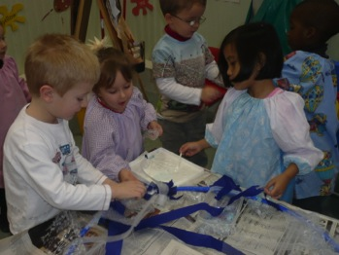

Clothing
Children are encouraged to wear a nursery hooded sweatshirt/t-shirt(These can be purchased from the nursery team)They need soft shoes with rubber soles for wearing inside and a drawstring bag to keep a change of clothes in. These should all be clearly named. Other clothing should be comfortable and easy for the children to cope with when they go to the toilet. We play outdoors in all seasons so the children should have suitable wear for all eventualities. If the children are doing a messy activity the nursery will provide an overall. |  | 

Health
Any relevant information on your child’s health (allergies, sensitivities etc.) should be shared with staff, who will maintain confidentiality at all times. Children who are unwell are best kept at home for their own sakes as well as the interests of others. Parents are asked to keep at home any child who has been vomiting or had diarrhoea until at least 48 hours have elapsed since the last attack. Sending a sick child to nursery means putting all the other children and the staff at risk. We ask that parents provide each child with a box of tissues to be used in nursery during the course of the year, and a box of wet wipes to freshen up after snack.

Safety
At all times we do our best to ensure that the nursery is a safe environment for all.
Children must be accompanied to and from nursery by a responsible adult (over 16 years old). Please notify staff of any changes to your normal collection procedure .
For the safety of all children, parents should not park on the zig-zag lines outside school.

Snack-time
‘Snack-time’ is an enjoyable and instructive part of the nursery curriculum, allowing the children to help prepare, serve and taste a variety of foods. As a health promoting school, we provide a daily portion of fruit with other small items that can be selected to reflect the teaching in the classroom. Milk and water are available to drink. A weekly menu is posted outside the classroom.
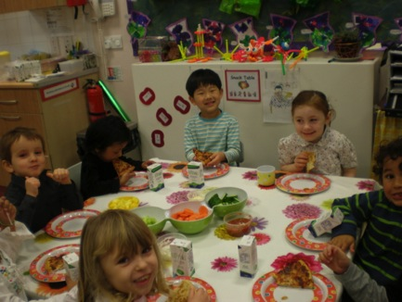
Staff should be informed of any allergies or restrictions on diet for religious or other reasons.

Snack costs £10 per month per child. As the food has to be purchased in advance, it is not possible to give refunds for absence.

Starting Nursery
When your child is allocated a place you will be invited to an induction meeting where you can familiarise yourself with the school, listen to a brief introductory talk and raise any questions you may have.

Phased Entry
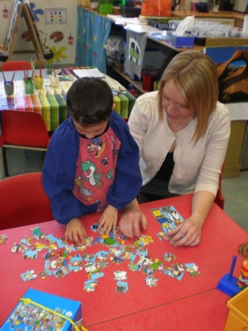
According to Authority policy, children will be phased into nursery in small groups, over a short period of time. This is to let the staff get to know your child as an individual and make their entry as pleasant as possible.

Most children enjoy nursery and settle in quickly but don’t be upset if your child becomes clingy or unwilling to be left. Be positive – reassure your child and tell them when you will return. Tears usually disappear as soon as the parent/carer has gone, but be assured that the staff will be in contact if your child is in lasting distress.

Play and the Curriculum

Curriculum for Excellence aims to achieve a transformation in education in Scotland by providing a coherent, flexible and enriched curriculum from 3 to 18. The purpose of Curriculum for Excellence is to enable each child or young person to be a successful learner, a confident individual, a responsible citizen and an effective contributor.
It should enable every child to develop his or her full potential through a broad range of challenging well-planned experiences which help them develop qualities of citizenship, enterprise and creativity.

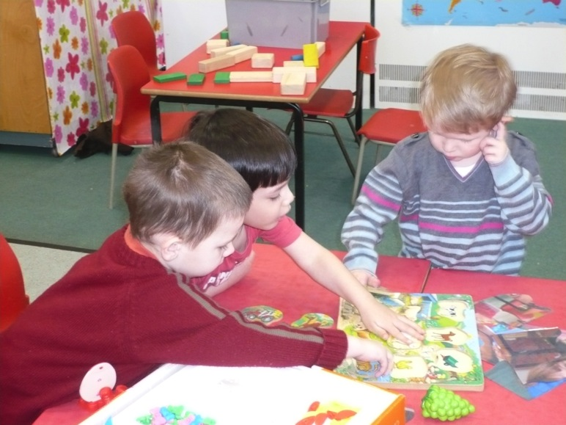

Learning

Play is a child’s work, it is the way in which they learn about the world around them. Through quality play experiences, supported by the staff, children explore, investigate, observe and experiment.
Play can be solitary, parallel or co-operative, and opportunities to enjoy different ways of playing are provided. Children are given activities appropriate to their own development selected by staff in consultation. Activities provided will include both the challenging and the familiar.
Play is a holistic experience allowing for expression of feelings and personal growth. Children can learn many different things from a single play experience in a supportive environment.

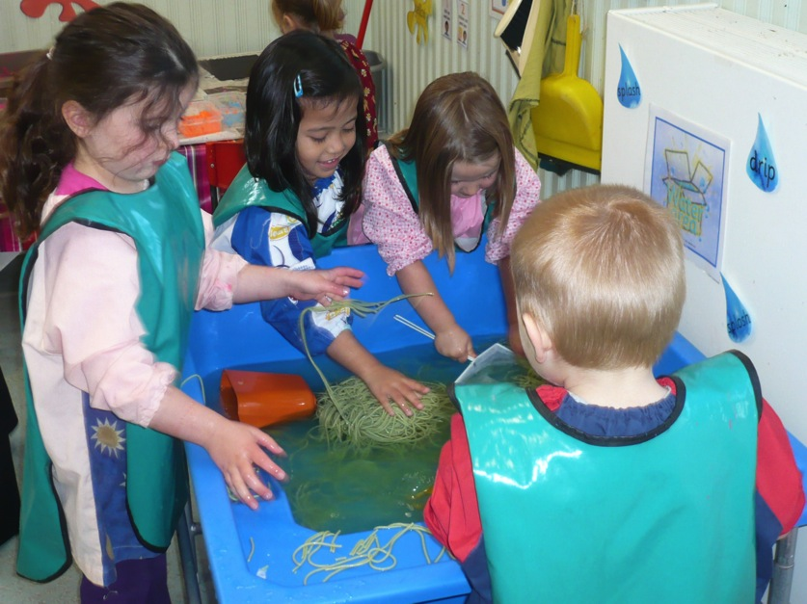

Assessment and Reporting

When your child starts nursery you will be asked to fill in a form so that the staff have basic information about your child, especially any medical or family circumstances that might affect their learning.
Throughout the year the staff will be observing your child at play. This helps them plan how best to support the children’s needs. They will keep a record of his/her development and significant achievements, a summary of which will be shared with you at the end of the year.
Parents/Carers will also be given a chance to meet formally with staff to discuss their child’s progress during the autumn and summer terms.

Parental Involvement

As well as formal meetings and the daily informal contact we share, the staff are always happy to discuss any issues that may arise. Effective communication is important, so please talk to us if you have any concerns. An appointment can always be made, if necessary, to ensure more time and privacy.
Parents are children’s prime educators in their earliest years and continue to play a major role when they enter more formal settings. Home – school links are essential to your child’s education and we greatly value our relationships with parents.

You can help us by:
- not arriving too early or being late to collect your child as this cuts into staff preparation time
- reading the nursery notice-board (outside the classroom ) for information and displays
- participating in nursery life by attending sessions on an occasional or regular basis to help with activities
- sharing any talents or skills you may have, coming along on trips and excursions, or just ‘mucking in’.
- distributing our Story Sacks which the afternoon children borrow on a weekly basis
- helping out with tooth brushing for one session a week


You can help your child at home by:
- encouraging conversation
- sharing books
- playing games
- singing songs and learning rhymes, drawing,
- painting, cutting and sticking
- looking at print in the environment
- encouraging independence
Praise, Discipline and Rules
All children respond favourably to praise and recognition. In nursery we give children encouragement and focus on positive behaviour. This builds self-esteem and confidence. There are few rules, but those we have are necessary for the safety and well-being of us all. Staff will deal with your child in a kind and caring manner. The children are similarly encouraged to treat each other and adults with respect and consideration.

When in nursery we:
- walk, don’t run in the area
- use our quiet voices, don’t shout
- are careful, look after our things and each other
- have fun and keep safe ( no child is ever left without an adult nearby)

Equal Opportunities and Inclusion
In line with Aberdeen City Council policy, we are committed to a policy of multi-cultural and anti-racist education. Through a range of activities we let children see that there are many different ways of seeing and understanding the world. The creation of a stimulating environment reflecting different cultural traditions through art, drama, stories or food enhances the early years setting. Books, pictures, stories, rhymes and puzzles reflect positive images of people of different races and cultures and show girls, boys, men and women in a variety of roles. Children with disabilities will be given full access to our provision, and care will be taken that their needs are met.

Transition to Primary One

The staff will complete your child’s record of development and liaise with the Primary 1 teacher to ensure continuity and progression. Your child should by this time be very familiar with our school setting. However she/he will be given the chance to take part in a transition project with the primary ones, visit their future classroom and meet with their teacher. You will be invited to a meeting, where you will find out more about the provision.

Deferred Entry
Some children may benefit from another year in nursery although they may technically be old enough to go to school. This is known as ‘Deferred Entry’. Those who have their 5th birthday in January or February have the right to defer entry to school if their parents wish. Those whose birthday falls between the start of the school term in August and the end of December, may choose to defer if this is felt to be in the best interest of the child.

Complaints Procedure
If you have a query or a problem which you feel has not been reasonably addressed by the nursery staff, please in the first instance contact one of the following:
Mr David Wallis (Headteacher)
Mrs Ruth Legdon (Depute Headteacher)
The key principle of the Education Service’s customer care procedure is that concerns and issues should be resolved as close to the point of delivery as possible.

If you feel the query has still not been reasonably addressed, please contact:
Penny Morton
If you still feel your issue has not been resolved, contact:
The Care Commission
Penny Morton Quality Improvement Officer.  Mariscal College Broad Street Aberdeen AB10 1AB  Tel. (01224) 523818  pmorton@aberdeencity.gov.uk | Care Commission North Region Johnston House Rose Street Aberdeen AB10 1UD  Tel. (01224) 793870

Finally
We hope that this booklet has given you a brief insight into our nursery and that you have found the information useful. We are looking forward to getting to know you and your child and to a happy future together.

