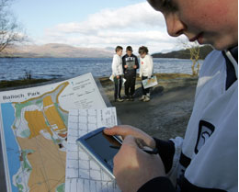
Opportunities for personal achievement

Pupils attending our school have opportunities to achieve in a range of activities out with class contact hours.
We work, or could work, as a school and in partnership with local organisations to support and encourage our young people to undertake activities detailed in the table below. Our pupils’ participation will be, or could be, affirmed, achievements recognised, and where appropriate we will, or could, allow the opportunity for skills developed by pupils and targets for improvement to be discussed.

Activity Delivered by Age/stage Day/time Location Person responsible Awards/Recognition Uptake/notes
available
Junior Shinty | Lochavish  Shinty Club | P1-P7 | Wednesdays  6pm-7pm | Community  Playing field | Jim Hudson  (local volunteer) | Local Shinty sixes League | 18 attend: all pupils at school
School Choir | School | P4-P7 | Mondays  3.30-4.30pm | School | Marie MacPherson (teacher) | Certificate of participation + Local/Nat Mod competitions | 16 attend

