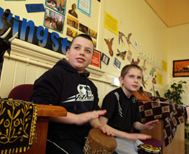
Interdisciplinary learning and more . . .

- Add rows as you see fit e.g. personal achievement, discrete curriculum/subject areas.
- Customise stages/CfE level.
Stage / CfE level |  | Term 1 |  | Term 2 | Term 3
EXAMPLE  Early or  Early level class | IDL
Ethos/
Life
EXAMPLE  First or  P2/3/4 stage | IDL
Ethos/
Life
EXAMPLE  Second or  P5/6/7  stage | IDL
Ethos/
Life
At all stages
- This is you starting to map out the seven to nine year plan (a snapshot in time plan, not a 2014/15 – 2023/24 plan!).

