Curriculum area/subject | Main or core method of delivery/resource | Partner organisations, groups, individuals | Events or contexts for application | Other features/notes
EXPRESSIVE ARTS
art & design, drama, music

HEALTH & WELLBEING
Personal & social development, health, PE

LITERACY/ENGLISH/GAIDHLIG

LANGUAGES (ADDITIONAL)

NUMERACY/MATHEMATICS

RME
Christianity, other world religions, philosophy

SCIENCES
biology, chemistry, physics + environmental contexts

SOCIAL STUDIES
history, geography + social, political/economic/business contexts

TECHNOLOGIES
craft, design, engineering, graphics, food, textile, IT

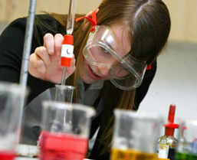
Curriculum areas and subjects

