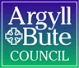

Standards and Quality Report 2025 - 2026

Small Isles Primary School & ELC


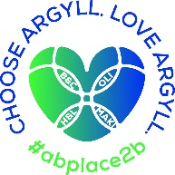


Context of the school
Including some or all of the following:
- basic school details (roll, class composition etc.)
- school vision, value and aims;
- local contextual issues;
- factors affecting progress (e.g. staffing changes/issues).

Small Isles Primary and ELC is a non-denominational and co-educational school situated in the village of Craighouse on the Isle of Jura. In session 2025/26, we had 19 children ranging from P1-7 and 3 children in our Pre 5 unit.

Our school staffing consists of a full-time class teacher for P5-7 and a part time class teacher for P1-4 who is also our Principal Teacher. We also have a class teacher covering NCCT and P1-4.
A classroom assistant also supports both classes. A Shared Head Teacher works between Small Isles and Keills on the neighbouring island of Islay.

In ELC, we have two full time Childcare and Education workers for Pre 5 and an ELC Classroom assistant. The ELC unit had a Care Inspectorate Inspection in June 2025.

The school is a relatively modern single storey building, situated close to the shore, with one large open plan classroom which provides teaching bases for both school pupils and those pupils who attend the Pre 5 unit. There is a small hall which functions as a meeting room, a dining room and a workspace for pupils when required.

Including ELC, 47% of our children live within 2 miles of the school within the village of Craighouse. The remaining children are split between local settlements ranging between 4 and 10 miles away.
Our attendance as of June 2026 was 93.86%.
Our associated High school is Islay High.

Our Vision, Values and Aims were established in 2024 and are as follows:

Our Vision: At Small Isles, we strive for our children to flourish, be caring local and global citizens, be themselves and be celebrated for who they are.
Our values are: Ambition, Respect and Compassion.
We aim to:
O Ensure our children reach their potential and be ambitious by supporting them to achieve and persevere through a Growth Mindset.
O Recognise our children’s’ achievements inside and outside of school.
O Display kindness and empathy towards all, supporting each other on our school journeys.
O Listen to each other and make sure everyone has a voice.
O Ensure that Children’s Rights are at the heart of everything we do!

Small Isles Primary is situated in the village of Craighouse on the Isle of Jura. Craighouse is the main village and is located on Jura’s sheltered east coast. Main industries on Jura are; Whisky Distilling, Farming, Fishing, estate work and Tourism. Access to the island is by ferry from Islay or rib from Tayvallich.

Being an island school within a strong local community rightly influences our place-based learning curriculum design. Our Curriculum Rationale was developed this year.

In June 2025, Small Isles earned GOLD status in the Rights Respecting schools Award. A Rights Respecting Gold school in Scotland is a school that has achieved the highest level of the UNICEF UK Rights Respecting Schools Award (RRSA). This Gold accreditation signifies that the school has fully embedded children's rights throughout its policies, practice, and ethos, using the United Nations Convention on the Rights of the Child (UNCRC) as its foundation.

SCHOOL
Quality Indicator | How are we doing? | How do we know? (Evidence) | School Self-Evaluation (1-6) *
1.1 Self-Evaluation for Self-improvement | All staff, parents and pupils are regularly consulted and involved in improving life and work of the school.  Regular opportunities for parent views through Google Forms and PC meetings.  Regular opportunities for pupil views through weekly assemblies and consultations.  Staff work effectively as a team. All involved in SIP.  Children involved in aspects of school improvement.  Children regularly reviewing own learning.  Staff engage in up-to-date research and relevant literature to inform practice.  Parents have regular opportunities to support improvement. | Collegiate Calendar developed in consultation with staff. Quality Assurance Calendar developed.  Regular staff meetings through course of the year to address SIP priorities.  Parent and pupil consultations. Results actively used in SIP planning.  All pupils in Improvement Teams. Views sought and acted upon.  Regular opportunities for joint planning within school and between cluster schools.  Pupils review work and set next steps both verbally and by recording in jotters.  Pre 5 staff engaged in reading tasks relating to Realising the Ambition document, Literacy and Numeracy tracking and assessment.  PTA support with funding resources and transport. | 4
1.3 Leadership of Change  This QI also focusses on the following aspects of empowerment:  - curriculum;  - improvement activities;  - parental and community engagement; and  - pupil participation. | All staff have high expectations of all learners.  All staff have a clear understanding of local context and use this to shape vision.  All staff clear on areas of improvement and future vision of school.  Staff are involved in leading change throughout the school.  Children are involved in leading change across the school | Regular dialogue at staff meeting regarding expectations, vision, evaluations and improvement.  Staff live locally and have established relationships with families.  Children involved in redesigning VVA. Linked to HWB curriculum and RRSA work.  Children involved in developig a new relationships policy.  Opportunities for staff to attend collegiate meeting with cluster schools eg. TLC and Moderation meetings.  Regular HT consultations with stakeholders on areas for improvement.  RRSA GOLD Status Award.  PRD meetings highlight areas for staff CLPL and opportunities to lead aspects of school improvement.  Staff attending CPD events relevant to SIP and own development needs.  Staff are given areas of SIP and are supported by HT.  PT supports CT and Pre 5 staff when HT not in school. | 4
2.3 Learning, teaching and assessment | Children are motivated and active participants in learning.  New planning formats developed to allow for high quality learning experiences.  Learning experiences are varied and use high quality resources now including digital technologies.  Learners receive high quality feedback and create own next steps.  Learners are involved in learning process.  Tracking and monitioring is now in line with XBRA and being used effectively.  Power up Pedagogy elements introduced this session. | Robust Quality assurance calendar created to ensure a variety of evidence (Observations, pupil conversations, jotter monitoring, peer shadowing)  HT and CT tracking meetings taking place using various evidence including assessments and teacher professional judgemements alongside benchmarks.  Shared expectations across learning community and authority wide with moderation activities (TLCs and INSET Moderation session)  Learners activley involved in decision making around planning across school and including Pre 5.  Peer Observation & Collaboration  Professional Learning Logs  Co-Constructed Rubrics | 4
3.1 Ensuring wellbeing, equality and inclusion | Staff and Pupils Wellbeing placed as high priority each year.  Staff and pupils have a shared understanding of wellbeing and learners can demonstrate how to be safe, healthy, achieving, nurtured, active, respected, responsible and included.  Positive relationships across school community.  Staff model behaviour which supports wellbeing of all.  Children are active participants in discussions and decisions.  Children with additional learning needs supported with interventions.  Outdoor space used more to enhance learning experiences and wellbeing. | Rights Respecting School award: GOLD  Regular staff check in meetings.  Regular Leavens observations for children and scores tracked, interventions in place if required.  Weekly whole school and Pre 5 assemblies on Wellbeing Indicators, school values and Rights.  Staff, pupil and parent feedback on positive and supportive ethos of school.  School Improvement Teams actively involved in leading school change.  HT observations, term 1 based on learning environment.  Improvement Teams led by children  Regular involvement of children in discussions around school improvement at assemblies.  Allocated classroom assistant time given to interventions to raise attainment and support pupils.  Island partnerships established and new partnerships recently formed. | 4
3.2 Raising attainment and achievement | Attainment levels are a central feature of SIP.  Interventions/catch up plan/additional teacher put in place to support pupils not on track to achieve a level.  Children involved in decision making relating to own learning. | Literacy and Numeracy Data tracked from termly Progress and achievement tracking meetings. XBRA tracking used.  HWB information tracked over time using Leuvens Scales.  Interventions planned, monitored and evaulated termly.  Teaching judgements are made using benchmarks and range of assessments | 4

ELC Small Isles ELC had a CI Inspection in June 2025-Evaulation is based on the findings from this Inspection.
Quality Indicator | How are we doing?  (Progress) | How do we know?  (Impact + Evidence) | Establishment  self-evaluation  (1-6) *
Leadership and management of staff and resources | The service's aims and objectives set out a clear vision for the setting.  A structured and proactive approach to monitoring and evaluating the quality of service delivery through the implementation of a quality assurance calendar. Regular audits, reviews, and reflective practices are scheduled and carried out consistently, supporting a culture of continuous improvement.  Regular meetings and daily debriefs at the end of the session provided opportunities for ongoing communication and responsiveness to children's needs.  The staff team demonstrate a commitment to their continued professional development and are supported by management to undertake both essential and targeted training aligned with identified areas for improvement | The staff team maintained an evaluation folder aligned with the framework 'How Good Is Our Early Learning and Childcare' (HGIOELC), which included action points from previous local authority early years team visits.  Professional Learning Logs to enhance the reflective practice and ensure that important insights are documented and acted upon.  QA Calendar  Regular monitoring of staff training, alongside more frequent one-to-one meetings to reflect on learning and set professional development goals.  CI Observation:  Staff told us that they felt well supported by the manager and they felt there was a  positive atmosphere of mutual trust and respect. This contributed to a happy, secure, and nurturing environment for children and their families | 4 Good
Curriculum | Our curriculum design has a strong pedagogical basis, blending a rights-respecting ethos with principles that value play and full-bodied movement as core vehicles for learning. We maximise our unique island location, utilizing our local environment, community, and heritage to provide a context-rich, outdoor-heavy learning experience.  The curriculum framework is highly responsive, adapting dynamically to the shifting interests, developmental stages, and universal needs of our young learners.  Literacy, numeracy, and health and wellbeing are seamlessly integrated across both our indoor and outdoor environments. Practitioners use high-quality interactions, intentional questioning, and rich vocabulary to extend learning during spontaneous play. Health and wellbeing is an exceptional strength; our outdoor environment offers robust opportunities for children to evaluate risk, develop gross motor skills, and build emotional resilience through active physical exploration. | A written, shared Curriculum Rationale document co-created by staff that explicitly cites Realising the Ambition: Being Me  Planning documentation and floorbooks that demonstrate a clear shift away from rigid, adult-led weekly themes toward child-initiated pathways of exploration  Parental feedback confirming that families understand and value our focus on outdoor, community-connected, and play-based learning.  Environmental Audits showing a print-rich environment, accessible numeracy resources (measuring tapes, loose parts for counting), and dedicated quiet reading zones indoors and outdoors.  Classroom observation data showing staff using open-ended questions to stimulate critical thinking and mathematical vocabulary. | 4 Good
Learning, teaching and assessment | Children have access to a variety of spaces and resources that encouraged rich and purposeful play. These included a cosy story area, a popular and inviting play rug that was used as a designated space for dancing, playing with cars, and building. | Staff were engaged with the children, actively supporting language development and promoting inquiry-based learning.  Staff demonstrated an understanding of when to step in to extend play and deepen the level of challenge, helping to enrich children's learning experiences.  We observed children engaged in a wide range of play experiences, including block building, arts, music, sensory play, and storytelling. Throughout these experiences, staff created meaningful opportunities for developing math, language, and literacy skills  Creative STEAM (Science, Technology, Engineering, Art and Maths) learning was evident in play experiences  Children were actively engaged in a wide range of learning experiences within their local community. These included visits to the beach, woodland areas, the island of Islay, and participation in community events such as beach cleans. These opportunities enriched children's learning beyond the nursery setting and fostered a strong sense of community, connection, and belonging. | 4 Good
Nurturing care and support | Our setting provides a deeply nurturing, safe, and secure environment where children are treated with dignity and mutual respect, fully reflecting our RRSA Gold status  Practitioners are highly tuned into children's individual emotional and physical needs, using the SHANARRI indicators to foster a strong sense of belonging and wellbeing  Staff communicate with parents through Seesaw, which provides a valuable link  between home and nursery. These digital profiles offered parents insights into their children's daily experiences and development  The service maintains strong communication through regular conversations at pick up and drop offs, end of year reports, letters, and stay and play sessions  Information on children's sleep requirements are gathered as part of the children's personal care plans. | CI Observation:  The setting was warm, welcoming, and nurturing. Children appeared happy, busy, and confident as they played in the setting and engaged with staff. Staff were supportive and friendly in their interactions with the children, helping children to feel secure and settled. The staff knew the children well and were able to discuss their likes, dislikes and needs in detail. We sampled all the children's personal plans. Each child's plan had helpful information about their needs, likes, and dislikes. These plans were reviewed regularly in partnership with parents, ensuring that information reflected each child's evolving interests and needs.  Children enjoyed a healthy lunch that met their individual dietary needs. Mealtimes were used to help children build independence and practise their fine motor skills  Children were also involved in managing food intolerances within the setting.  Lunch was a calm, relaxed and social time where children chatted with staff and friends on a range of subjects. This helped to build strong relationships and support the children's social and language development.  Varied approach to communication helped build trusting relationships and kept parents well-informed.  Carefully considered and cosy quiet area where children could rest and sleep if required. | 4 Good
Wellbeing, inclusion and equality | A strong culture of care, warmth, and mutual respect underpins our entire setting. Practitioners prioritise the emotional and physical wellbeing of every child, using the SHANARRI indicators to dynamically assess and support individual needs. Children demonstrate a strong sense of security, belonging, and emotional literacy. Our commitment to rights-respecting values ensures that children feel deeply respected and responsible, with their views actively shaping the daily life and environment of the playroom | Regularly updated Personal Plans that explicitly track health, wellbeing, and medical needs in partnership with families  RRSA Gold accreditation documentation showing that rights-respecting vocabulary and principles are embedded within daily playroom interactions  Daily use of emotional check-ins and nurture-based tools that allow children to communicate their feelings and self-regulate effectively  Strong connections and relationships with families were a clear strength of the service. Staff and parents highlighted effective communication. | 4 Good
Children’s progress | All children are making steady, measurable progress in early literacy, communication, and numeracy.  Children are confident communicators who regularly articulate their needs and ideas.  Children are making exceptional progress in their physical development, emotional literacy, and overall wellbeing. | Use of Authority ELC Developmental Trackers showing a high percentage of children achieving their expected milestones in Literacy and Numeracy.  Evidence in Floorbooks and Learner Journeys of children applying new concepts spontaneously during play.  Individual Personal Plans and wellbeing profiles that record steady milestones in social-emotional development and self-care. | 4 Good

Evaluation 6-point Scale
6 Excellent
5 Very Good
4 Good
3 Satisfactory
2 Weak
- Unsatisfactory

Review of SIP | Priority 1
Teaching and Learning: Power up Pedagogy
Strategic Aim: To significantly improve the quality of learning, teaching, and assessment across all stages, ensuring all learners are engaged, challenged, and achieve their full potential.
Progress and Impact:
Strategic focus on Bruce Robertson’s "Power Up Your Pedagogy" has successfully elevated the baseline of pedagogical skills and knowledge across the school. Collaborative professional dialogue, both in school and within our cluster, has allowed staff to refine classroom practices and ground their daily routines firmly in the science of learning.
Explicit evidence of this strategy can be seen in our multi-composite environment, where teachers actively apply intentional presenting and high-impact questioning techniques. The implementation of structured daily reviews and spaced retrieval practice has noticeably improved pupils' retention of core knowledge, providing a stronger foundation for critical thinking. While pedagogical confidence has grown, our next step is to maximise differentiation by embedding these strategies adaptively within our Literacy curriculum. Informed by this year’s attainment data, we will alter the pacing and structure of retrieval tasks to better support vulnerable learners in bridging the gap between reading confidence and independent writing.

Teachers
100% engagement from teaching staff in termly self-evaluation cycles, have led to a clear, data-driven overview of strengths and development needs via RAG rating.
Observation feedback notes showing a measurable increase in specific strategies (active use of show-me boards, reduced teacher talk time, purposeful questioning).

Professional learning logs successfully triangulate theory and practice, providing clear evidence that teachers applied core principles of good practice directly to their classroom environments.

Staff surveys and professional discussions indicate increased teacher confidence in self-regulation and a more collaborative approach to sharing choices of good practice elements.

Triangulation of teacher self-evaluation data and Senior Leadership Team (SLT) class observations provides clear evidence that our target has been met. A majority (50–74%) of pupils across all stages now consistently demonstrate active engagement, deeper conceptual understanding, and independent learning skills.

Collaborative cluster working has significantly deepened professional dialogue, with teachers engaging with peers to critically self-evaluate their pedagogical knowledge and practice. A key outcome of this moderation has been the co-creation of robust pedagogical rubrics. These frameworks have empowered staff to accurately benchmark their current practice and identify precise pathways on their journey to excellence. This collaborative approach strongly aligns with HGIOS? 4 QI 1.1 (Self-evaluation for self-improvement) and QI 2.3 (Learning, teaching and assessment), demonstrating a shared, evidence-based commitment to raising attainment through high-quality, reflective teaching.

Learners
SLT observation data highlights that the strategic shift toward a more dynamic pedagogical approach has successfully minimized passive listening. In the majority of lessons observed, pupils were actively utilizing critical thinking skills to solve problems and were using self-scaffolding tools to drive their own independent learning. Teacher self-evaluations note a corresponding rise in pupil stamina during independent tasks.

By May 2026, the strategic shift toward a more dynamic pedagogical approach has resulted in a highly visible increase in pupil engagement and ownership of learning across all stages. The embedding of daily retrieval practice and structured questioning has visibly deepened pupils' understanding, moving them away from passive listening toward active cognitive participation.

Learners are increasingly able to articulate how they learn, demonstrating growing critical thinking skills during collaborative tasks. In our open-plan setting, independence has flourished; pupils utilise self-scaffolding tools and peer-feedback routines effectively, reducing their reliance on direct teacher direction. This development in independent learning skills ensures that pupils are not only highly motivated but are also active co-creators of their learning journeys.

Class survey data shows that all learners rated 100% of Pedagogy elements amber or green. All learners rated the following elements green: Daily review, Sharing Learning Intentions, checking in, teacher role modelling, Questioning, thinking time and feedback.

This data demonstrates that the embedded pedagogy framework is actively and consistently felt by the learners. The 100% Amber/Green rating shows there are no blind spots in our core teaching delivery; learners experience a safe, predictable, and highly effective learning environment. Specifically, the universal 'Green' rating for foundational elements (such as daily reviews, teacher modelling, and thinking time) indicates that high-impact formative assessment is now standard practice across all classrooms. As a result, learners are not passive recipients of education—they are explicitly aware of how they are being taught, feel cognitively supported, and are experiencing high-quality, equitable learning experiences.

Our tracking and monitoring data confirms that our target has been fully achieved. A majority (50–74%) of our primary pupils (P1–7) are achieving expected Curriculum for Excellence (CfE) levels in both Literacy and Numeracy. Crucially, 100% of our pupils demonstrate measurable, positive progress over time from their individual starting points.

Next Steps:
Writing and Reading Frameworks: Establish a consistent, evidence-informed approach to the teaching and learning of reading, with a sharp focus on:
Effective Questioning strategies to deepen comprehension.
High-Quality Feedback that guides learners on their next steps.
The consistent implementation of Spotlight Assessments.
Extend the use of Personal Learning Logs from session 2025/26, empowering teachers to direct their own professional development toward specific areas requiring improvement within their classrooms.
Embed the use of co-constructed rubrics across classrooms to promote teacher autonomy, self-evaluation, and developmental growth.
Literacy Trackers: Design and implement comprehensive Reading and Writing Trackers to ensure robust, consistent, and accurate monitoring of pupil progress over time.
Triangulated Assessment: Strategically incorporate Standardised Testing data into regular attainment reviews to validate and support holistic teacher professional judgment.
Sustain high levels of staff engagement in professional reading and collegiate discussion through Staff Meetings, Teacher Learning Communities (TLCs), and Cluster Collaboration.
Introduce a structured Peer Observation model, directly responding to recent staff survey data highlighting this as a priority for sharing best practices.

Review of SIP | Priority 2
Curriculum Rationale (Year 2)/OCTF Launch
Strategic Aim: A Curriculum Rationale alongside OCTF will deepen all stakeholders understanding of the ‘Why?’ This will provide a purposeful, cohesive and impactful experience, providing direction, understanding and leads to improved outcomes for both educators and learners.
Progress and Impact:
We have successfully achieved our priority to refresh our curriculum framework. By October 2025, robust consultation with staff, families, and learners culminated in the joint creation of a clear, context-specific curriculum rationale.
This process successfully brought our community together to define what makes a Small Isles education unique. By explicitly embedding refreshed OCTF key objectives into the foundation of the rationale, we have bridged local authority strategic goals with our distinct island context. Our multi-composite classes now benefit from a curriculum structure that clearly maps out how local industry, children's rights (Gold RRSA), and place-based learning interact to ensure all learners achieve their full potential.
Full participation across all stages has resulted in a comprehensive and vibrant Curriculum Rationale/OCTF wall display that actively reflects our school ethos. Every learner, from our youngest in ELC to our P7 pupils, contributed high-quality work, evidence, or reflections to the project.
Professional dialogue and learning walks confirm that this process has successfully deepened pupil understanding of their curriculum framework. Evidence gathered directly from classroom activities demonstrates that learners are not only aware of the OCTF objectives but are beginning to apply them to assess their own progress. The display stands as a clear, visual testament to our place-based curriculum design, proving that our children understand how their learning connects to their community and their rights.
Through targeted professional learning and regular, focused staff meetings, 100% of our staff have successfully developed a deep and secure understanding of the refreshed OCTF framework and our school’s Curriculum Rationale.
Following a comprehensive internal audit of practice, the strengths of our curriculum framework were clearly identified and verified. Using this robust evidence base, staff successfully designed and produced a bespoke 'OCTF at Small Isles' leaflet to showcase our educational approach. This document was shared directly with our school community, serving as a vital bridge between classroom theory and parental understanding. The leaflet has successfully deepened the home-school partnership, ensuring parents, carers, and local partners are fully informed and actively aligned with the strategic direction of the school. Furthermore, the leaflet was shared with the local authority via a shared Teams site, effectively demonstrating how our context-specific curriculum rationale aligns seamlessly with strategic, authority-wide Our Children, Their Future objectives.
A comprehensive consultation of pupils demonstrates that the school is highly successful in embedding the core principles of Argyll and Bute’s refreshed vision, Our Children, Their Future – Thriving Together. Across all 24 quality indicators surveyed, 100% of pupil responses indicated non-negative sentiment, with an exceptional 93.75% of children expressing strong agreement. Most notably, ten distinct indicators achieved a 100% agreement rate from the pupils, highlighting complete satisfaction regarding adult kindness, physical and mental wellbeing support, and digital safety.
Evaluation indicates a profoundly safe, inclusive, and empowering school culture where pupils feel safe to express their unique identities, brave enough to try new things, and genuinely involved in democratic decision-making. To build upon these excellent foundations, the school will continue to act on pupil feedback by targeting micro-trends. This includes deepening personalised adult-pupil connections and strengthening peer-to-peer encouragement systems to ensure every individual child feels thoroughly 'known' and supported by the entire school community.

Parent End of year survey (67% response)
An analysis of our parent consultation highlights an exceptionally strong partnership, demonstrating that our families feel their children are truly Thriving Together in line with the Argyll and Bute strategic vision. Across 27 comprehensive quality indicators, 100% of parental responses indicated non-negative sentiment, with 98.1% of parents expressing positive or strongly positive agreement regarding their child's experience. Furthermore, 23 out of 27 indicators achieved 100% satisfaction rate (Agree/Strongly Agree), with the vast majority of responses sitting securely within the 'Strongly Agree' category.
Evaluative data confirms that parents have confidence in the school's nurturing environment, specifically praising the kindness of staff, the proactive support for mental and physical wellbeing, and the recognition of pupil achievements. Parents feel highly assured that the school community joins together effectively to meet their children’s needs, fostering independent, resilient, and confident learners. To sustain these excellent standards, the school will continue to collaborate with families to further enrich peer-to-peer encouragement networks and expand wider achievement pathways beyond traditional school subjects."
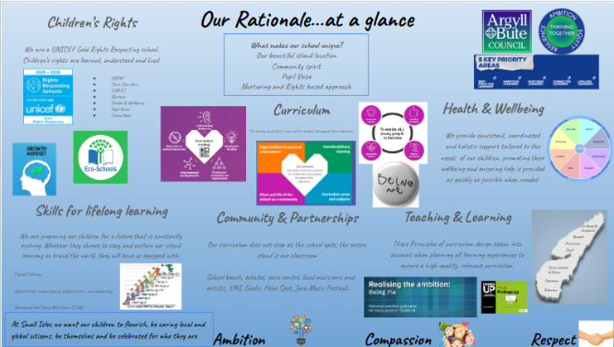
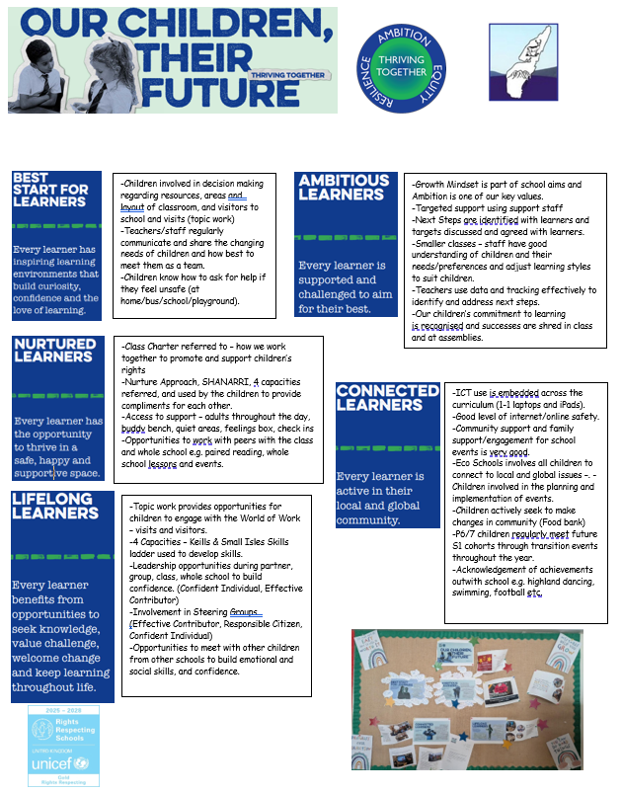
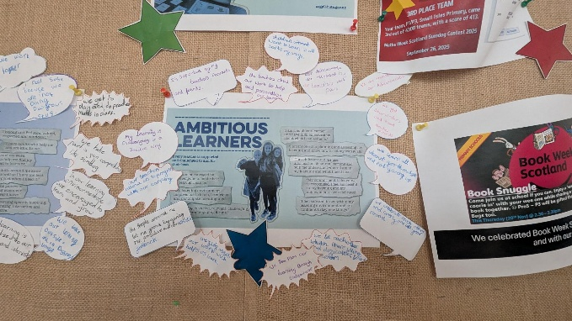
OCTF Parent Leaflet highlighting class practice
A section of our OCTF Display showing pupil comments
Small Isles Curriculum Rationale
Next Steps:
Strategic Intention: Move pupils from knowing the OCTF key elements to using them to track their own progress.
Actions:
Embed "OCTF Reflection Time" into weekly plenaries, where pupils use the language of the rationale to self-evaluate their learning stamina, critical thinking, and citizenship.
Adapt pupil learning profiles to feature the core pillars, allowing pupils to physically or digitally tag pieces of work that demonstrate these values in action.

Review of SIP | Priority 3
Policy Development inc Pupil versions
Strategic aim: To establish a clear, consistent and safe framework that guides the entire school community in achieving the school/authority objectives and fostering a positive and productive environment.
Progress and Impact:
By October 2025, our strategic policy review schedule was successfully established, resulting in the rigorous updating of two core operational frameworks: our Teaching and Learning Policy and our Rights Respecting Policy. Both documents were fully modernized in line with national guidance to reflect our high standards of practice.

Our updated Teaching and Learning Policy is now a highly comprehensive framework, having strategically integrated our planned parental engagement policy into its design. Grounded firmly in Bruce Robertson’s 'Power Up Your Pedagogy' methodology, this overarching document ensures that high-quality classroom instruction and home-school partnerships are driven by the same core standards. To ensure transparency, this document was shared and discussed with families at a recent parent meeting event.

Alongside this, our Rights Respecting Policy was fully refreshed to align with our UNICEF Gold status, ensuring children’s rights remain embedded at the heart of our school ethos. While both master policies are now complete and actively guiding staff practice, the co-creation of their corresponding child-friendly versions was deferred this session. This has been carried forward as a priority next step for the upcoming session, where we will work alongside pupil leadership groups to translate these strategic standards into accessible formats for all learners.
Next Steps:
Building upon the successful finalization of our comprehensive master frameworks this session, our policy review schedule will focus on expanding our library of current guidance, driving pupil ownership, and ensuring absolute transparency across our school community.
Our immediate priorities for development are:

Pupil Ownership & Accessibility: We will actively collaborate with student leadership teams and the Rights Steering Group to co-create and embed child-friendly versions of our existing Teaching and Learning and Rights Respecting policies, ensuring our learners across P1–7 fully understand and own these standards.
Health and Wellbeing Frameworks: In partnership with staff, pupils, and parents, we will design and implement modernised, context-specific policies for Anti-Bullying and Nurture, aligning our daily multi-composite practices with trauma-informed and rights-respecting principles.
Community and Lifestyle Alignment: We will review, refresh, and launch updated policies on Homework and Healthy Eating. These will be designed in close consultation with our families at upcoming parental engagement events, ensuring our curriculum rationale seamlessly bridges school expectations with island family life.

Review of SIP | ELC Priority
1. Curriculum, Planning, and Tracking (Care Inspectorate Action Plan)
Progress: Following the Care Inspectorate inspection, the Headteacher and ELC staff co-created a targeted Action Plan prioritizing Early Level Literacy and Numeracy. Practitioners embedded Curriculum for Excellence (CfE) outcomes across all pathways, using children's organic interests to drive learning. Monitoring systems were refined, utilizing systematic floorbooks to capture child voice and skill progression over time. Staff also engaged in cross-sector benchmarking and peer observations in larger settings to moderate and validate their documentation practices.

Impact:
Practitioners demonstrate high levels of professional confidence and rigor, ensuring that learning experiences are effectively tailored, consistent, and high-quality.
All children’s learning journeys are robustly captured in floorbooks, showcasing clear progression and strong pupil agency.
Operational refinement across the setting ensures that expectations for attainment remain rigorous and completely aligned with regional best practices.

2. Learning Environments: Numeracy, STEM, and Daily Routines
Progress: Strategic investment facilitated a numeracy-rich continuous provision across both indoor and outdoor environments, including a dedicated "home corner maths box" and visual calendar displays. High-quality, specialist STEM resources were introduced alongside permanent mathematical "discovery zones."

Impact:
Most children demonstrate deep engagement with tactile resources, transitioning smoothly from basic numeral recognition to independently constructing mathematical statements and sums (e.g., Freddie progressing rapidly beyond counting within 10 to completing independent sums using magnetic letters).
All learners have strengthened their temporal awareness, measurement skills, and early problem-solving capacities through structured daily routines.

3. Learning Environments: Literacy, Vocabulary, and Roleplay
Progress: Staff introduced multisensory literacy initiatives—such as glass paints, chalking, and updated literary resources—designed to lower barriers to writing. Spontaneous mark-making zones were established in the creative area, and roleplay spaces (such as shops and cafes) were skilfully scaffolded to incorporate functional writing like menus and signage.
Impact:
There is quantifiable evidence of accelerated vocabulary acquisition and enhanced narrative discourse across the cohort, driven by frequent, high-quality verbal interactions.
Target learners who were previously reluctant or faced barriers to writing have shown a significant increase in motivation, spontaneous mark-making, and communication (e.g., Ivan displaying a marked increase in interest and confidence in writing).

4. Family Learning and Partnerships
Progress: To strengthen the home-school link, the setting delivered curricular-themed "Stay and Play" sessions, including a Halloween Numeracy workshop and Bookbug literacy events. Digital communication via Seesaw was strategically adapted to actively invite two-way dialogue. Crucially, reflecting the unique relational context of Small Isles, the delivery of children's "next steps" was shifted from digital platforms to face-to-face professional dialogue with parents.
Impact:
Parents and families report feeling overwhelmingly valued and informed, showing increased confidence in modelling early literacy and numeracy pedagogy at home.
Two-way digital engagement on Seesaw has increased significantly, with families regularly sharing "learning beyond the classroom" which staff directly use to inform individual learning pathways.
The relational face-to-face approach to next steps has deepened parental understanding, allowing for immediate, collaborative target-setting for every individual child.

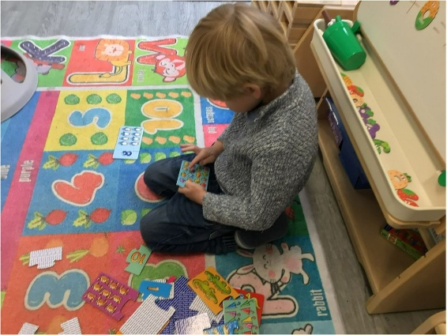
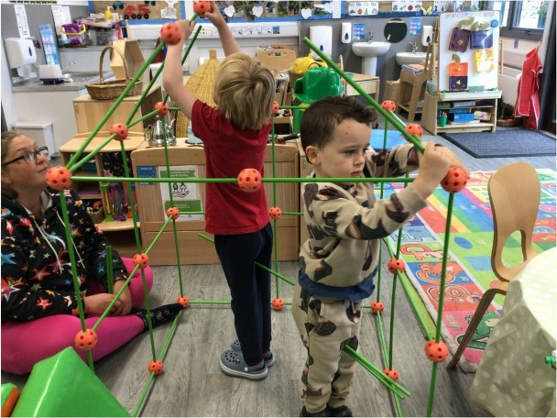

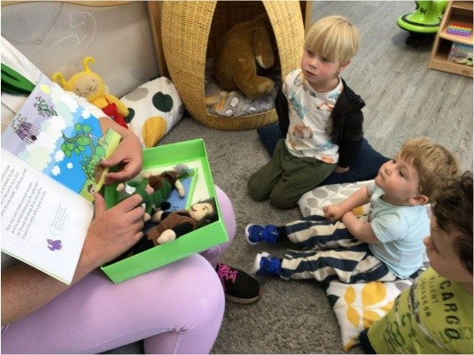
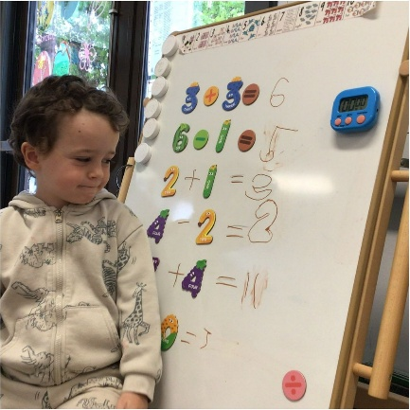
Next Steps:
Next step is to formally engage with the Counting on Excellence programme to enrich our play-based numeracy pedagogy. We will introduce a standardized Early Level Numeracy Progression and conduct an environmental audit to launch tactile, open-access "Discovery Zones" across our indoor and outdoor spaces. Furthermore, we will prioritize cross-sector moderation and collaborative planning, utilizing the expert skills of our ELC practitioners within the Primary 1 classroom. This partnership will establish a unified language of numeracy and a shared methodology, securing confident transitions and continuing to close the developmental attainment gap from day one of formal schooling.

1.1 Attainment Data
Attainment of Literacy Curriculum for Excellence levels 2021/22, 2022/23, 2023/24, 2024-2025 and 2025/2026 (teacher judgement – confirmed levels – 5 year trend).
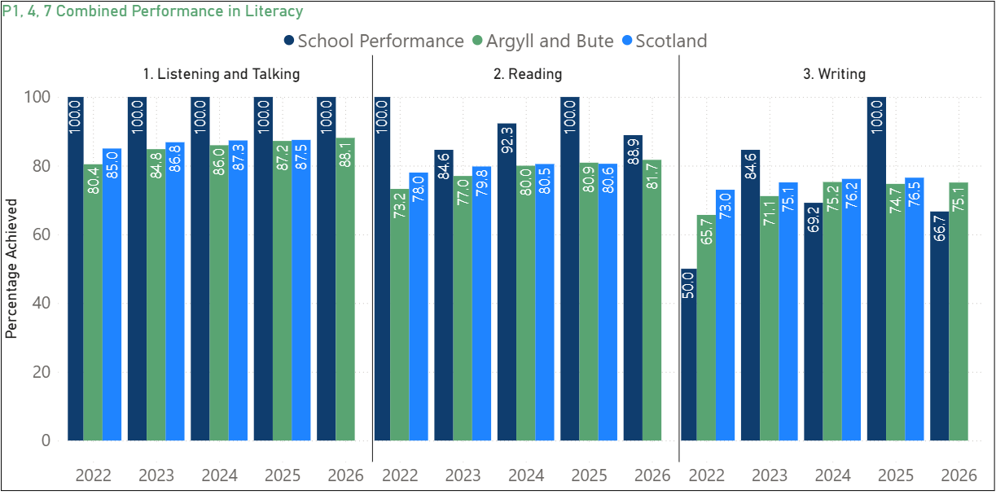

Please Note:
The above data (1.1) reports achievement of a level – P1/P4/P7 combined.

1.2 Attainment Data
Attainment of Numeracy Curriculum for Excellence levels 2021/22, 2022/23, 2023/24, 2024-2025 and 2025/2026 (teacher judgement – confirmed levels – 5 year trend).
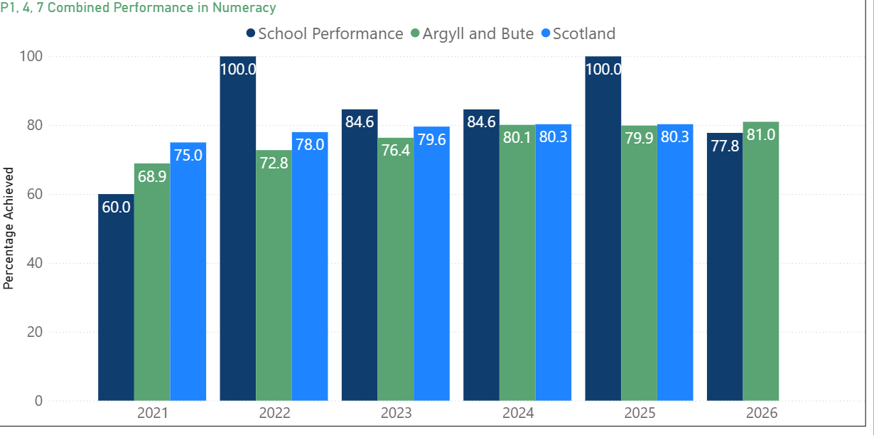

Please Note:
The above data (1.2) reports achievement of a level – P1/P4/P7 combined.

Wider achievements
- What opportunities for wider achievement were offered?
- What systems are in place to track and monitor participation?
- How have you addressed any gaps in participation?
At Small Isles, we embrace the diverse strengths and unique learning pathways of every individual. Our distinct island context serves as a rich, living classroom, offering meaningful opportunities for learners to connect deeply with their local heritage, environment, and community. Over the past session, pupils have enriched their skills through contextualised experiences, including outdoor learning, community partnerships, creative arts, and charity campaigns—fostering noticeable growth in their independence and resilience. Successes are tracked and celebrated through assemblies, school newsletters, public facing events and in the Ileach and Jura Jottings, fostering pride and a positive culture of achievement.
Below are just some of our highlights:
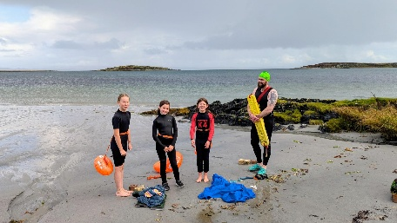
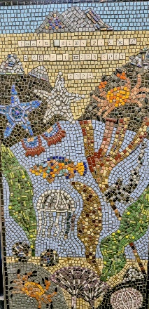
Inclusive Participation and Partnerships
‘Connected Learners’ ‘Lifelong Learners’ ‘Nurtured Learners’
In partnership with the Argyll Hope Spot this year, the school collaborated with a local artist to produce a whole-school mosaic, which was successfully presented at a local community showcase event. Furthermore, this valuable partnership enhanced our outdoor education curriculum by delivering an environmental beach workshop and sea swimming experiences for pupils in P4–7.
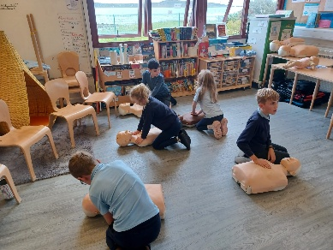
The Heartstart workshops successfully delivered essential life-saving skills to all pupils across stages P1 to P7.

Each year, all children performed the yearly Pantomime to the local community. Again, this was well attended in the school and provides a platform for all our children to be part of a whole school expressive arts performance.
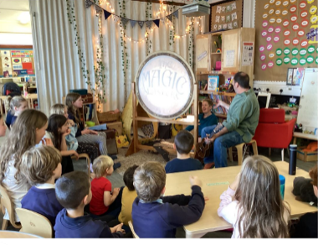
Sustained funding from the Youth Music Initiative (YMI) for the past nine years has enabled the school to embed high-quality expressive arts into the curriculum. This session, local music tutor Giles Perring delivered an impactful block of singing and percussion tuition across stages P1–7. Strengthening our valuable four-year partnership with the Jura Music Festival, all pupils had the opportunity to perform live to a wider audience, receiving high acclaim and significantly boosting their performance confidence. Furthermore, creative collaboration with professional storytellers allowed pupils to develop literacy and expressive arts skills by creating, developing, and performing their own shadow puppetry.
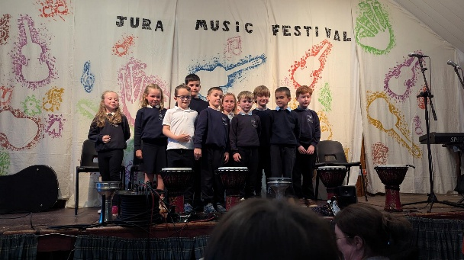
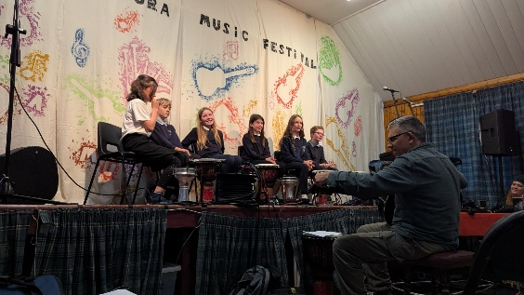

Creativity and Ambition
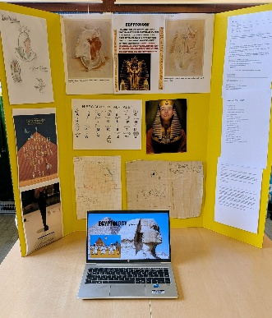
‘Ambitious Learners’ ‘Lifelong Learners’ ‘Best start for learners’
Our children have regular opportunities to showcase their work to the community, and these events are well attended by families. These opportunities lead to increased confidence and self-belief, resilience, communication skills, teamwork and collaboration, problem solving, planning and organisation. This particularly evident in our yearly ‘Endeavour’ projects. This year, P1-7 have taken part in Endeavour projects.

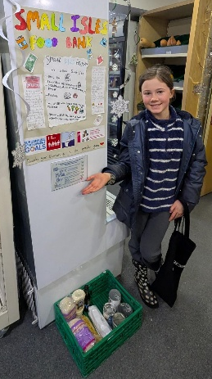
Pupil –Led Community Impact
‘Connected Learners’
Demonstrating a strong commitment to active citizenship, pupils led a community initiative this session to establish the Jura Foodbank in partnership with the Islay Food Bank. Pupils took ownership of the project by setting up a donation collection point in the local shop, and the foodbank now successfully operates from the local church. This initiative has significantly enhanced our pupils' leadership skills while providing vital, sustainable support to the wider community.

Holistic Wellbeing and Wider Attainment
‘Best Start for Learners’ ‘Connected Learners’ ‘Lifelong Learners’ ‘Nurtured Learners’
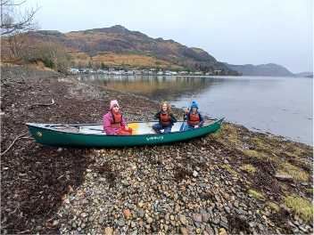
The P7 outdoor residential was a key driver for Wider Achievement this session, providing a purposeful platform for pupils to develop essential skills for life and work. Through team-building challenges and outdoor pursuits, pupils demonstrated significant growth in independence, mutual respect, and personal resilience. The impact of this experience extended well beyond the trip, as pupils returned with heightened self-confidence and enhanced interpersonal skills, directly supporting their readiness for the transition to S1.

This session, the school successfully hosted a vibrant Health Festival designed to promote holistic health and wellbeing across all stages. By leveraging the expertise of parents, local organisations, and community members, we delivered a diverse program of interactive workshops.
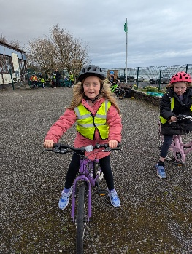
Notable highlights included collaborative healthy eating sessions with our Catering Manager, Yoga, a Family World Cup Football event, and Bikeability training. Furthermore, essential health, hygiene, and safety education was enriched through valuable partnerships with local GPs and our community PC. This initiative successfully fostered a whole-school culture of health awareness and strengthened our community links.
